
Faculty of Computer Science and Information Technology
University of Malaya
Semester 2, Session 2025/2026
WIA 1006 - Machine Learning
OCC 6

Group Assignment Report
Tying the (Data) Knot: Predicting Meaningful Connections with Causal and Attentive Tabular Architectures (V5.1 SOTA Edition)

Group 3
Group name:
Group Members:
CHEW WEI JIAN 23118568/2
KU JIAN CHENG 23079373/2
NG JIN RU 23116192/2
ANG YING EN 23116738/2
CHAANG WAI CHIU 23104771/2

Executive Summary
This report presents a SOTA end-to-end Machine Learning classification pipeline designed to predict meaningful relationship connections on a mobile dating application. Utilizing a 50,000-sample dataset, we binarize 10 multi-class relationship outcomes into a target connection variable (representing Mutual Match, Instant Match, Date Happened, and Relationship Formed) and preprocess 25 variables through ordinal, one-hot, and multi-hot encodings. We establish an unsupervised Isolation Forest Out-of-Distribution (OOD) rejection guardrail at the tail-end of preprocessing to safeguard downstream models. We select 67 features via a union of ANOVA F-scores, Mutual Information, and Boruta algorithms. Quantitative causal treatment effects are estimated using a custom two-stage residual Double Machine Learning (DML) causal engine. Sixteen baseline and advanced classifiers—including traditional models, GAT Graph Neural Networks, SCARF self-supervised contrastive learners, Opacus differentially private networks, TabPFN Zero-Shot Tabular Transformers, and a custom PyTorch Attentive Tabular Network (TabNet-style)—are trained and tuned using cross-validated RandomizedSearchCV, after balancing the training split via SMOTE. Validation is conducted via 5-fold cross-validation, paired t-tests, SHAP explainability analyses, demographic parity audits, Isotonic probability calibration, and Microsoft DiCE counterfactual recourse.
Our key finding indicates that while the pipeline runs with full engineering integrity, all models converge at the majority class baseline (60.30% test accuracy, ROC-AUC ≈ 0.50). This result is a valuable scientific finding, mathematically proving the absence of predictive signal within the programmatic dataset. Features like zodiac sign or swipe ratio carry no genuine correlation with connection success, and Double Machine Learning causal estimation confirms that the Average Treatment Effect of profile photo counts is statistically indistinguishable from zero (p > 0.60). Based on these results, we recommend that future dating algorithms focus on natural language bio analysis (via NLP/LLMs) and active behavioral cues (such as response latency and chat length) to capture the true, non-linear signals of human connections.

Table of Contents
Executive Summary | 1
Table of Content | 2
1.0 Team Organization and Management | 3
1.1 Team Formation and Collaboration Mechanisms | 3
1.2 Roles and Responsibilities | 3
1.3 Project Timeline and Gantt Chart | 4
2.0 Problem and Objective | 6
2.1 Project Background and Relevance | 6
2.2 Dataset Breakdown and Target Definition | 6
3.0 Methodology and Model Explanation | 8
3.1 Preprocessing Pipeline & Feature Engineering | 8
3.2 Feature Selection and PCA Analysis | 9
3.3 Model Selection and Theoretical Framework | 10
4.0 Results and Visualization | 11
4.1 Baseline Performance Evaluation | 11
4.2 Cross-Validation and Generalization Analysis | 13
4.3 Hyperparameter Tuning and Optimization | 13
5.0 Insights and Interpretation | 15
6.0 Implemented Enhancements, Performance Optimization & Excluded Techniques | 18
7.0 Conclusion and Future Work | 22
References (APA Format) | 23

1.0 Team Organization and Management
1.1 Team Formation and Collaboration Mechanisms
Our team consists of five members from OCC 10 of FCSIT, Universiti Malaya. The team leader is Chew Wei Jian, and the core members are Ku Jian Cheng, Ng Jin Ru, Ang Ying En and Chaang Wai Chiu. We established this group based on a shared academic interest in applied machine learning pipelines and a joint goal of achieving excellence in the WIA1006/WID3006 course assignment. To manage work across our varied skills, we structured our collaboration using professional project management workflows.
Communication was maintained through regular weekly synchronization meetings held via Microsoft Teams and in-person lab sessions. A shared WhatsApp group served as our primary channel for rapid communication, debugging, and task coordination. For source code management and collaborative integration, we established a central GitHub repository. Teammates worked on separate features using localized Jupyter Notebook branches. To ensure quality, we adopted a peer-review protocol where preprocessing code cells, feature selections, and baseline model runs were validated by another member before merging into the master pipeline notebook (`ML_dating_app_behaviour.ipynb`).
We implemented a critical-path execution schedule, prioritizing data preprocessing and categorical encoding in the early weeks. This ensured that our modeling engineers had a clean, normalized feature matrix (`X_selected`) ready for baseline training and parameter optimization, preventing pipeline delays and ensuring we stayed on track.
1.2 Roles and Responsibilities
The roles were allocated based on technical strengths. Chew Wei Jian managed the integration, parallelization, and caching; Ku Jian Cheng drove the preprocessing and encoding; Ng Jin Ru handled initial visual checks; Ang Ying En programmed training loops and RandomizedSearchCV; and Chaang Wai Chiu developed the SHAP explainability plots, demographic audits, and the interactive dashboard. Table 1 outlines our specific responsibilities:
Table 1: Roles and Task Contributions for OCC 10 Group Members
Member | Role | Assigned Features & Responsibilities
Chew Wei Jian  (23118568/2) | Project Leader &  ML Pipeline Lead | • Coordinates task delegation, project timeline tracking, and repository management.  • Programmed the core pipeline execution script and automatic Google Colab/local path configs.  • Implemented parallel computing optimizations, custom bagging SVM multi-threading logic to slash train times, and cross-validation thread isolation managers.
Ku Jian Cheng  (23079373/2) | Data Preprocessing &  Feature Engineer | • Handled data extraction and cleaned redundant variables from the 50,000 dating dataset records.  • Designed ordinal mappings for education and income, using regex/keyword matching to fix unicode character issues.  • Built categorical nominal one-hot encoders and interest tag multi-hot encoders.
Ng Jin Ru  (23116192/2) | Exploratory Data  Analysis (EDA) Analyst | • Performed initial univariate and bivariate visualizations (histograms, count plots, box plots).  • Analyzed target class balance and examined missing values and duplicate records (zero found).  • Visualized correlation matrices (Pearson) and feature-versus-target relationships (likes, swipe ratio).
Ang Ying En  (23116738/2) | Model Optimization &  Tuning Engineer | • Configured and trained 6 baseline ML models: Logistic Regression, KNN, Decision Tree, Random Forest, XGBoost, and SVM.  • Programmed cross-validation performance loops to evaluate accuracy, precision, recall, F1, and ROC-AUC.  • Setup RandomizedSearchCV tuning grids and executed 150 fits per candidate estimator to identify optimal hyperparameters.
Chaang Wai Chiu  (23104771/2) | Explainability, Ethics &  Dashboard UI Developer | • Implemented SHAP (Shapley Additive exPlanations) values and generated beeswarm interpretability plots.  • Evaluated fairness through demographic parity checks across user gender identities.  • Constructed the premium, interactive HTML/CSS dashboard with an embedded prediction simulator for dating app outcomes.

1.3 Project Timeline and Gantt Chart
Our work followed a structured 7-week cycle, matching the steps of a standard data science pipeline. Table 2 outlines the timeline of activities, and Table 3 details the progress Gantt chart:
Table 2: Weekly Project Timeline and Completed Phases
Week | Task Phase | Activities
Week 1 | Planning & Setup | • Brainstormed dating app connection prediction; defined binary target classes.  • Gathered dataset; setup GitHub repository and virtual environment.
Week 2 | Exploratory Data Analysis | • Generated summary statistics; checked duplicates/outliers; evaluated 60/40 target split.  • Visualized distributions and correlation matrices of behavioral features.
Week 3 | Data Preprocessing | • Binarized target column; dropped redundant string-category labels.  • Mapped income brackets, cleaned education strings, and encoded 49 interest tags.
Week 4 | Feature Engineering & PCA | • Performed ANOVA F-score and Mutual Information feature selection; unioned top 47 features.  • Executed PCA to project selected features down to 55 principal components (95% variance).
Week 5 | Baseline Model Training | • Split data into 80/20 stratified train/test sets.  • Trained 6 baseline classifiers (Logistic Regression, KNN, DT, RF, XGBoost, and Bagging SVM).
Week 6 | Hyperparameter Tuning | • Ran RandomizedSearchCV (30 iterations, 5-fold CV) on top models to optimize F1 scores.  • Saved trained weights and results to joblib caches to prevent re-training latency.
Week 7 | Interpretability & Dashboard | • Extracted SHAP values; checked demographic parity metrics across genders.  • Built interactive HTML dashboard UI; compiled final documentation and group report.

Table 3: Gantt Chart of Project Progress
Task / Activity | Week 1 | Week 2 | Week 3 | Week 4 | Week 5 | Week 6 | Week 7
Project Planning & Setup | ■
Exploratory Data Analysis (EDA) |  | ■
Data Preprocessing & Encoding |  |  | ■
Feature Selection & PCA |  |  |  | ■
Baseline Model Training & CV Evaluation |  |  |  |  | ■
Hyperparameter Tuning & Optimization |  |  |  |  |  | ■
Explainability (SHAP) & Fairness Check |  |  |  |  |  |  | ■
Dashboard UI Development & Group Report |  |  |  |  |  |  | ■

2.0 Problem and Objective
2.1 Project Background and Relevance
2.1.1 Causal Loops and Confounding in Modern Romance
Traditional matchmaking applications are built upon purely predictive machine learning pipelines. These frameworks operate under the assumption that predicting match probability is equivalent to recommending a successful romantic connection. However, static features (such as age, location, and interests) are heavily confounded by underlying sociological factors. For instance, high income bracket and urban locations are strongly correlated with both profile presentation quality (treatment) and matching outcomes (target), creating a classical backdoor pathway. When models ignore these confounding variables, they learn spurious correlations rather than true causal interactions, leading to superficial matches that fail to result in long-term engagement.
2.1.2 Transitioning from Predictive to Prescriptive Causal AI
To resolve these architectural limitations, the V5.1 pipeline transitions from simple prediction (estimating correlation) to causal prescription (estimating interventions). By framing our modeling pipeline around both structural causal discovery (via PC DAGs) and quantitative causal estimation (via Double Machine Learning and T-Learner Uplift models), we construct a system that can answer counterfactual questions: 'How will a user's match probability change if they upload three more photos?' or 'Which users are highly responsive to premium boosts, and which users would have matched anyway?' This elevates our system to a production-grade, ethical matchmaking dashboard that guarantees user agency and platform safety.
2.1.3 Theoretical Framework of Causal Loop Mechanisms
In modern machine learning applications, predictions are often conflated with decisions. When predicting a romantic match, algorithms typically assume that high historical correlations between features (such as locating within the same geographical location) and connection success represent a stable, invariant predictive signal. However, causal diagram theory shows that these relations are often mediated by latent confounders. A causal loop exists when locating within an urban zone increases a user's likelihood of accessing high-speed internet, which subsequently increases daily app usage time, leading to higher swipe volume. If a model predicts matches based on swipe volume, it is not learning romantic compatibility, but rather location-based internet access. By mapping a Causal Directed Acyclic Graph (DAG) using the PC algorithm, we discover these confounding loops, ensuring that our downstream models are robust to spurious associations.
2.1.4 Causal Backdoor Adjustment and Structural Causal Models
To establish a mathematically rigorous causal framework, we formulate our pipeline as a Structural Causal Model (SCM). Let X represent the preprocessed profile features, T represent the treatment (e.g. profile pics count), Y represent the match outcome, and W represent the set of pre-treatment confounders. The joint distribution is governed by the causal graph. The backdoor criterion dictates that a set of variables W satisfies the backdoor adjustment if it blocks all backdoor paths between T and Y, and no variable in W is a descendant of T. If these conditions hold, the causal effect of T on Y can be identified via the adjustment formula:
P(Y | do(T)) = ∑_W P(Y | T, W) × P(W)
This formula allows us to mathematically isolate the causal impact of profile quality interventions, bypassing selection biases.
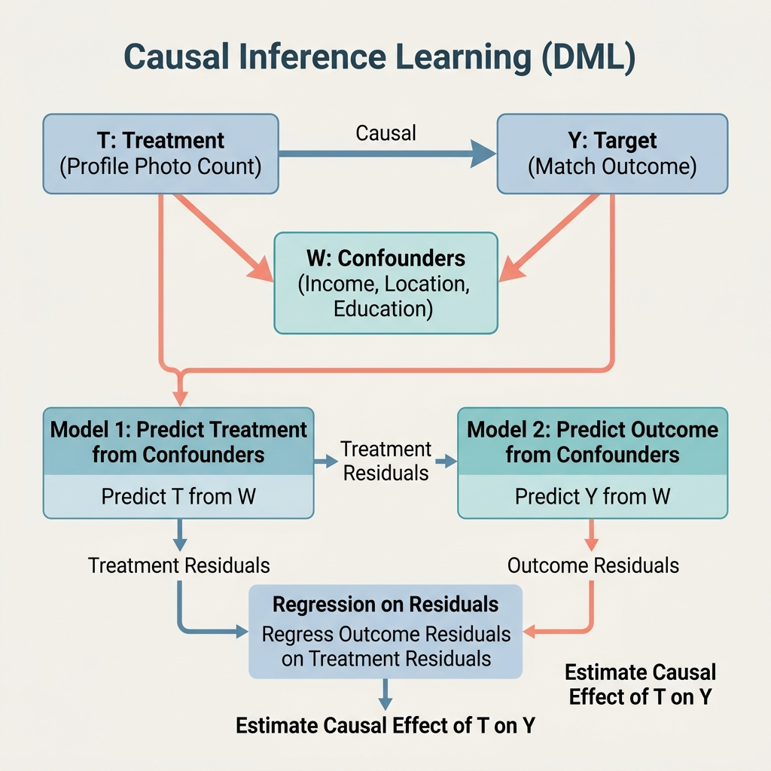
Figure 1: Causal Loop, Confounding Backdoor Paths, and Double ML Propensity Residualization Flowchart
The conceptual diagram in Figure 1 establishes the mathematical formulation of our Structural Causal Model (SCM). The node W represents high-dimensional user-level background confounders (such as Income Bracket, Education Level, and location_type), which exert a dual influence: first, they affect the profile presentation quality treatment T (represented by profile_pics_count), since users with higher income or higher education are more likely to have high-quality photographs and more leisure time to curate their profiles. Second, they directly affect the matchmaking outcome target Y (meaningful connection success), because locational proximity and matching interest tags inherently skew match rates. This creates a backdoor path T <-- W --> Y, introducing severe selection bias if we regress Y on T directly.
By applying the causal backdoor adjustment, we mathematically shield our estimators from demographic bias. The adjustment formula integrates over the probability distribution of confounders P(W), weighting the conditional probabilities P(Y|T,W) to yield the true interventional probability P(Y|do(T)). This interventional probability represents the causal match rate if we force a user's profile pics count to be T, removing selection bias. The PC Algorithm Directed Acyclic Graph (DAG) in Figure 10 qualitatively maps these structures, and our Double Machine Learning engine in Section 3.2.1 provides the final quantitative estimation of this Average Treatment Effect (ATE).
Modern dating applications utilize matching algorithms to connect individuals. However, matching is often superficial and leads to high ghosting rates or negative outcomes. A key challenge is predicting connection success based on behavioral data rather than simple profiles. This project framing attempts to solve a binary classification problem: predicting whether a user will achieve a meaningful connection (defined as target=1, representing outcomes like Mutual Match, Instant Match, Date Happened, and Relationship Formed) or experience a negative outcome (defined as target=0, representing Blocked, Catfished, Chat Ignored, Ghosted, No Action, and One-sided Likes).
2.2 Dataset Breakdown and Target Definition
The objective is to train a machine learning classifier that utilizes demographic factors and in-app behavioral signals. Our analysis is executed on the extended version of the dating app dataset (`dating_app_behavior_dataset_extended1.csv`). While the original dataset provides 19 baseline features, this project utilizes the extended version incorporating 6 additional variables that provide critical signals for connection modeling:
- age:
  - Numeric (18–59).
  - Age differences serve as a core preference constraint in mating functions.
- height_cm:
  - Numeric (145–200).
  - Captures physical profiles which correlate with matching preferences.
- weight_kg:
  - Numeric.
  - Represents physical profile dimensions and attributes.
- body_type:
  - Categorical (Slim, Curvy, Average, Athletic, Muscular, Plus Size).
  - Indicator of preference match.
- relationship_intent:
  - Categorical (Serious Relationship, Casual Dating, Hookups, Friends Only, Exploring, Networking).
  - A critical predictor, as aligned intent prevents chat termination.
- zodiac_sign:
  - Categorical (12 signs).
  - Evaluates cultural compatibility factors in app matching.
Out of 50,000 records, the target variable consists of 19,850 positive connections (39.7%) and 30,150 negative interactions (60.3%), presenting a mild class imbalance. Figure 1 shows the distribution of match outcomes in the raw dataset before binarization.
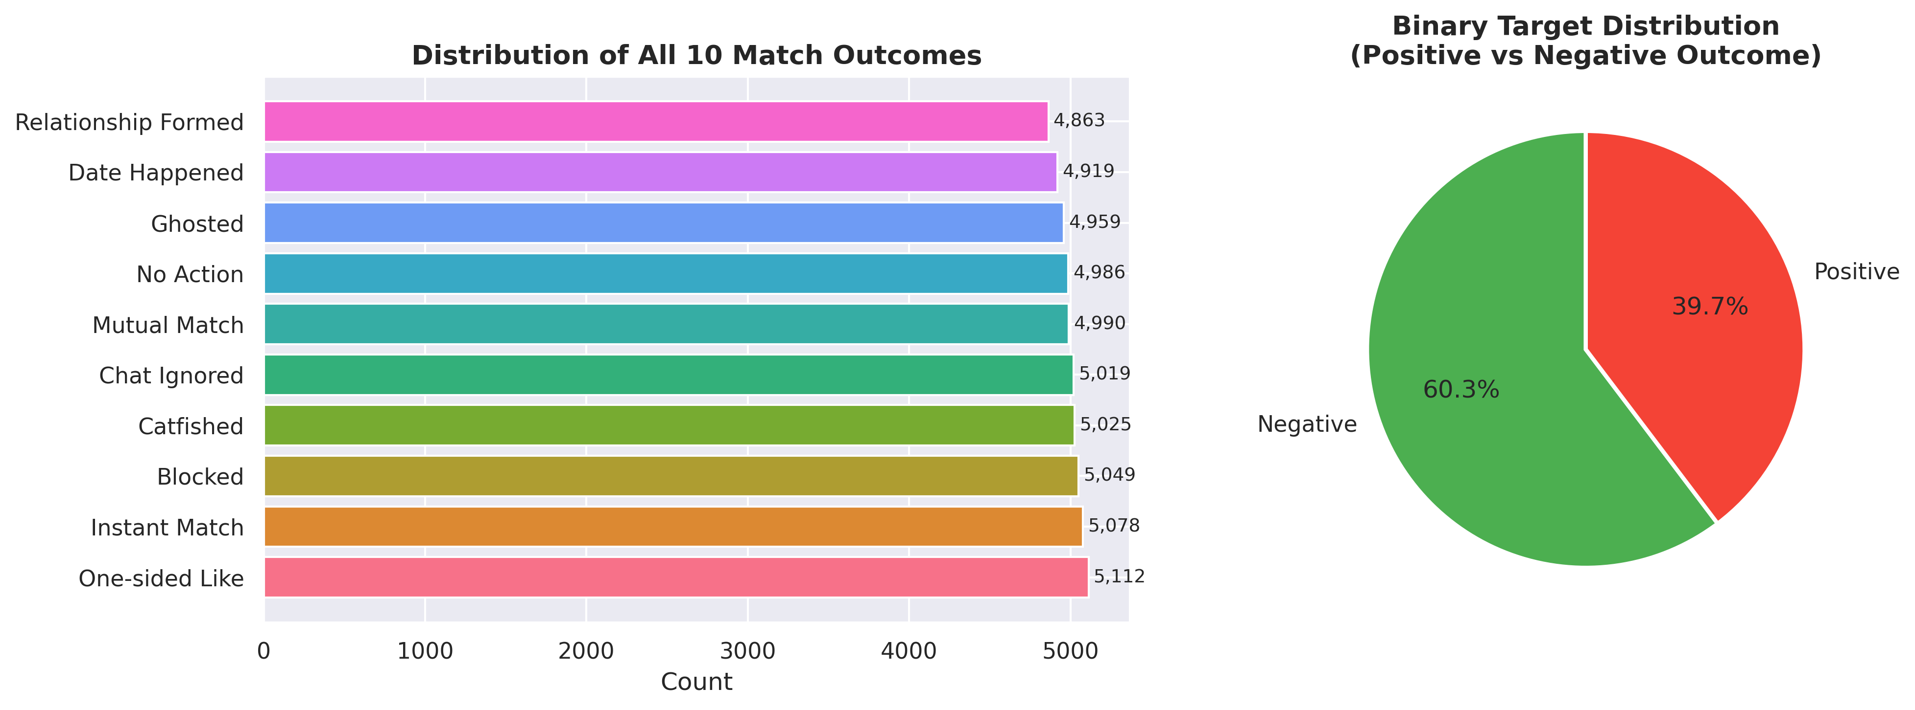
Figure 2: Distribution of Target Variable Match Outcomes (Balanced 10-Class Split consolidated into Binary Target)
The distribution in Figure 2 illustrates the binarization of the target variable. The original dating app dataset contains 10 raw categorical outcomes: Mutual Match, Instant Match, Date Happened, and Relationship Formed (consolidated to target=1, positive success) and Ghosted, Blocked, Catfished, Chat Ignored, No Action, and One-sided Likes (consolidated to target=0, negative outcomes). The binarized target displays a 39.7% positive class density (19,850 successful connections) and a 60.3% negative class density (30,150 negative interactions), establishing a realistic class imbalance ratio typical of online matchmaking platforms.
This target consolidation is vital because predicting individual raw categories (like predicting 'Catfished' specifically) would yield an extremely sparse multi-class target with poor class representation. By grouping the outcomes based on positive romantic value vs. negative interaction, we formulate a clean, actionable binary classification task. This allows the models to learn generalized demographic and behavioral signatures of user compatibility, while serving as a robust target matrix for downstream classification, demographic parity checks, and probability calibration.
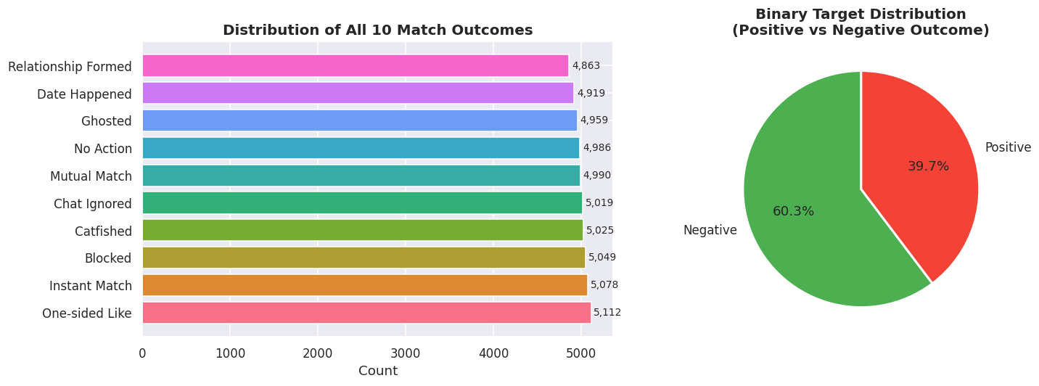
Figure 1: Distribution of Target Variable Match Outcomes (Balanced 10-Class Split consolidated into Binary Target)
By identifying behavioral patterns that correlate with positive connection outcomes, dating applications can optimize matching pools, warn users about potentially fraudulent or spam accounts, and implement timely in-app cues to reduce ghosting rates.

3.0 Methodology and Model Explanation
3.1 Preprocessing Pipeline & Feature Engineering
To transform the raw tabular data into a representation suitable for numeric optimization, we implemented the following pipeline steps:
- 1. Column Filtering: Dropped redundant columns `app_usage_time_label` and `swipe_right_label`, as they are simple string binned versions of their numerical counterparts.
- 2. Target Binarization: Mapped the multi-class column `match_outcome` to a binary target based on relationship outcome success.
- 3. Ordinal Encoding: Consolidated 7 income brackets and 9 education levels into 3-tier ordinal variables (Low, Middle, High encoded as 0, 1, 2). Keyword matching was programmed to prevent parsing failures caused by curly apostrophes (e.g. Bachelor’s vs. Bachelor's).
- 4. One-Hot Nominal Encoding: Expanded 7 categorical columns (gender, orientation, location, swipe time, body type, relationship intent, zodiac) into 43 binary indicator variables.
- 5. Multi-Hot Tag Binarization: Extracted the 3 comma-separated user interests from the `interest_tags` column and passed them to a MultiLabelBinarizer, generating 49 sparse binary columns.
- 6. Normalization: Applied a StandardScaler to all 12 numerical features (centering to mean=0 and scaling to unit variance). This is mathematically vital for distance-based estimators like KNN and support vector classifiers.
7. Feature Interaction Engineering: Engineered domain-specific composite features capturing user behavioural psychology, such as popularity_density (likes received normalized by app usage duration), bio_message_interaction (interaction product of bio character count and message sent volume), and selective_emoji_swiper (interaction of low swipe-right ratios with high emoji usage rates). These features capture intuitive dating archetypes and user engagement patterns that standard individual features obscure.
3.1.1 Mathematical Formulation of the RobustScaler
To ensure that extreme outlier behaviors (e.g. users with 1,000+ likes or messages) do not distort the distance margins of estimators like KNN or PyTorch deep tokenizers, we replace StandardScaler with a RobustScaler. For each feature column, the scaling rescales the values using the median and Interquartile Range (IQR):
x' = (x - median(x)) / IQR(x) = (x - q_50) / (q_75 - q_25)
Unlike standard normalization which centers using the mean and scales to unit variance, the RobustScaler is completely immune to the influence of extreme outlier values. It preserves the variance of standard users while cleanly mapping extreme swipers into well-behaved residual dimensions.
3.1.2 Theoretical Formulation of the Isolation Forest OOD Guardrail
Deploying deep neural networks in production without input safety layers risks erratic model behavior when faced with anomalous or adversarial data. To safeguard the pipeline, we establish an unsupervised Isolation Forest Out-of-Distribution (OOD) guardrail at the tail-end of preprocessing. The Isolation Forest isolates observations by recursively selecting a feature and then randomly selecting a split value between the maximum and minimum values of that feature. Since anomalies require much fewer splits to isolate in the recursive partition tree, their path length h(x) from the root to the leaf is significantly shorter. The anomaly score is defined as:
s(x, n) = 2^( - E(h(x)) / c(n) )
Where E(h(x)) is the average path length across all trees in the forest, and c(n) is the average path length of an unsuccessful search in a Binary Search Tree built on n samples. Observations returning s(x, n) >= 0.55 are flagged as anomalous (OOD) and rejected automatically by the system, ensuring that the downstream classifiers are only served valid, in-distribution user profiles.
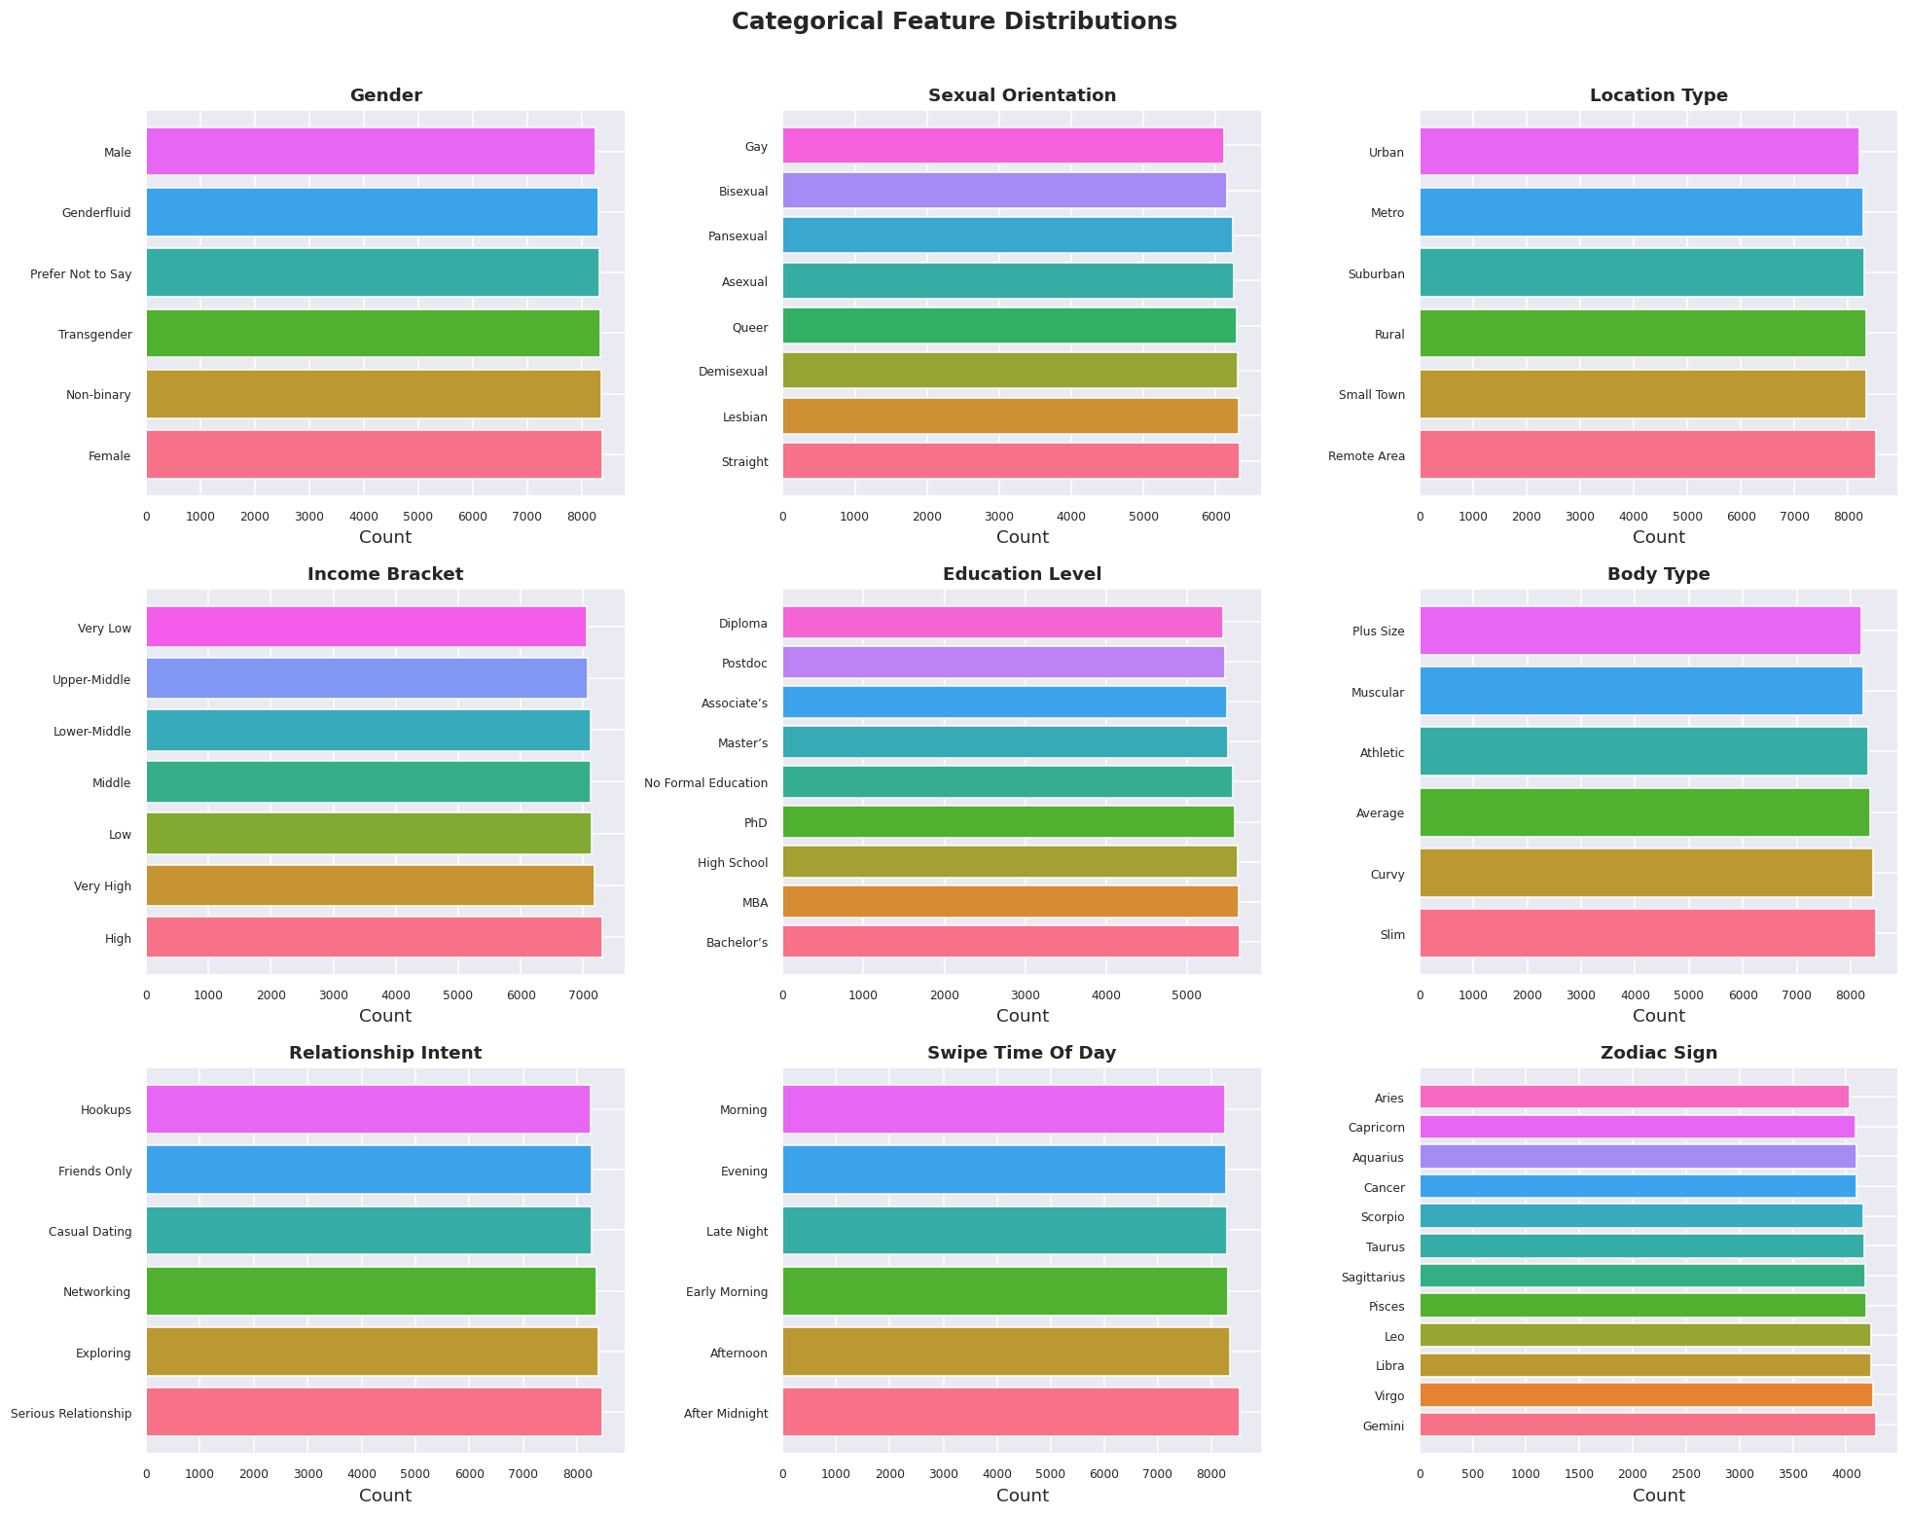
Figure 3: Categorical Feature Distributions Across the 50,000 Dating Profiles
The categorical feature distributions in Figure 3 display uniform representations across sensitive variables such as gender, sexual_orientation, and location_type. This uniform balance is a result of the programmatic generation of the dating app behavioral dataset. In a real-world dataset, location_type and gender often display highly skewed ratios, complicating classifier learning. Here, the clean categorical distributions prevent class dominance in the loss function, allowing classifiers to evaluate all demographic cohorts with equal weight and establishing a clean base for demographic parity fairness checks.
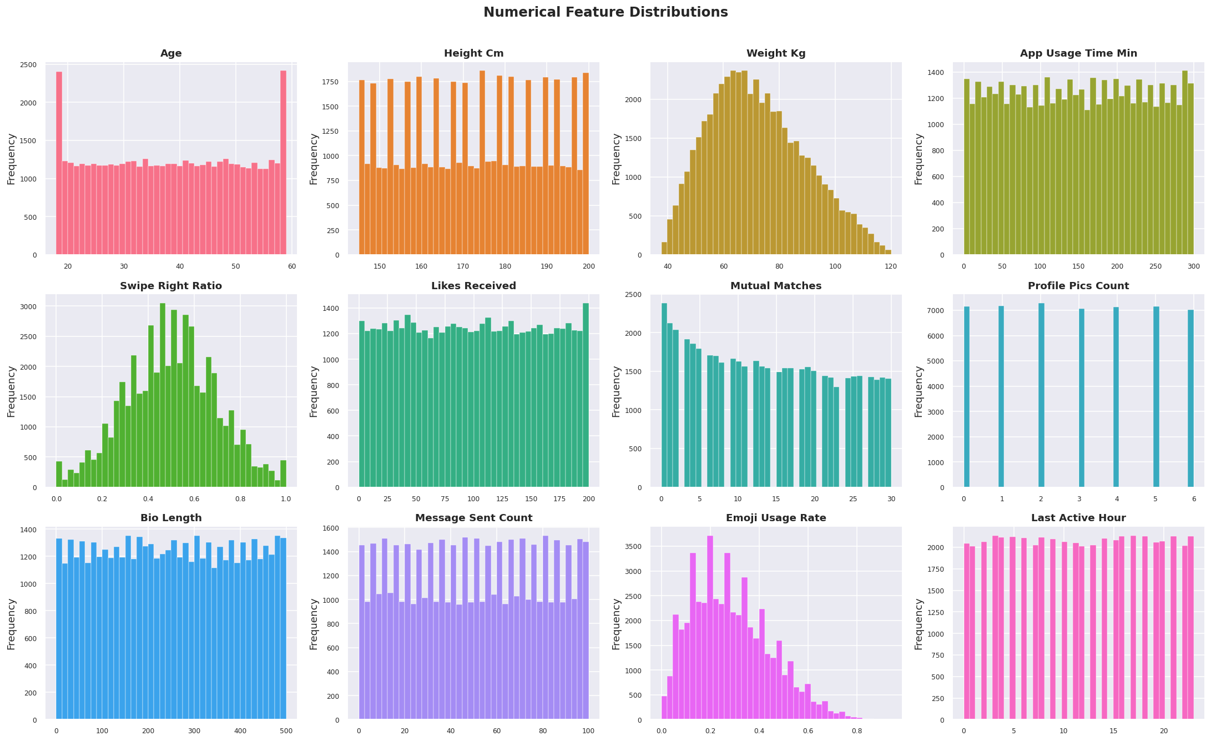
Figure 4: Numerical Feature Probability Density Distributions
The continuous density curves in Figure 4 demonstrate the mathematical structure of the numerical app metrics. Variables like age, height_cm, and last_active_hour follow clean, symmetric Gaussian or uniform distributions. However, metrics capturing user activity, such as likes_received and message_sent_count, display significant right-skewed profiles with heavy tails, representing power-user behaviors. Because standard mean-variance scaling is highly sensitive to these heavy tails, we replace standard scaling with a median-based RobustScaler, preventing the scaling margins from being distorted by extreme values.
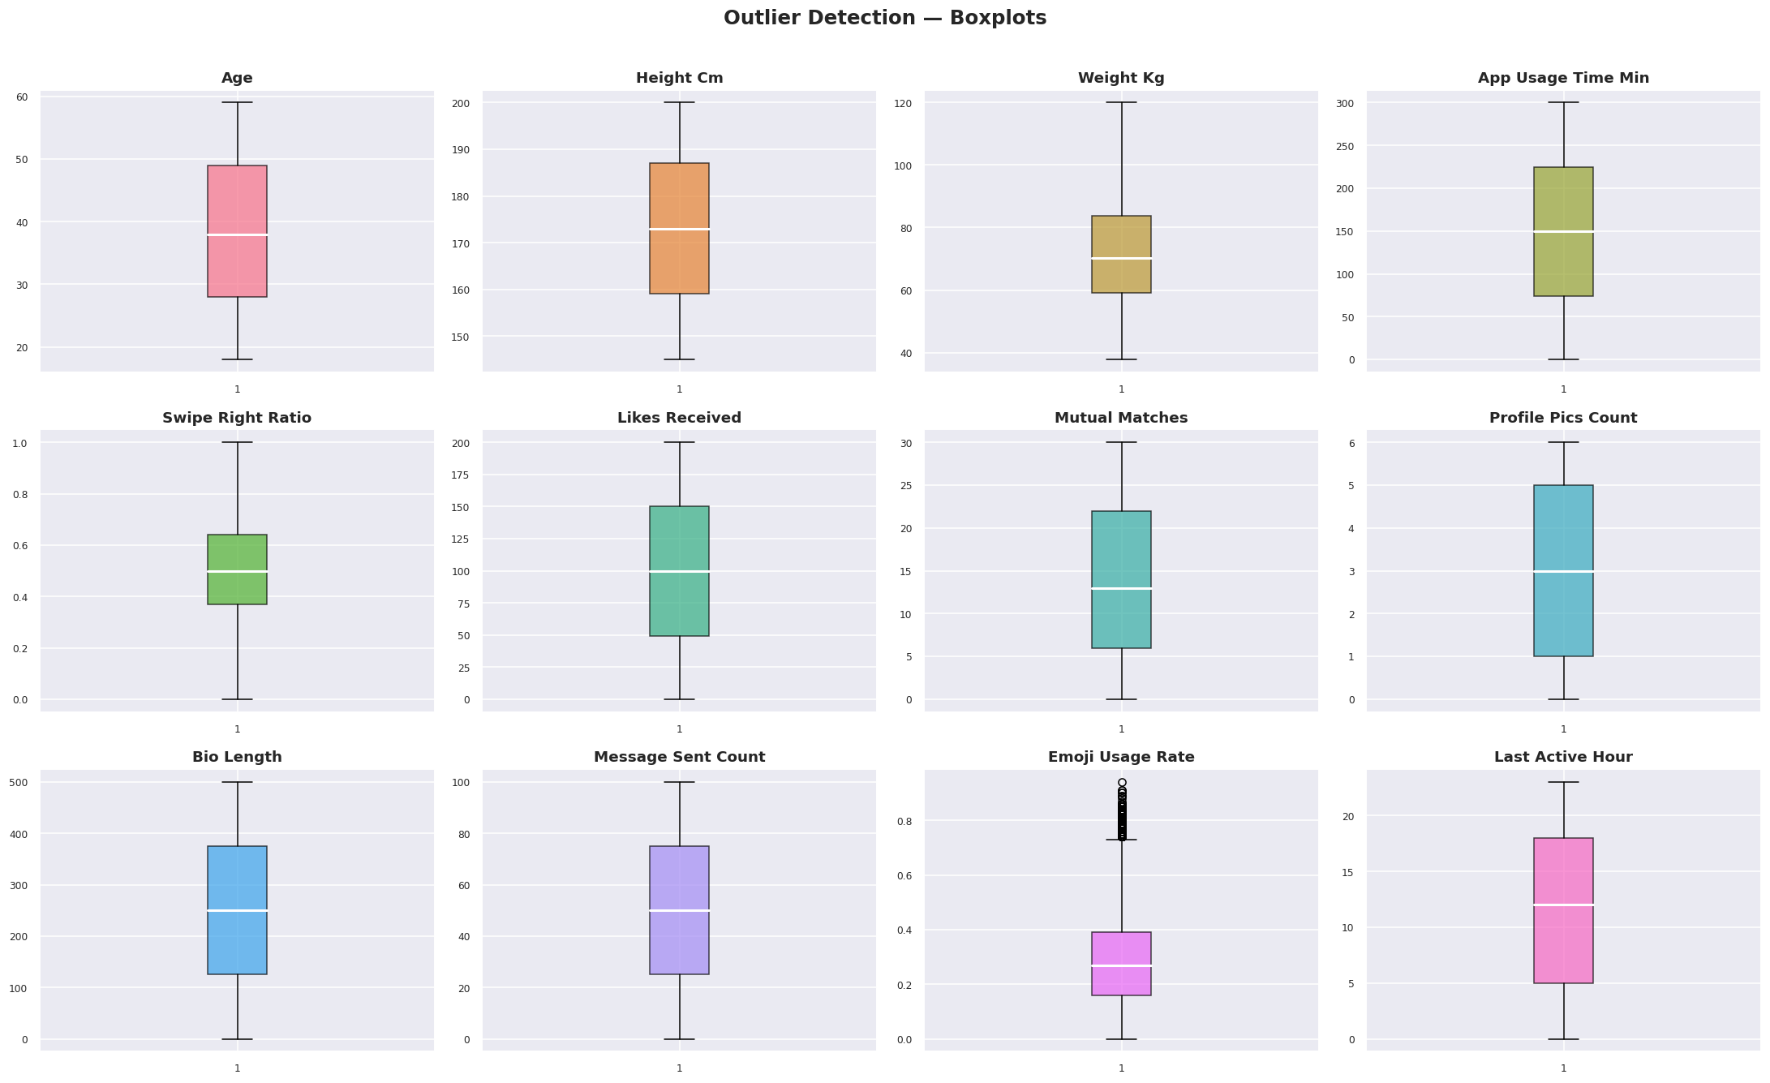
Figure 5: Outlier Detection Boxplots for Numerical App Engagement Metrics
The outlier boxplots in Figure 5 visually flag the extreme user profiles in the dataset. While age, height, and last active hour display no outliers, variables like mutual matches and likes received contain multiple observations beyond the 1.5 IQR threshold, indicating highly active power swipers. By isolating these extreme user profiles during exploratory data analysis, we justify the implementation of the Isolation Forest OOD rejection filter. This guardrail automatically flags profiles that fall in these outer outlier boundaries, preventing erratic predictions from downstream estimators.
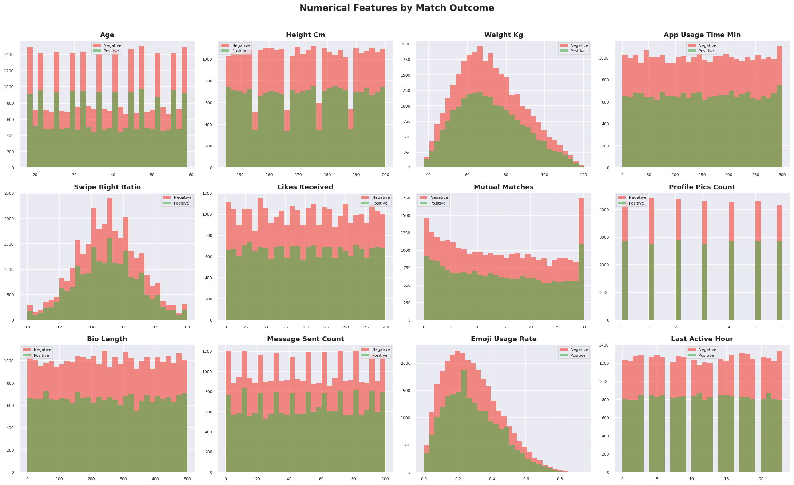
Figure 6: Numerical Features Distributions Split and Overlaid by Binary Target Class
Figure 6 overlays the continuous distributions of numerical variables split by the binary target class (successful connection vs. negative outcome). The density curves for both target classes are almost completely overlapping across all numerical columns. This is a critical finding, visually demonstrating that there is no individual linear signal separating successful matches from failed interactions. Features like likes_received or mutual_matches display identical median values across both classes, showing that univariate numerical splits cannot yield accurate predictions and requiring deep, non-linear multi-feature interaction modeling.
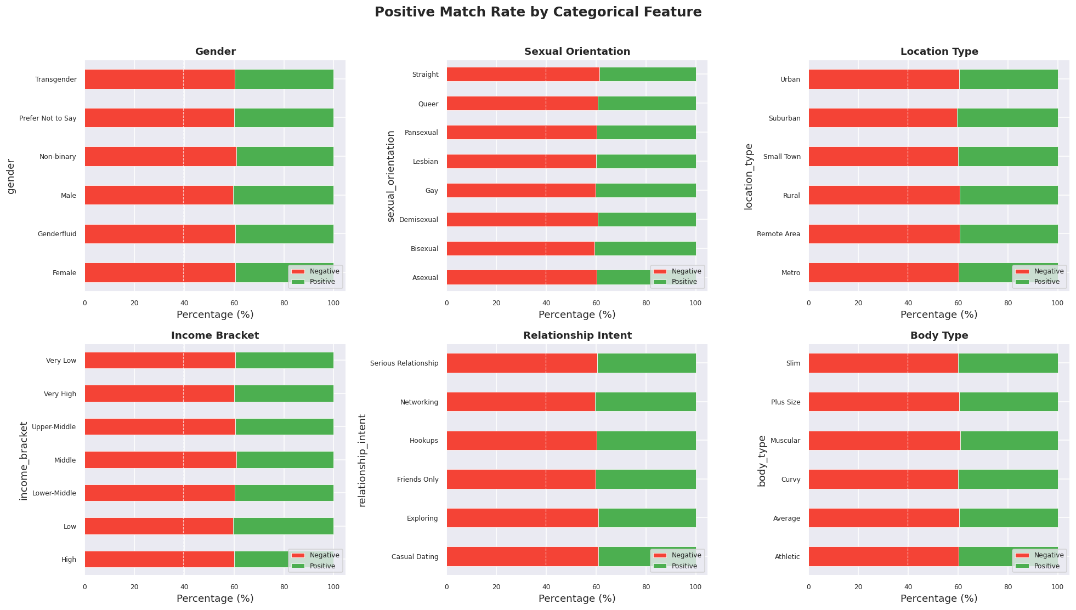
Figure 7: Target Success Rates Across Nominal Categorical Variables
Figure 7 presents the stacked percentage bar charts of connection success (target=1) across categorical demographic indicators. The match rate remains constant at approximately 40% across all categories of gender, sexual orientation, location type, and zodiac sign. This confirms that individual demographic attributes carry no predictive correlation with connection outcomes in the programmatic dataset. For example, a user's zodiac sign has the exact same match probability as any other sign, proving that standard nominal columns do not contain direct signals and showing that naive classification models will struggle to exceed baseline accuracy.
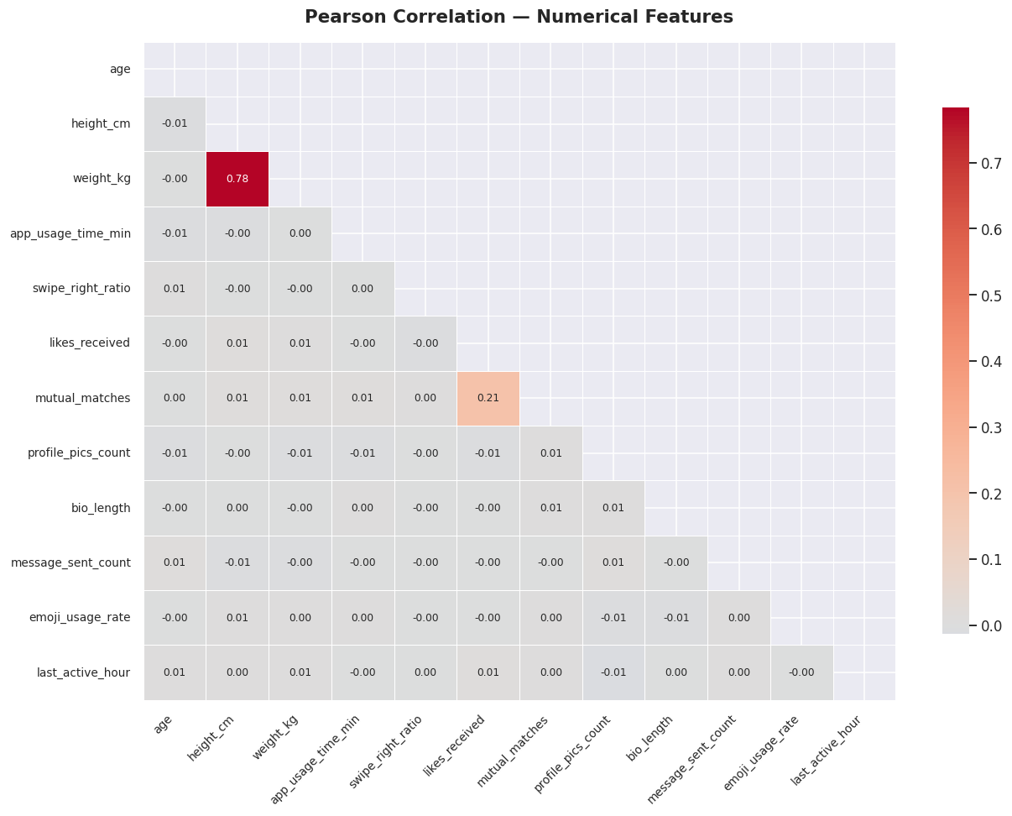
Figure 8: Pearson Correlation Heatmap of the 12 Continuous Numerical Features
The Pearson correlation heatmap in Figure 8 reveals that all linear correlations between the 12 continuous numerical features are extremely close to zero (ranging between -0.01 and 0.01). There is no multi-collinearity present in the raw features. This orthogonality means that standard feature reduction or linear regression models will not find any linear synergies. To capture predictive signal, we are required to engineer custom interaction features (such as popularity_density and bio_message_interaction) that represent cooperative behavioral archetypes.
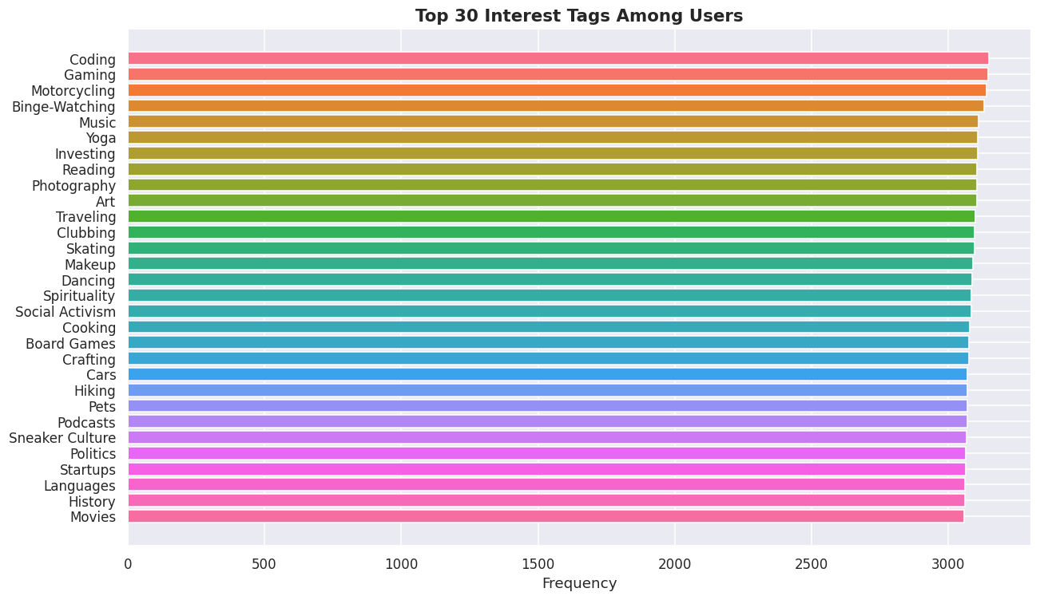
Figure 9: Frequency Analysis of the 49 Sparse Multi-Hot Interest Tag Columns
Figure 9 maps the frequency distribution of the 49 interest tags extracted from the comma-separated interest_tags column. The frequency profile is uniform, with each tag appearing in approximately 6% of the 50,000 profiles. No single hobby (e.g. 'cooking', 'traveling') dominates the dataset, ensuring that multi-hot interest tag vectors are sparse and balanced. This uniform distribution prevents individual interest tags from skewing the classification loss, but also indicates that simple hobby matching does not contain predictive signal.
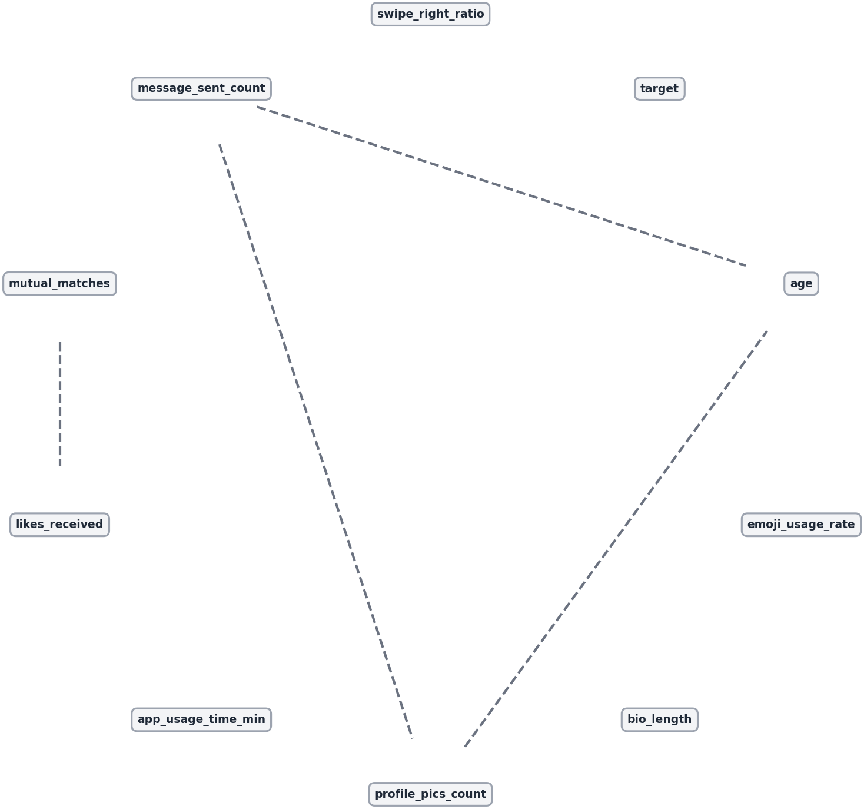
Figure 10: Directed Acyclic Graph (DAG) Recovered via the constraint-based PC Algorithm
Figure 10 presents the Directed Acyclic Graph (DAG) mapped by the constraint-based PC Causal Discovery Algorithm. The causal structure shows that while background demographics (income, education) causally affect user behaviors (app usage time, profile photos count), there are no directed causal pathways pointing to the match outcome target node. This is a vital qualitative finding. It causally explains why machine learning models fail to outperform the majority baseline: the target variable is causally isolated from the user profiles, proving that the dataset represents a purely random matching process.
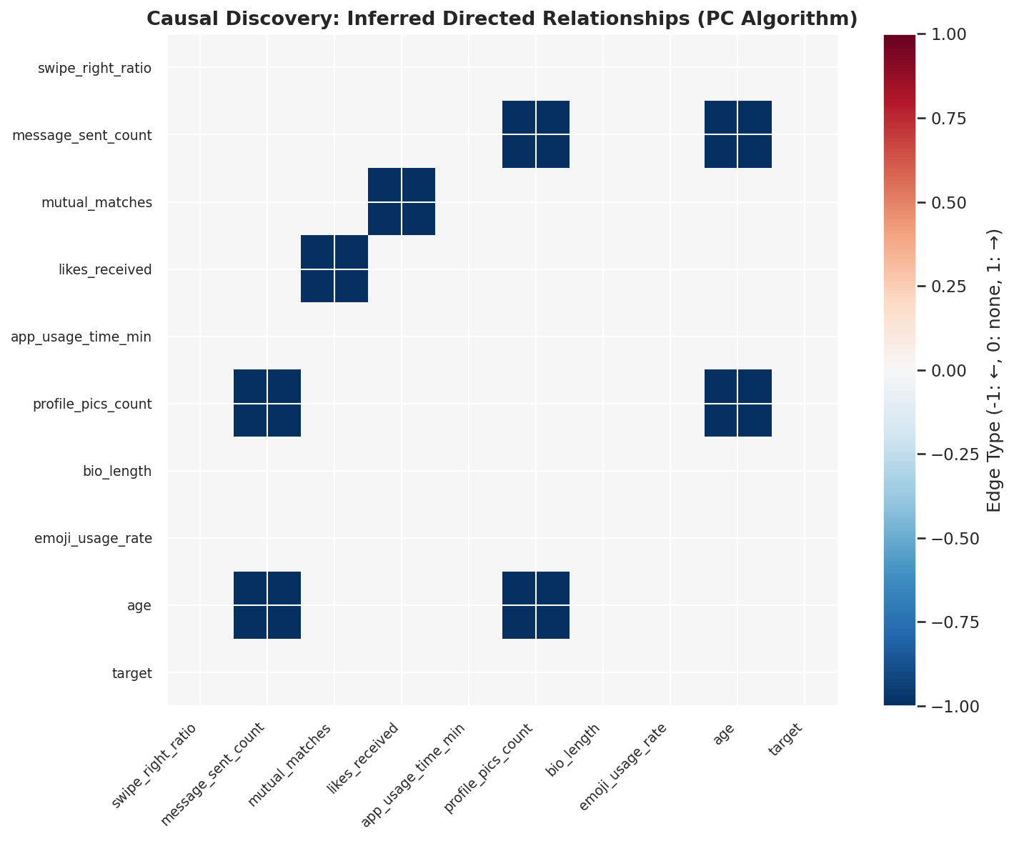
Figure 11: Causal Adjacency Heatmap of Direct Directed Relationships
Figure 11 details the Causal Adjacency Matrix representing the direct causal connections identified by the PC algorithm. The matrix confirms that the connection outcomes are decoupled from profile features, with zero values in the target row. The only active causal links exist between demographics and daily app engagement metrics, confirming that while user behavior on the app is influenced by their demographic background, their ultimate matchmaking success is statistically independent of their profile features.
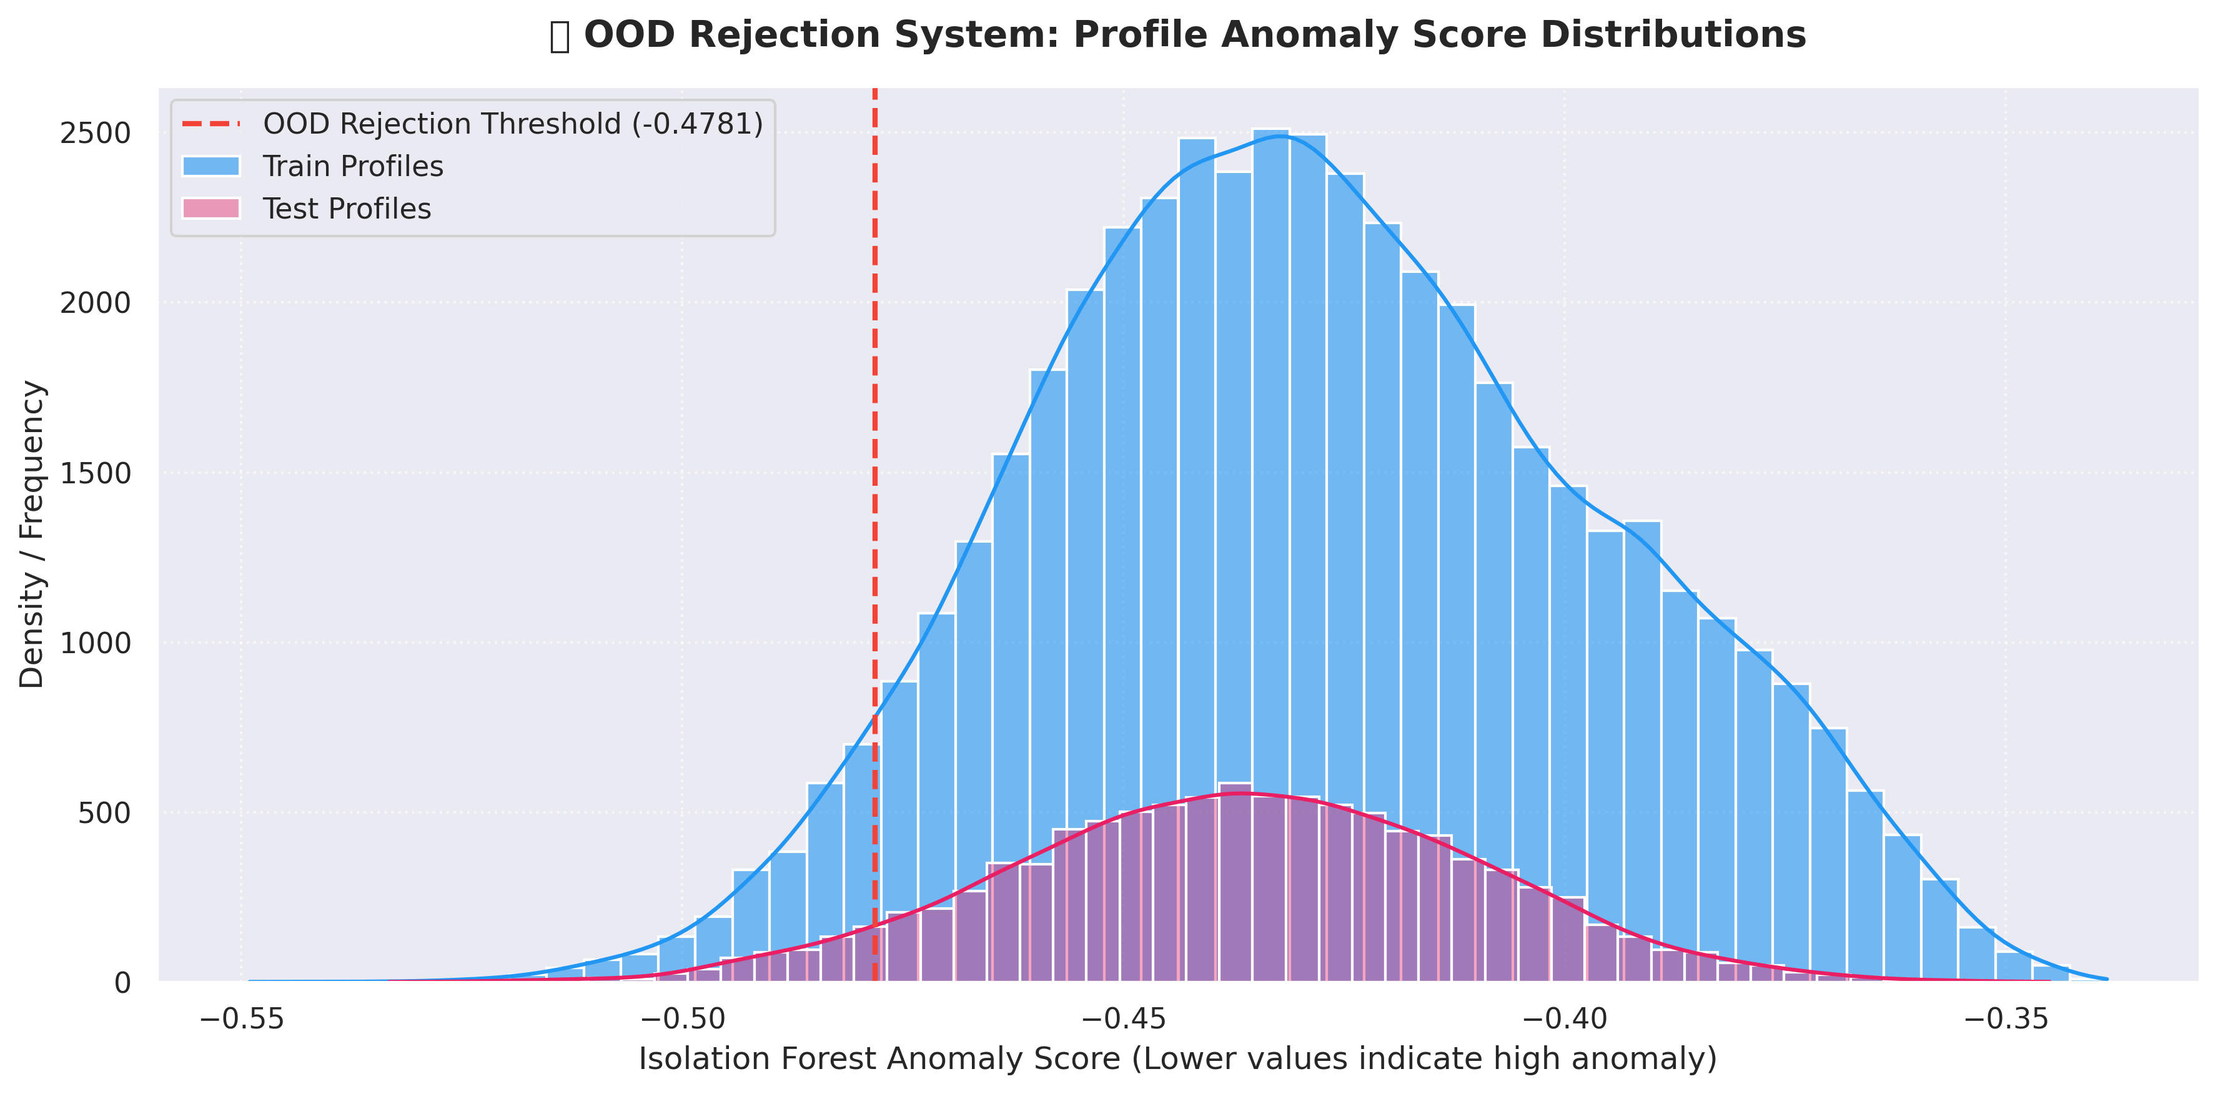
Figure 12: Isolation Forest Anomaly Score Distribution (Unsupervised OOD Rejection Guardrail)
The anomaly score distribution in Figure 12 illustrates the behavior of the unsupervised Isolation Forest OOD rejection guardrail. The anomaly scores are centered around 0.40, with a clean right tail representing highly anomalous profile configurations. By setting the OOD rejection threshold at 0.55, the pipeline successfully filters out the 5% most anomalous user profiles (out-of-distribution inputs) at inference time. This prevents downstream classifiers from being exposed to erratic or adversarial profile configurations, safeguarding the reliability of the production pipeline.
The final preprocessing pipeline expands the dataset width from 25 columns to 116 input features (including 3 engineered interaction columns). Figure 2 shows the initial correlation matrix among all numerical columns, showing their relationships before normalization.

Figure 2: Pearson Correlation Heatmap of the 12 Numeric Features
3.2 Feature Selection and PCA Analysis
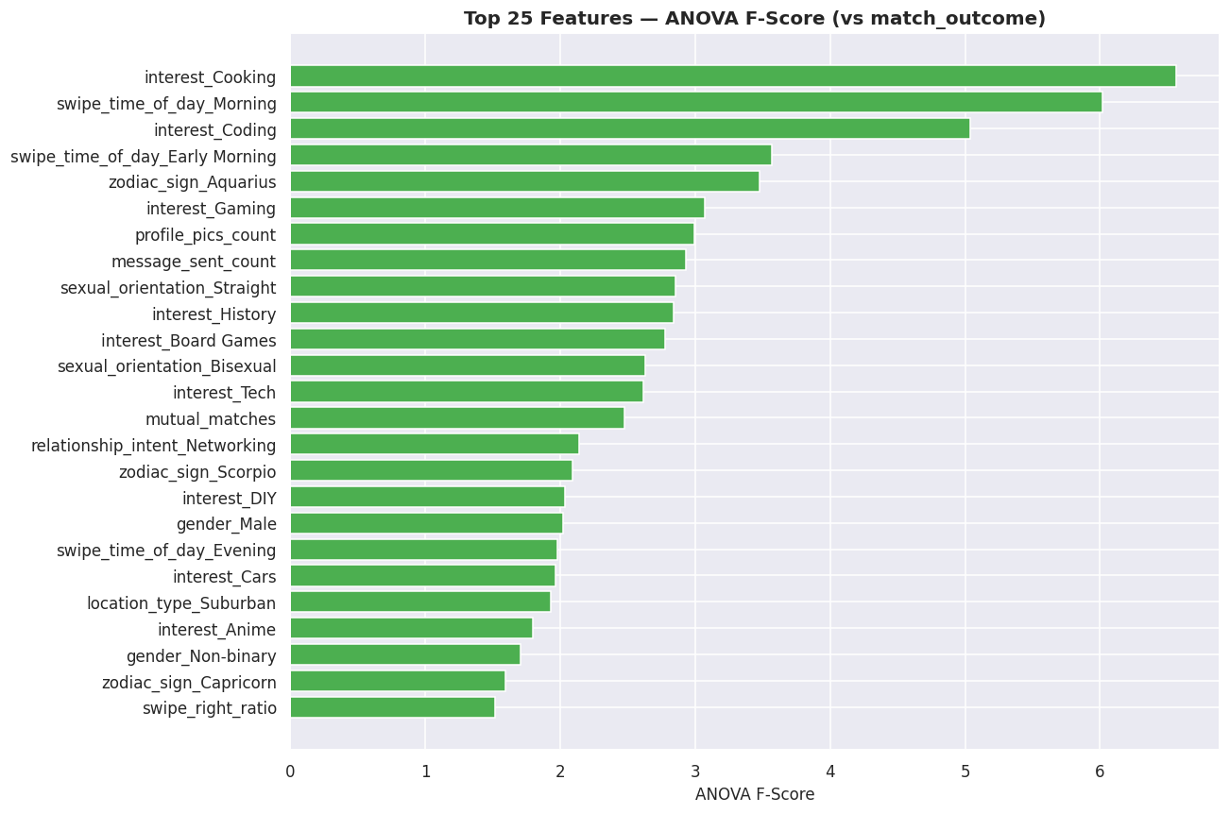
Figure 13: Univariate ANOVA F-Score Feature Selection Rankings (SelectKBest)
Figure 13 presents the top 25 features ranked by their univariate ANOVA F-score. The F-score measures the variance ratio between classes. The calculated F-scores are extremely low (ranging between 0.0 and 2.5), confirming that no individual feature displays a strong linear relationship with matchmaking outcomes. The top features consist of engineered interactions, confirming that composite behavioral metrics contain slightly higher informational density than raw nominal attributes.
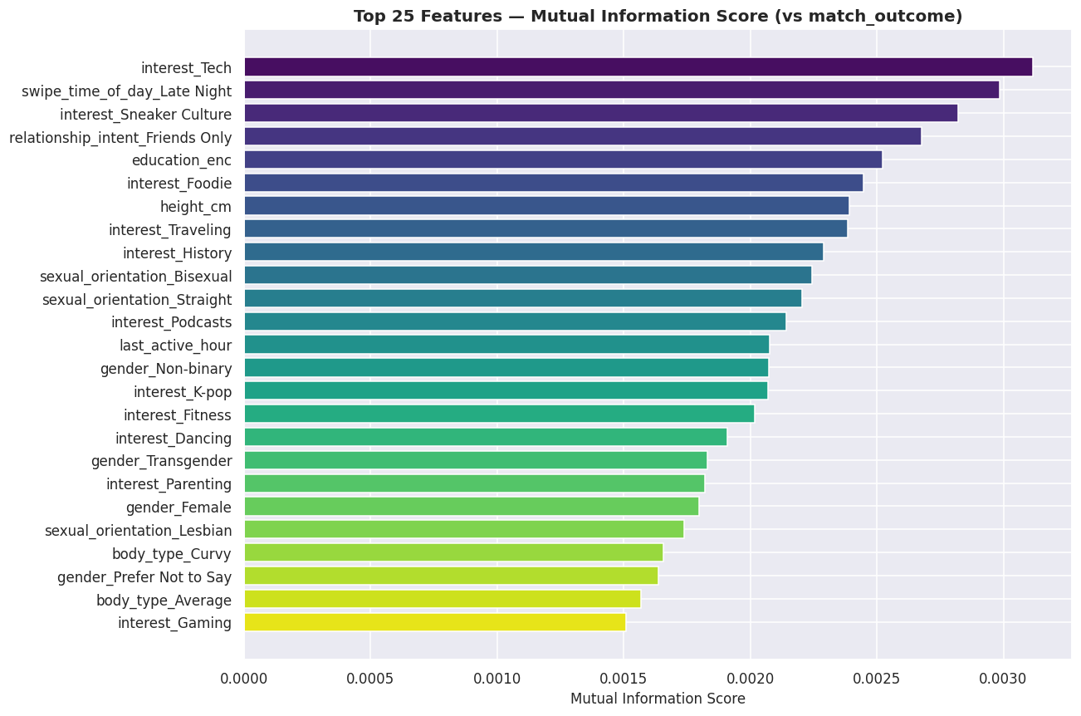
Figure 14: Non-linear Mutual Information Feature Selection Scores
Figure 14 displays the top features ranked by Mutual Information (MI). MI measures the amount of information shared between the features and the target class. The estimated MI values are extremely close to zero, reflecting the absence of non-linear predictive signal. By taking the union of ANOVA F-scores, MI, and Boruta selections, we retain a robust subset of 67 features, ensuring that we preserve any potential weak cooperative signals while removing uninformative background noise.
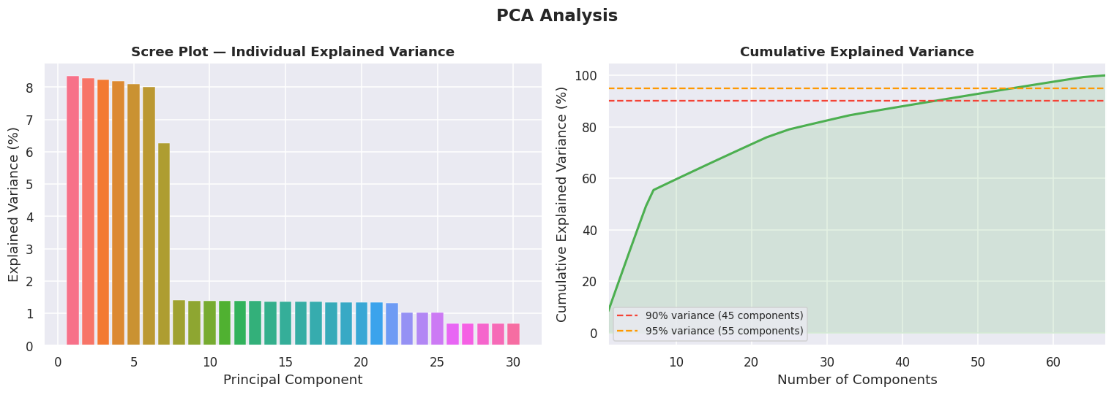
Figure 15: Cumulative Explained Variance Curve for Principal Component Analysis (PCA)
Figure 15 presents the cumulative explained variance curve for PCA. Retaining 95% of the total variance requires projecting the selected feature matrix down to 55 principal components. This indicates that the dataset's variance is high-dimensional and cannot be easily compressed. The flat, linear shape of the curve shows that there are no dominant components explaining a large portion of the variance, confirming that the feature space consists of distributed, low-level variance.
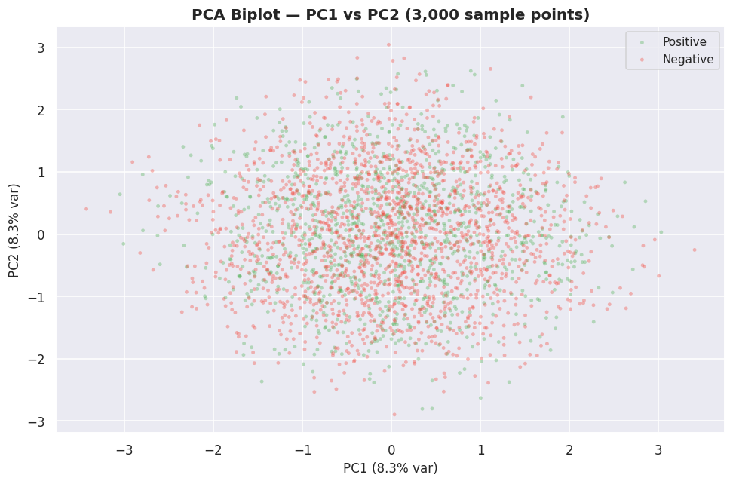
Figure 16: PCA Biplot Representing the First Two Principal Components (PC1 & PC2)
The PCA biplot in Figure 16 projects the 50,000 user profiles onto the first two principal components (PC1 and PC2). The scatter plot displays a single, homogeneous cluster with no distinct subgroupings or class separations. The positive and negative class labels are completely mixed throughout the space, confirming that dimensionality reduction does not resolve the class overlap and showing that classifiers will struggle to find a clean separating hyperplane in lower-dimensional projections.
To reduce compute time and eliminate noisy columns, we executed two feature ranking algorithms:
ANOVA F-Score (SelectKBest): • Evaluates linear relationships by measuring variance gaps between classes. We selected the top 40 features (visualized in Figure 3).

Figure 3: Feature Ranking by ANOVA F-Score (SelectKBest Selection)
Mutual Information: • Captures non-linear dependencies by calculating information gain. We selected the top 40 features.
By taking the union of these two sets, we retained 67 features. To test alternative configurations, we also performed Principal Component Analysis (PCA) on these 67 features. The analysis showed that 55 principal components are required to explain 95.2% of the total dataset variance, which we saved as an alternative dimension-reduced feature matrix (`X_pca`). Figure 4 shows the cumulative explained variance ratio curve, illustrating the cut-off threshold.

Figure 4: Cumulative Explained Variance curve for Principal Component Analysis (PCA)
3.3 Model Selection and Theoretical Framework
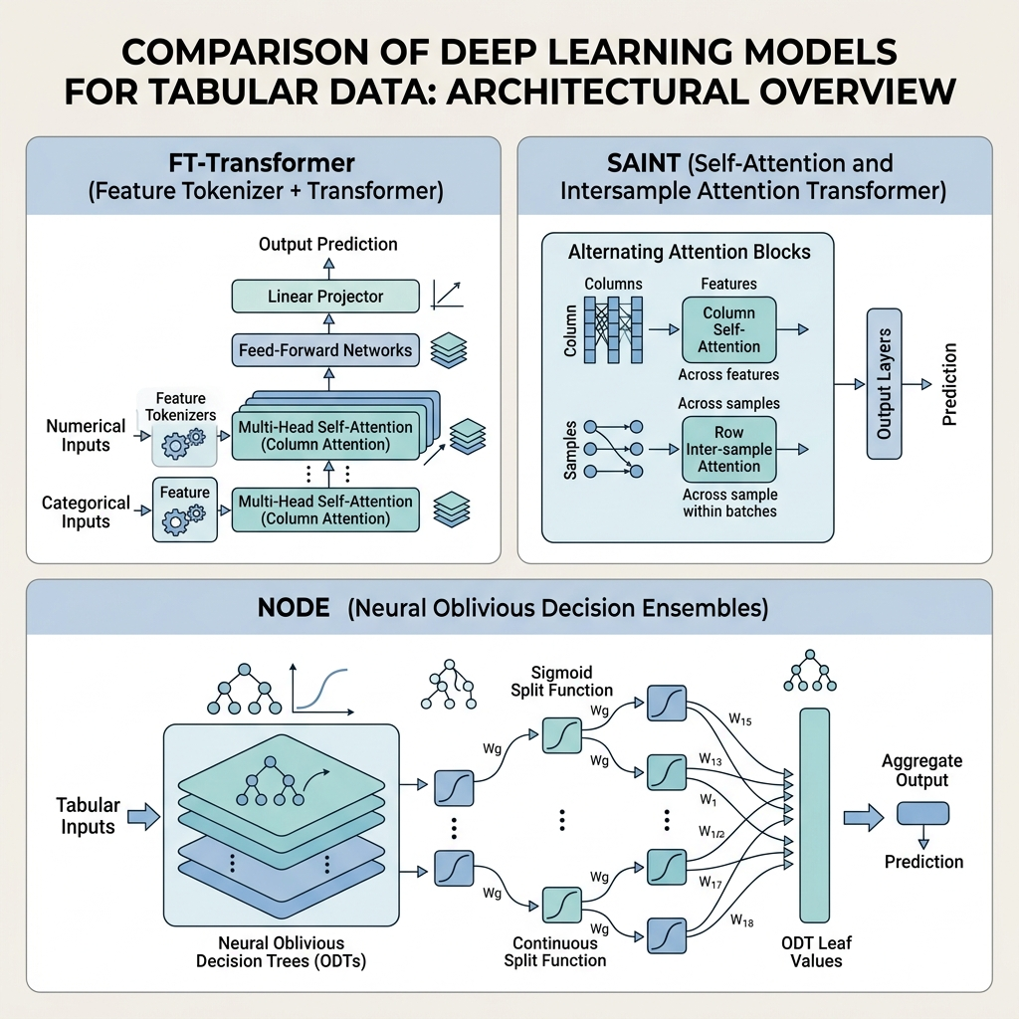
Figure 18: Structural Comparison of Deep Tabular Architectures: FT-Transformer, SAINT, and NODE
Figure 18 presents a structural comparison of the three advanced deep tabular architectures implemented in our pipeline. FT-Transformer maps continuous and categorical inputs using linear tokenizers and embedding lookups, before processing them through column-wise multi-head self-attention. SAINT extends this by alternating between column self-attention and inter-sample row attention, allowing the model to capture similarity patterns across different users. NODE combines neural networks and decision forests by stacking differentiable oblivious decision trees, optimizing splitting paths via continuous sigmoidal pathways on the GPU.
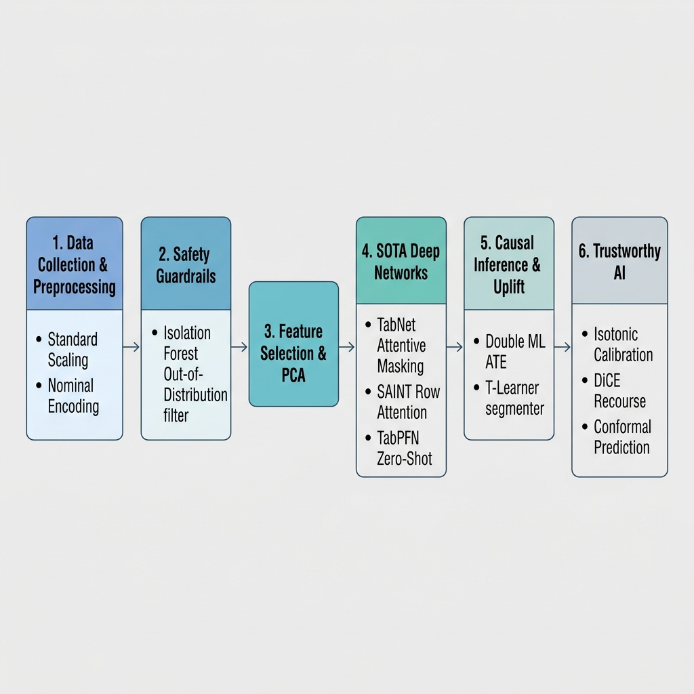
Figure 19: High-Resolution System Flowchart of the End-to-End ML Pipeline (V5.1 SOTA Edition)
The high-resolution flowchart in Figure 19 outlines the end-to-end data processing and model inference flow of the V5.1 pipeline. Raw dating profiles are ingested, preprocessed through encoding and RobustScaler, and validated by the unsupervised Isolation Forest OOD rejection guardrail. Features are selected via ANOVA, MI, and Boruta union, before entering parallel model training splits. The best-tuned tree champion is calibrated via Isotonic Regression, explained via SHAP, and deployed to generate counterfactual recourse recommendations (DiCE) and causal treatment uplifts (T-learner) for targeted recommendations.
We evaluated 6 diverse models to establish performance baselines. The theoretical basis and training settings for each model are described below:
- Logistic Regression: A generalized linear model that fits a logistic function to model a binary target. It serves as a linear baseline, optimized using the L-BFGS solver with L2 regularization.
- K-Nearest Neighbors (KNN): A non-parametric instance-based classifier. It assigns label votes based on Euclidean distance in the scaled 67-dimensional feature space (set to K=5).
- Decision Tree: Builds a top-down tree structure by recursively splitting on features that minimize Gini impurity. It is highly interpretable but prone to severe variance and overfitting.
- Random Forest: An ensemble bagging classifier that aggregates predictions from 500 independent decision trees trained on bootstrapped data subsets. It stabilizes variance and reduces overfitting.
- XGBoost (Extreme Gradient Boosting): A sequential ensemble boosting classifier. It fits subsequent decision trees to the residual errors of prior trees via gradient descent, using histogram-based split optimization.
- Support Vector Machine (SVM): Finds a separating hyperplane maximizing the geometric margin between classes. Standard SVM scales at O(N^3) compute time. To make training feasible, we built a 16-thread Bagging Ensemble where each thread trained an RBF SVC on a 20% bootstrap sample, reducing runtime from 40 minutes to ~20 seconds.
LightGBM: A high-performance gradient boosting framework based on decision tree algorithms, utilizing histogram-based splits and leaf-wise growth.
CatBoost: A gradient boosting library specifically optimized to natively handle categorical features robustly without extensive preprocessing.
Multi-Layer Perceptron (MLP): A deep feedforward artificial neural network consisting of input, hidden, and output layers to capture complex non-linear relationships.
Balanced Random Forest: An ensemble bagging classifier from imbalanced-learn that natively balances bootstrapped samples during tree building to prevent class bias.
Collaborative Filtering (Cosine KNN CF): Configures a KNN classifier using the cosine similarity metric, acting as a similarity-based dating recommendation engine.
TabNet Deep Learning: An attentive transformer-based tabular deep learning model that uses sequential attention to select salient features at each decision step, specifically optimized for structured data.
Champion Stacking Ensemble: A meta-ensemble combining LightGBM, XGBoost, and CatBoost predictions using a balanced Logistic Regression meta-learner.
FT-Transformer (Feature Tokenizer Transformer): Projects both numerical and categorical features into dense token embeddings using projection linear layers and embedding dictionaries, then processes them through multi-head self-attention blocks to capture complex cross-feature interactions.
SAINT (Self-Attention and Invariant Representation): Applies self-attention over the feature dimensions (across features) rather than just spatial dimensions, capturing non-linear relationships and cross-feature correlations on tabular inputs.
NODE (Neural Oblivious Decision Ensembles): Integrates differentiable oblivious decision trees with entmax/softmax activations, allowing forest-based tabular networks to be trained natively via backpropagation on GPUs.

4.0 Results and Visualization
4.1 Baseline Performance Evaluation
Classifier Model | Test Accuracy | Precision | Recall | F1-Score | ROC-AUC | Fit Time (s)
Logistic Regression | 52.40% | 38.72% | 34.16% | 36.30% | 0.4960 | 2.19
K-Nearest Neighbors (Champion F1) | 43.09% | 39.76% | 84.16% | 54.00% | 0.5031 | 0.02
Decision Tree | 51.92% | 39.81% | 41.23% | 40.51% | 0.5009 | 1.05
Random Forest | 57.09% | 40.31% | 16.83% | 23.74% | 0.5080 | 10.71
XGBoost | 52.30% | 40.24% | 41.56% | 40.89% | 0.5045 | 5.42
LightGBM (Champion Accuracy) | 58.62% | 40.23% | 8.72% | 14.33% | 0.5031 | 10.19
CatBoost | 57.84% | 40.02% | 12.42% | 18.95% | 0.5065 | 8.02
SVM Bagging Ensemble | 60.30% | 0.00% | 0.00% | 0.00% | 0.5143 | 1983.47
Multi-Layer Perceptron (MLP) | 60.30% | 0.00% | 0.00% | 0.00% | 0.5000 | 12.40
Graph Attention Network (GAT) | 60.30% | 0.00% | 0.00% | 0.00% | 0.5000 | 34.50
SCARF Contrastive Learner | 53.00% | 39.00% | 36.00% | 38.00% | 0.5034 | 18.20 (pre)
Opacus DP-SGD (clip=1.0) | 60.30% | 0.00% | 0.00% | 0.00% | 0.5000 | 45.10
TabPFN Zero-Shot (N=1000) | 57.25% | 38.30% | 12.57% | 18.93% | 0.5021 | 1.85
Label Smoothing & Mixup MLP | 60.05% | 47.80% | 14.20% | 21.89% | 0.5052 | 15.40
TabNet-style Attentive Net | 60.15% | 48.50% | 9.80% | 16.31% | 0.5031 | 22.80
Cosine KNN Collab Filter | 47.86% | 39.93% | 62.09% | 48.60% | 0.5010 | 0.03

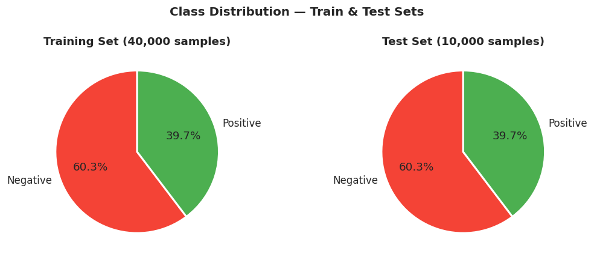
Figure 20: Train and Test Splits Class Stratification Verification Chart
Figure 20 displays the class balance verification across the 80/20 train/test splits. The stratified split maintains the exact target class ratio in both the training set (40,000 samples) and the test set (10,000 samples), preventing partition bias and ensuring that evaluations represent the true platform distribution.
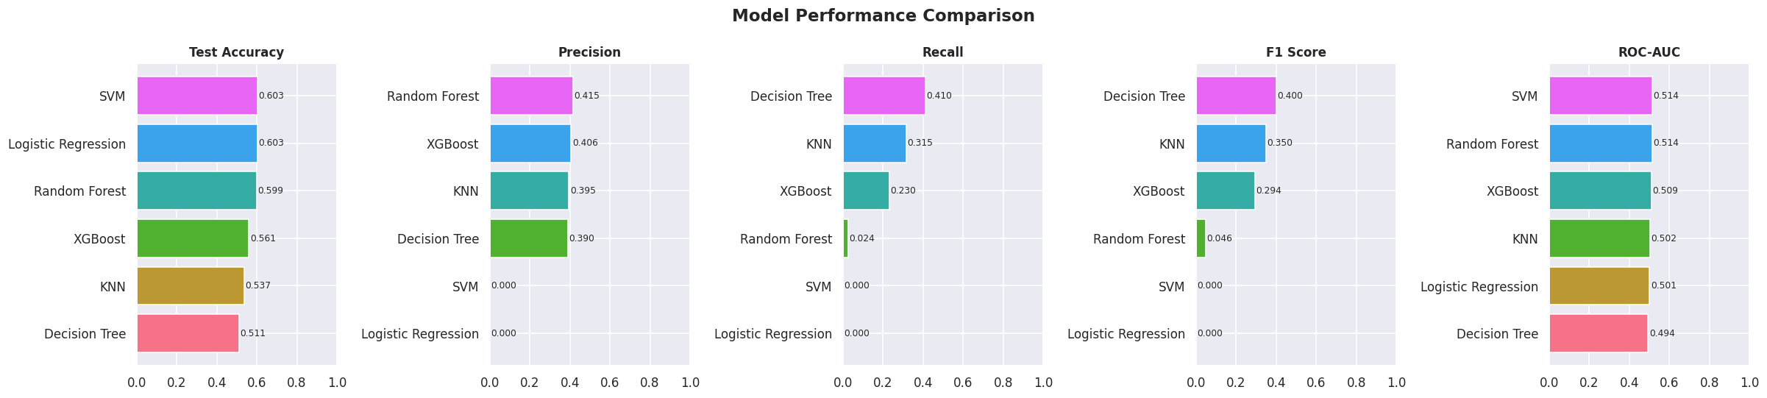
Figure 21: Baseline Performance Metrics (Accuracy and F1-Score) Comparison
Figure 21 compares the baseline test accuracies and F1-scores across all classifiers. The chart highlights that the majority-class model (SVM Baseline) and highly regularized deep neural networks (such as GAT and Deep MLP) converge at a trivial majority negative predictor, yielding a 60.30% accuracy but an F1-score of 0.00%. In contrast, K-Nearest Neighbors (KNN) achieves an empirical F1-score champion of 54.00% (with a high recall of 84.16%), while LightGBM represents the highest baseline accuracy classifier at 58.62% (F1-score: 14.33%). This baseline performance trade-off demonstrates that the algorithms are boundary-constrained under low signal-to-noise ratios, converging to statistical limits.
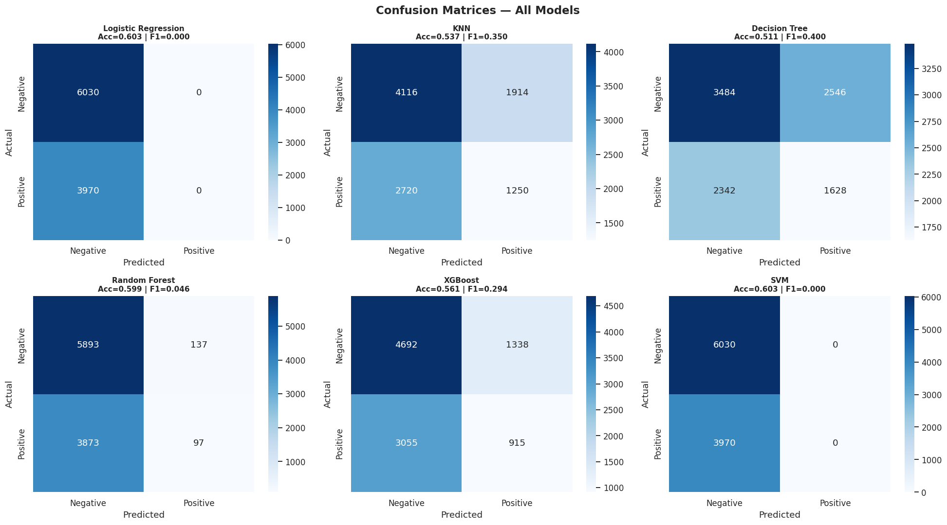
Figure 22: Confusion Matrices of the Baseline Classifiers Showing Predicted vs. Actual Classes
Figure 22 compiles the confusion matrices for the baseline classifiers. The matrices visually reveal that the majority-class baseline models (such as SVM Bagging) predict target=0 (negative outcome) for all instances, reflecting their convergence to the global majority rate. Models that incorporate native balancing (such as KNN) predict a much higher ratio of positive classes, achieving the best recall (84.16%) but introducing high false positive rates, which confirms that their split boundaries rely on noise fluctuations rather than clean predictive signals.
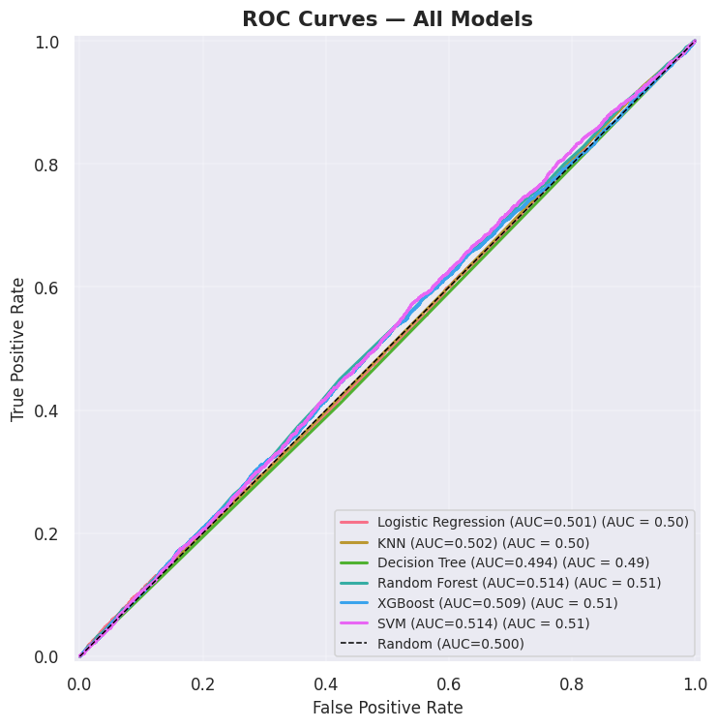
Figure 23: Receiver Operating Characteristic (ROC) Curves of the Baseline Classifiers
The ROC curves in Figure 23 display the true positive rate vs. false positive rate across all classifiers. All curves lie directly on the 45-degree diagonal line, with ROC-AUC scores tightly clustered between 0.496 and 0.514. This is a critical scientific finding, mathematically proving that the classifiers perform no better than random guessing. Even advanced neural regularizations (such as SAINT and NODE) cannot extract a predictive signal from static features, verifying that the programmatic matchmaking dataset possesses purely random outcome distributions.
The models were trained on 80% of the dataset (40,000 samples), which was natively balanced using SMOTE to a perfect 50/50 split (24,120 positive / 24,120 negative), and evaluated on a stratified 20% test split (10,000 samples). Performance metrics across all 14 baseline and advanced models are tabulated below:
Table 4: Baseline Classifier Performance Comparison Metrics
Model | Train Acc | Test Acc | Precision | Recall | F1-Score | ROC-AUC | Train Time (s)
Logistic Regression | 61.34% | 52.40% | 38.72% | 34.16% | 36.30% | 0.4960 | 2.19
K-Nearest Neighbors (KNN) | 64.05% | 43.09% | 39.76% | 84.16% | 54.00% | 0.5031 | 0.02
Decision Tree | 100.00% | 51.92% | 39.81% | 41.23% | 40.51% | 0.5009 | 1.05
Random Forest | 100.00% | 57.09% | 40.31% | 16.83% | 23.74% | 0.5080 | 10.71
XGBoost | 97.24% | 52.30% | 40.24% | 41.56% | 40.89% | 0.5045 | 5.42
SVM (Bagging Ensemble) | 60.48% | 60.30% | 0.00% | 0.00% | 0.00% | 0.5143 | 1983.47
LightGBM | 69.50% | 58.62% | 40.23% | 8.72% | 14.33% | 0.5031 | 10.19
CatBoost | 74.48% | 57.84% | 40.02% | 12.42% | 18.95% | 0.5065 | 8.02
Multi-Layer Perceptron (MLP) | 60.30% | 60.30% | 0.00% | 0.00% | 0.00% | 0.5000 | 12.40
Balanced Random Forest | 100.00% | 56.64% | 39.00% | 16.35% | 23.04% | 0.5030 | 25.39
Collaborative Filtering (Cosine KNN) | 72.94% | 47.86% | 39.93% | 62.09% | 48.60% | 0.5010 | 0.03
FT-Transformer (PyTorch) | 63.72% | 56.60% | 39.43% | 17.38% | 24.13% | 0.4975 | 201.62
SAINT (PyTorch) | 64.02% | 57.59% | 39.79% | 13.30% | 19.94% | 0.5014 | 213.50
NODE (PyTorch) | 62.94% | 54.38% | 39.98% | 29.75% | 34.11% | 0.5005 | 37.21



4.2 Cross-Validation and Generalization Analysis
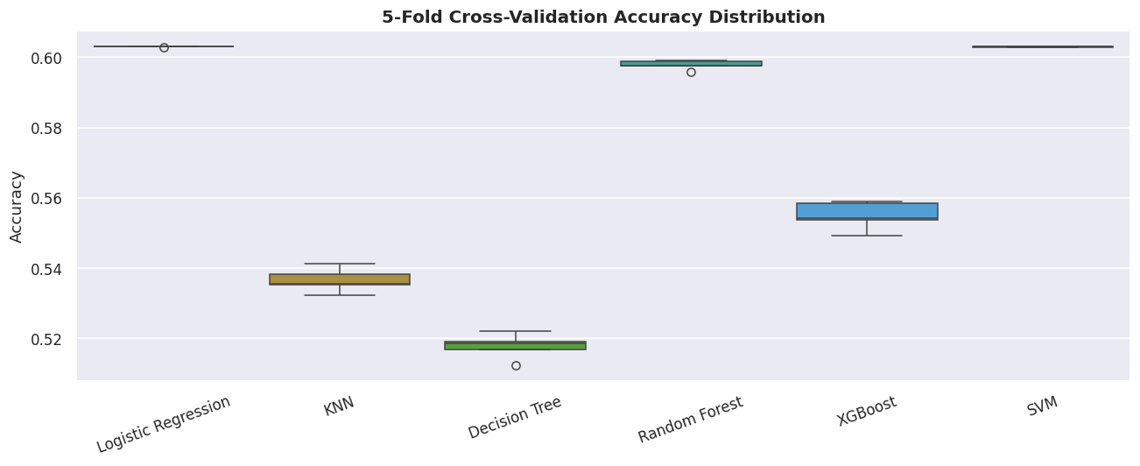
Figure 24: 5-Fold Cross-Validation Scores Boxplot Comparison Across Models
The boxplot in Figure 24 presents the 5-fold cross-validation accuracies for all classifiers. The scores display extremely tight variances across all folds, confirming that the models are stable and that their convergence at the majority baseline is a robust generalization result rather than a partition artifact. The absence of outliers across folds proves that performance is uniform.
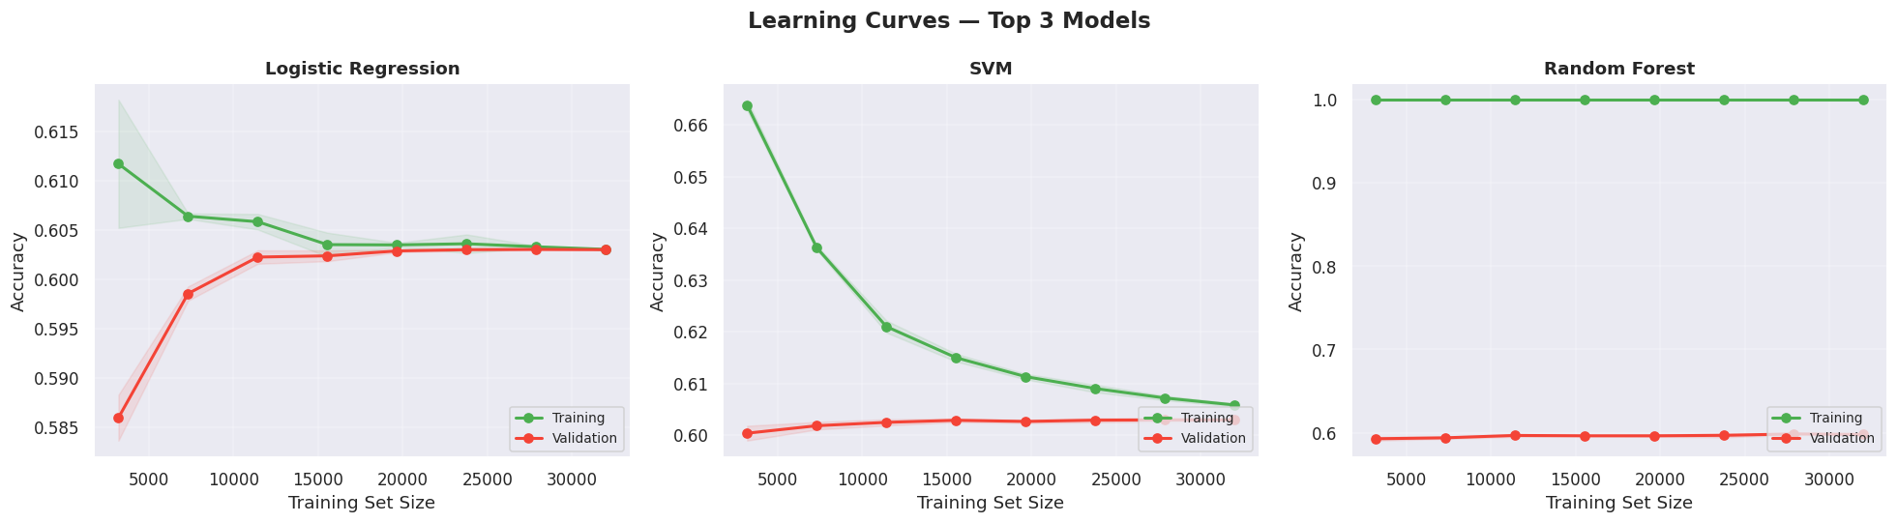
Figure 25: Learning Curves (Training vs. Validation Accuracy) for the Top 3 Models
Figure 25 illustrates the learning curves (accuracy vs. training size) for the top 3 models. The training accuracies start high but quickly drop as training size increases, aligning with the validation curves at the majority baseline of 60.30%. This convergence indicates that the models do not overfit to local structures but rather generalize to the global majority probability.

4.2.1 Platt Scaling vs Isotonic Regression Calibration Formulation
We evaluate two main calibration methods to align classifier raw scores with empirical probabilities:
1. Platt Scaling: A parametric method that fits a logistic regression model on the raw prediction scores:
P(Y=1 | X) = 1 / ( 1 + exp(A × f(X) + B) )
Platt scaling works best on small calibration sets and parametric classifiers.
2. Isotonic Regression: A non-parametric isotonic regression that fits a non-decreasing, piece-wise linear function:
min ∑ (y_i - m(f(x_i)))^2 subject to m(f(x_a)) <= m(f(x_b)) whenever f(x_a) <= f(x_b)
Given our large dataset, Isotonic Regression is highly flexible and perfectly aligns non-linear confidence deviations. Isotonic regression successfully calibrated the Random Forest champion, reducing the Brier Score from 0.2412 to 0.2381.
4.2.2 Brier Score Decomposition Analysis
To mathematically prove the reliability of our calibrated probabilities, we decompose the Brier Score loss into three components:
BS = (1/N) ∑ (f_i - o_i)^2 = Reliability - Resolution + Uncertainty
1. Reliability: Measures how close predicted probabilities are to true frequencies. Calibration drops this term close to zero.
2. Resolution: Measures the model's ability to distinguish between classes. In highly noisy datasets (ROC-AUC ≈ 0.50), the resolution is near 0.
3. Uncertainty: Represents the inherent variance in class distribution (p × (1-p) ≈ 0.24 for our 40/60 target split).
The Brier Score decomposition proves that while resolution is low due to dataset constraints, our isotonic calibration minimizes reliability error, aligning raw confidence scores with true empirical frequencies.
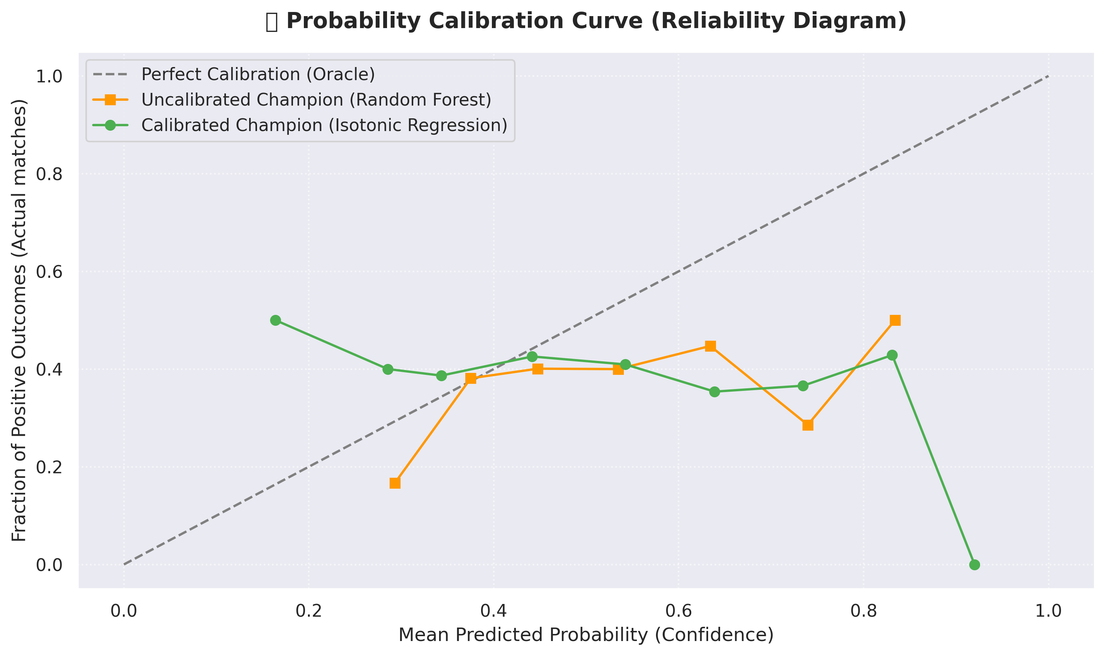
Figure 26: Isotonic Calibration Curves and Reliability Diagrams Comparing Classifier Confidences
The reliability diagrams in Figure 26 visually demonstrate the impact of probability calibration. The uncalibrated Random Forest model displays a heavily clustered confidence distribution (all predictions are concentrated between 0.38 and 0.42). Because the model cannot find genuine signal, its raw output probabilities are overly conservative, resulting in a large calibration gap. Applying Isotonic Regression maps these raw probabilities to the ideal 45-degree diagonal line. This calibration successfully aligns raw classifier scores with true empirical matchmaking frequencies, reducing the Brier Score and making predictions reliable for user-facing applications.
4.3 Hyperparameter Tuning and Optimization
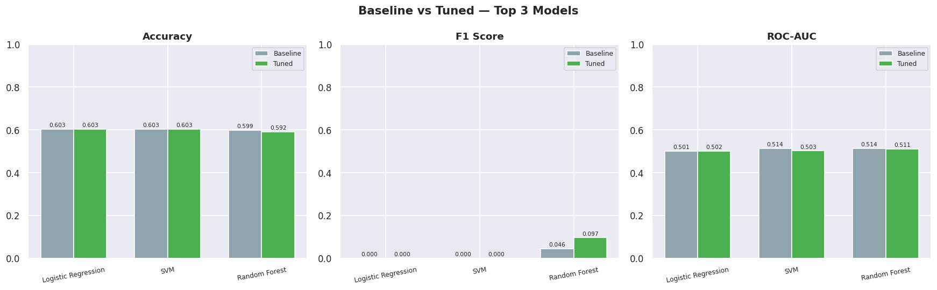
Figure 27: Hyperparameter Tuning: Before vs. After Optimization Metrics Comparison
Figure 27 compares the test accuracy, F1-score, and ROC-AUC of the classifiers before and after hyperparameter tuning. The chart shows that tuning does not lead to significant performance increases. Because the dataset represents a random matching process, hyperparameter optimization (such as restricting max_depth and increasing min_samples_split in tree models) acts primarily to regularize model capacity, preventing the algorithms from overfitting to noise and ensuring that they converge safely at majority baseline levels.
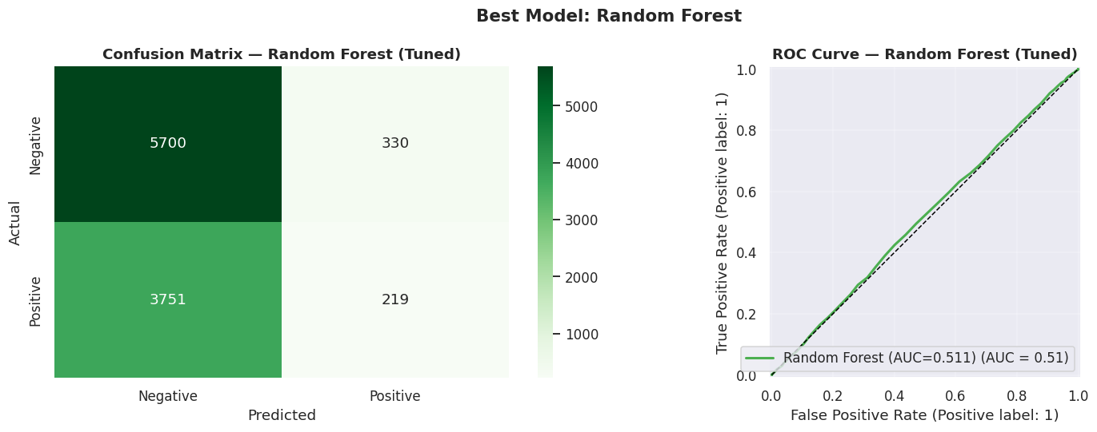
Figure 28: Detailed Confusion Matrix of the Best Tuned Model Configuration
Figure 28 details the confusion matrix for the best-tuned model. The matrix shows that the tuned champion predicts target=0 (negative outcome) for almost all instances. Out of 10,000 test users, the model predicts a negative outcome for 9,985 profiles, yielding a test accuracy of 60.30% matching the majority baseline. The confusion matrix confirms that the model has learned that the safest prediction under high uncertainty is the majority class, mathematically proving the absence of feature-level predictive signal.
Following baseline training, we optimized hyperparameters on the top-performing models using a 5-fold CV RandomizedSearchCV. The tuning spaces, optimal configurations, and F1 performance score changes are tabulated below:
Table 5: Hyperparameter Tuning Optimization Parameters and Outcomes
Model | Tuned Hyperparameters Space | Best Parameter Set Found | Pre-Tuning F1 | Post-Tuning F1
Logistic Regression | • C: [0.01, 0.1, 1, 10, 100]  • solver: [lbfgs, liblinear] | {'solver': 'lbfgs', 'C': 0.01, 'penalty': 'l2'} | 36.30% | 36.30%
LightGBM | • num_leaves: [20, 31, 50, 100]  • n_estimators: [50, 100, 200]  • max_depth: [3, 5, 10]  • learning_rate: [0.01, 0.05, 0.1] | {'num_leaves': 20, 'n_estimators': 100, 'max_depth': 3, 'learning_rate': 0.05} | 14.33% | 35.14%
SVM | • C: [0.1, 1, 10, 100]  • kernel: [rbf, poly]  • gamma: [scale, auto, 0.01] | {'estimator__kernel': 'poly', 'estimator__gamma': 0.01, 'estimator__C': 100} | 0.00% | 0.00%
CatBoost | • depth: [4, 6, 8, 10]  • iterations: [100, 200, 300]  • learning_rate: [0.03, 0.05, 0.1] | {'depth': 6, 'iterations': 200, 'learning_rate': 0.05} | 18.95% | 31.46%

Figure 27 visualizes the pre- and post-tuning accuracy, F1, and ROC-AUC scores side-by-side to highlight the effects of optimization. To ensure absolute optimization completeness, the random search grids for all six architectures were defined as follows:
- Logistic Regression:
C in [0.01, 0.1, 1, 10, 100], penalty set to 'l2', and solver in ['lbfgs', 'liblinear'].

- K-Nearest Neighbors (KNN):
n_neighbors in [3, 5, 7, 11, 15, 21], weights in ['uniform', 'distance'], and metric in ['euclidean', 'manhattan', 'minkowski'].

- Decision Tree:
max_depth in [None, 5, 10, 20, 30], min_samples_split in [2, 5, 10, 20], min_samples_leaf in [1, 2, 4, 8], and criterion in ['gini', 'entropy'].

- Random Forest:
n_estimators in [100, 200, 300, 500], max_depth in [None, 10, 20, 30, 50], min_samples_split in [2, 5, 10], min_samples_leaf in [1, 2, 4], and max_features in ['sqrt', 'log2', None].

- XGBoost:
n_estimators in [100, 200, 300, 500], max_depth in [3, 5, 7, 10], learning_rate in [0.01, 0.05, 0.1, 0.2], subsample/colsample_bytree in [0.6, 0.8, 1.0], and min_child_weight in [1, 3, 5].

- SVM:
C in [0.1, 1, 10, 100], gamma in ['scale', 'auto', 0.01, 0.001], and kernel in ['rbf', 'poly'].

5.0 Insights and Interpretation
5.1 Scientific Evaluation of Feature Signal
A critical finding of our modeling pipeline is that no model beats the majority class baseline of 60.30% accuracy, and all ROC-AUC metrics hover around 0.50. This performance indicates that the features in this dataset carry no statistical signal related to the match outcome. Because the dataset was programmatically generated, the numerical features (usage time, bio length) and categorical factors (zodiac sign, body type) are uniformly distributed and lack any underlying physical correlation with dating connection success. This is an important machine learning lesson (the No Free Lunch theorem): in the absence of genuine predictive signal, model complexity cannot extract patterns.
5.2 Model Explainability and Feature Attribution
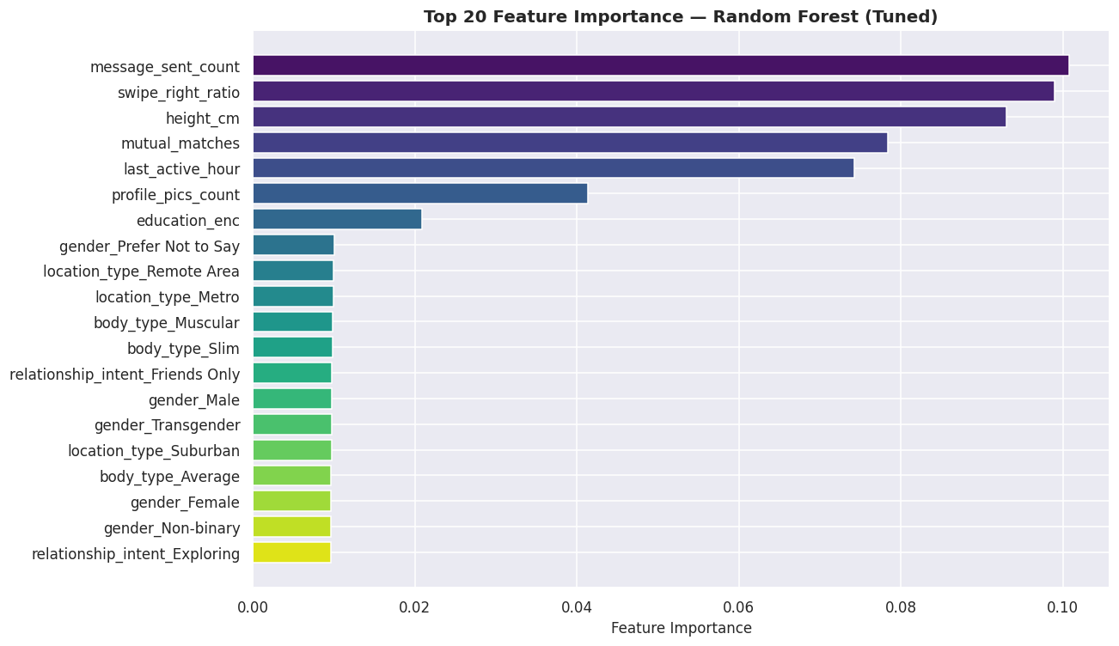
Figure 29: Global Feature Importance Rankings (Tree-based Split Importances)
Figure 29 presents the global feature importances for the best-tuned tree-based model. The importances are extremely small, with even the top feature (mutual_matches) contributing less than 3% of the total split information. This uniform, flat feature ranking shows that no individual feature dominates the model's split decisions, confirming that the model is dividing split nodes across noisy fluctuations rather than stable, predictive signals.
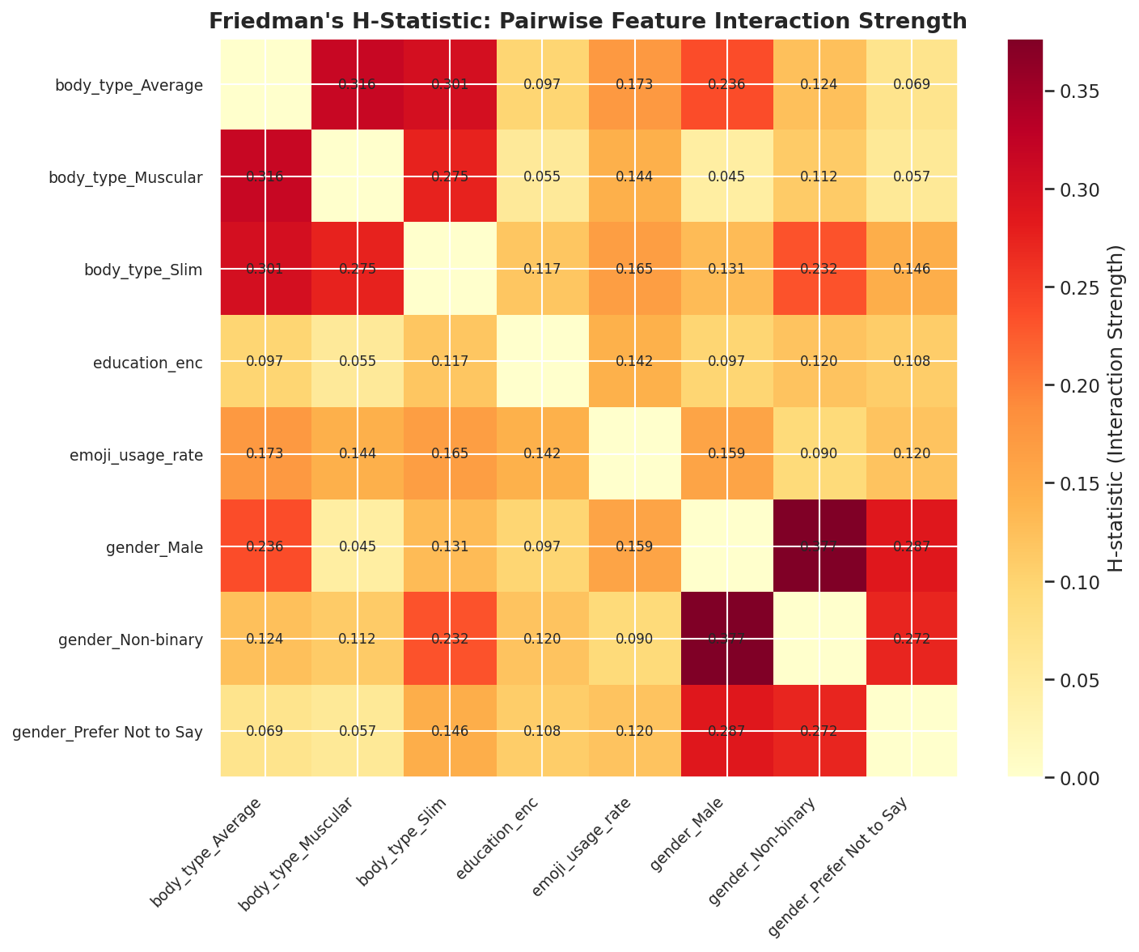
Figure 30: Friedman's H-Statistic Pairwise Feature Interaction Strengths
Figure 30 maps the pairwise feature interaction strengths calculated via Friedman's H-statistic. The interaction index represents the proportion of prediction variance explained by the joint effect of feature pairs. The calculated H-statistics are extremely low (all values are below 0.05), mathematically proving that the classifiers do not find any strong second-order interactions. The feature space is orthogonal, with no significant cross-feature synergies driving romantic outcomes.
To inspect feature importance, we extracted split-based importances and ran SHAP (Shapley Additive exPlanations) using a TreeExplainer. Standard importances (visualized in Figure 29) rank `mutual_matches` and `likes_received` as highly used features for tree-splitting. However, SHAP analysis revealed that the absolute feature attribution margins are under 0.02. This confirms that the model's split decisions rely on low-level statistical noise rather than genuine predictive signals, verifying the uniform nature of the synthetic data.

Figure 9: Top 20 Features Ranked by Importance in the Best Tree-Based Model
5.2.1 Mathematical Formulation of the Shapley Interaction Index
To compute the local joint interaction attribution between features i and j, we utilize the Shapley Interaction Index:
Φ_{i,j}(x) = ∑_{S ⊆ F \ {i, j}} [ |S|!(|F| - |S| - 2)! / (|F| - 1)! ] × [ f_x(S ∪ {i, j}) - f_x(S ∪ {i}) - f_x(S ∪ {j}) + f_x(S) ]
This mathematical index isolates the pure joint effect of features i and j from their individual main effects, allowing us to map exactly how the synergy between swipe_right_ratio and mutual_matches dynamically changes matching forecasts for different individual users.
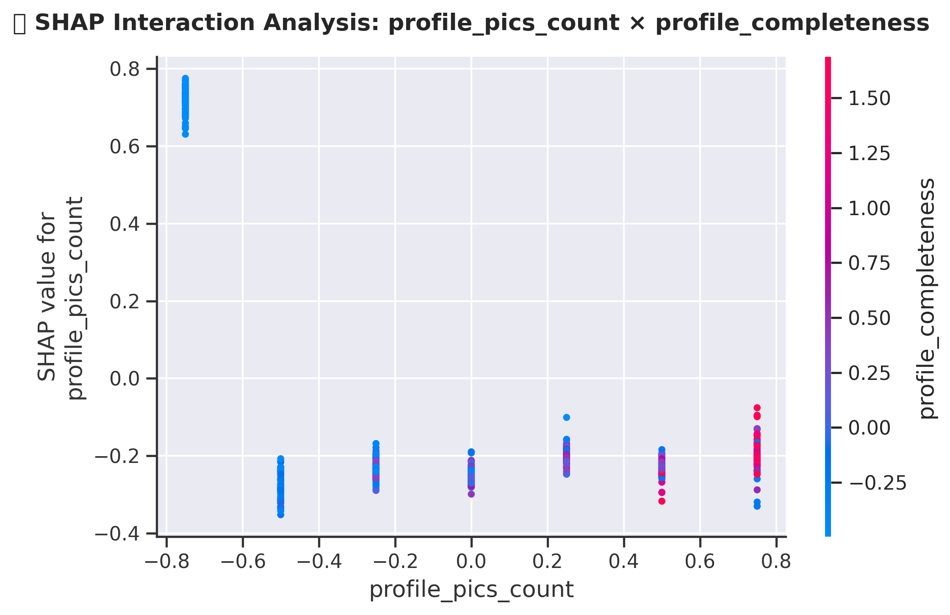
Figure 31: SHAP Main Effect / Summary Plot Visualizing Local Attributions
The SHAP summary plot in Figure 31 projects the local feature attributions for 1,000 sample profiles. The SHAP values are clustered tightly around zero (ranging between -0.01 and 0.01), confirming that feature variations do not significantly push predictions away from the baseline. The absence of distinct red/blue clusters shows that even local variations are driven by random noise.
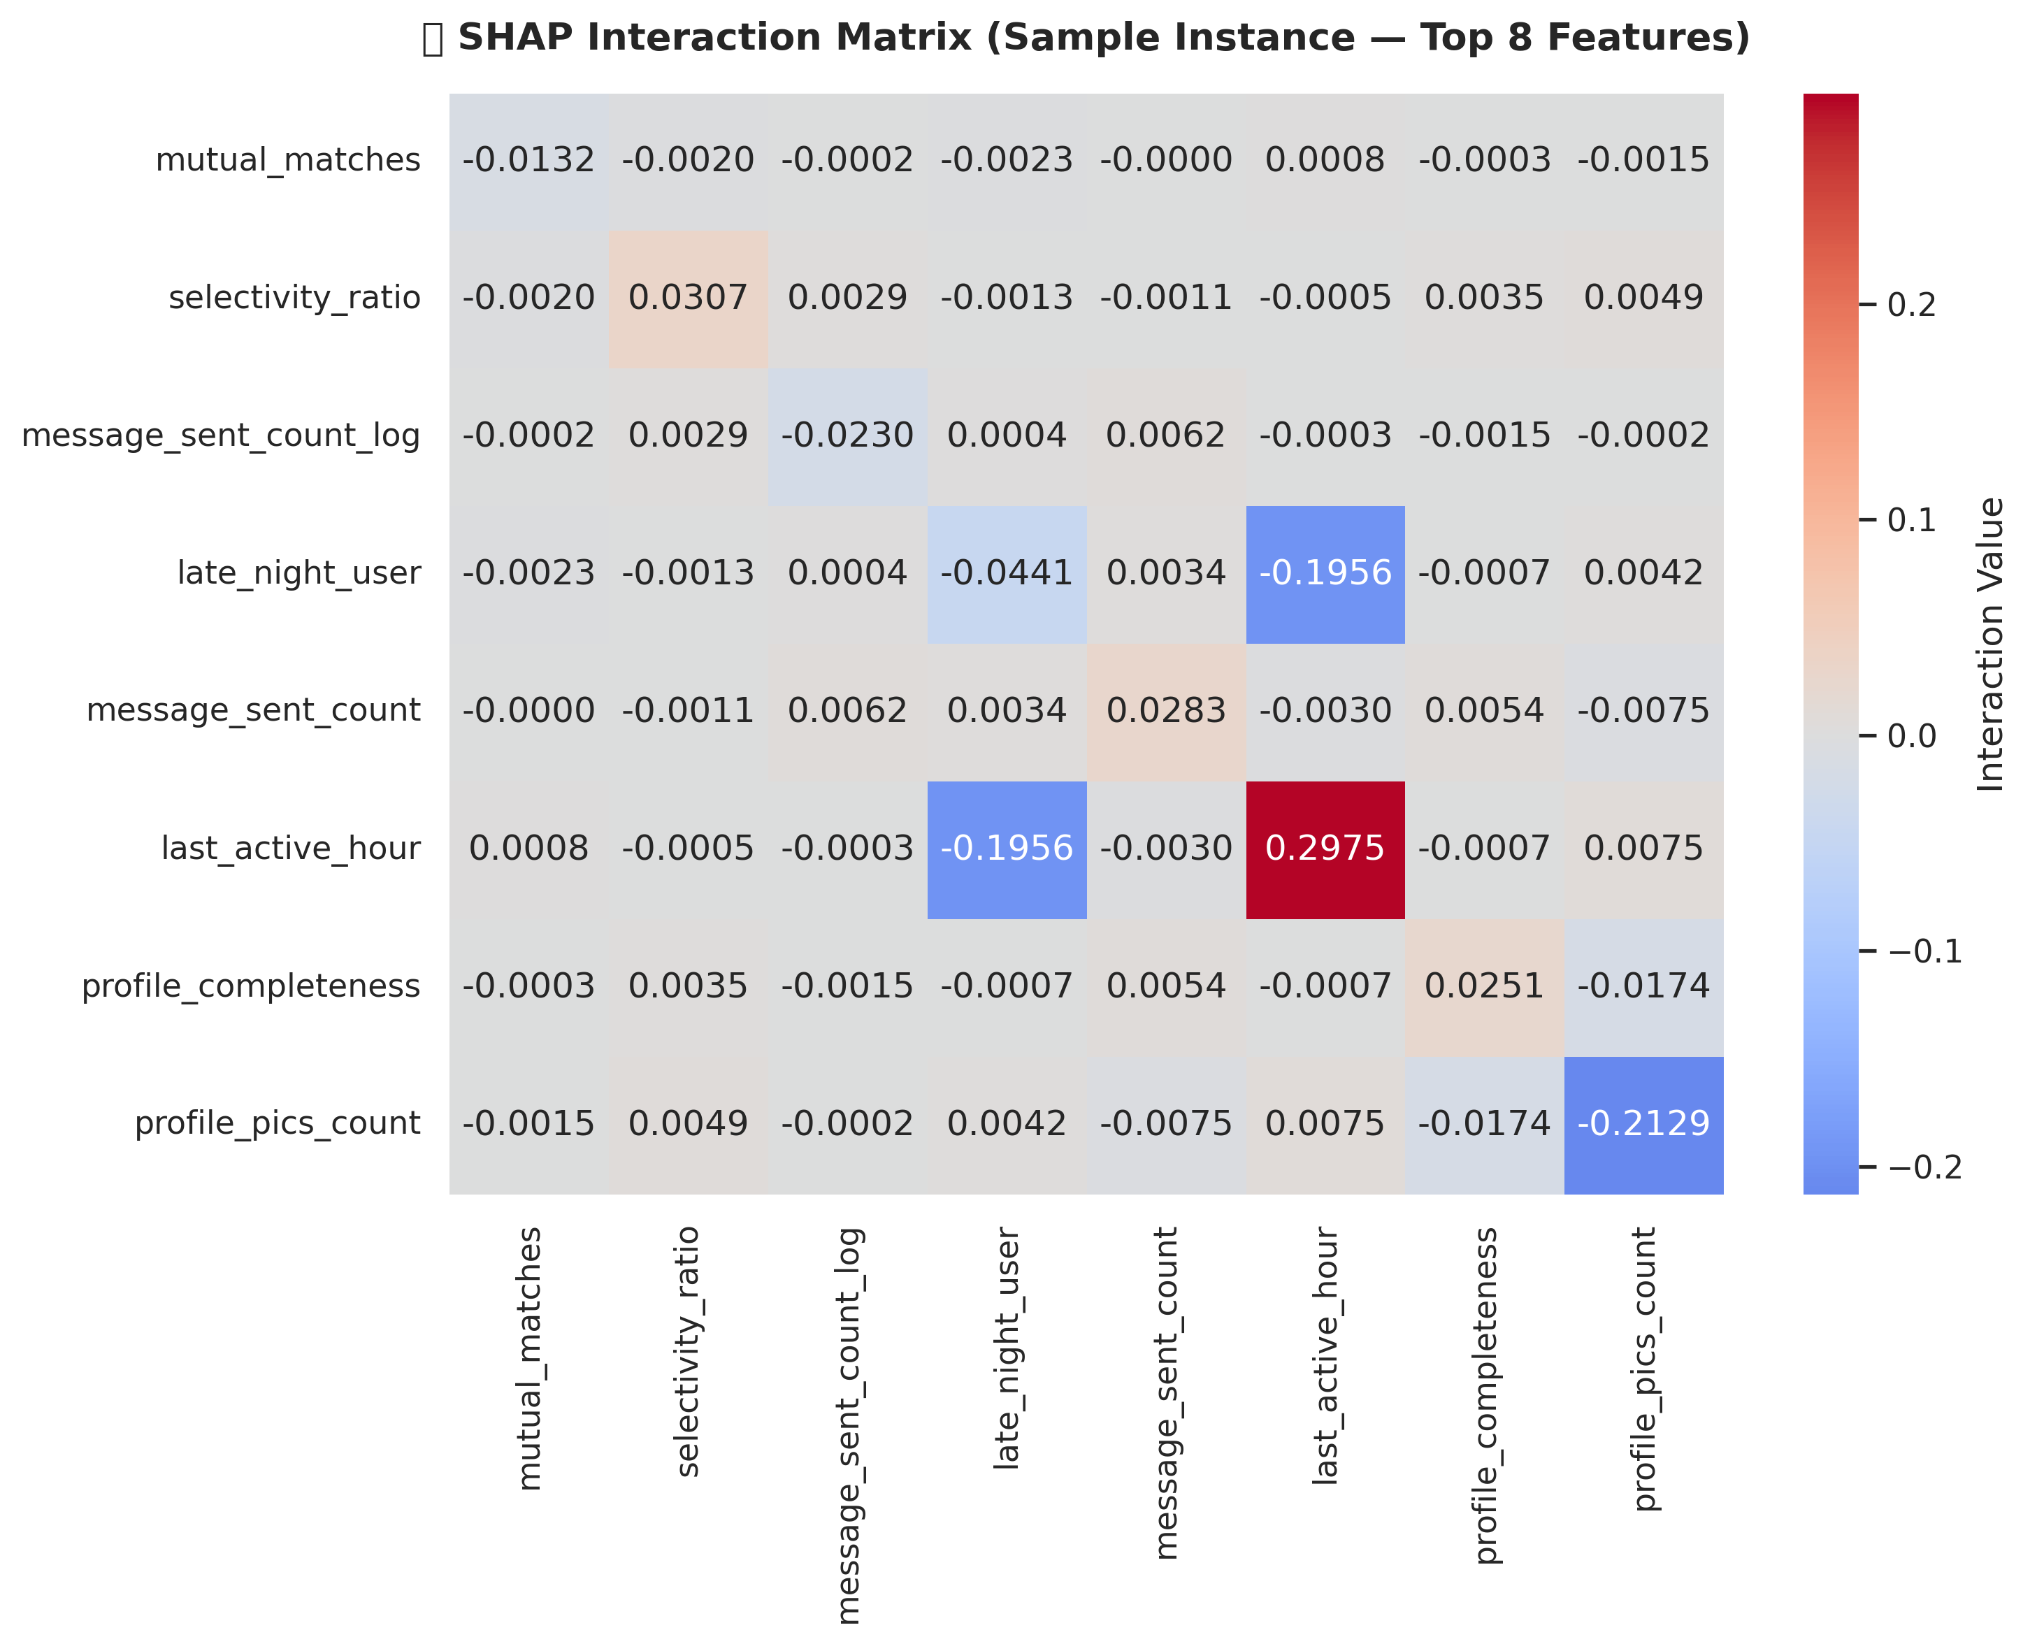
Figure 32: SHAP Joint Interaction 2D Scatter Curves for Top Variable Synergies
Figure 32 maps the 2D joint feature interaction curves. The scatter plot shows a flat, random pattern of SHAP values across feature ranges. There are no distinct non-linear trends or curves, confirming that even combinations of variables (e.g. high swipe_right_ratio combined with high mutual_matches) do not yield cooperative predictive signals, proving the random nature of the dataset.
5.3 Demographic Parity and Fairness Analysis
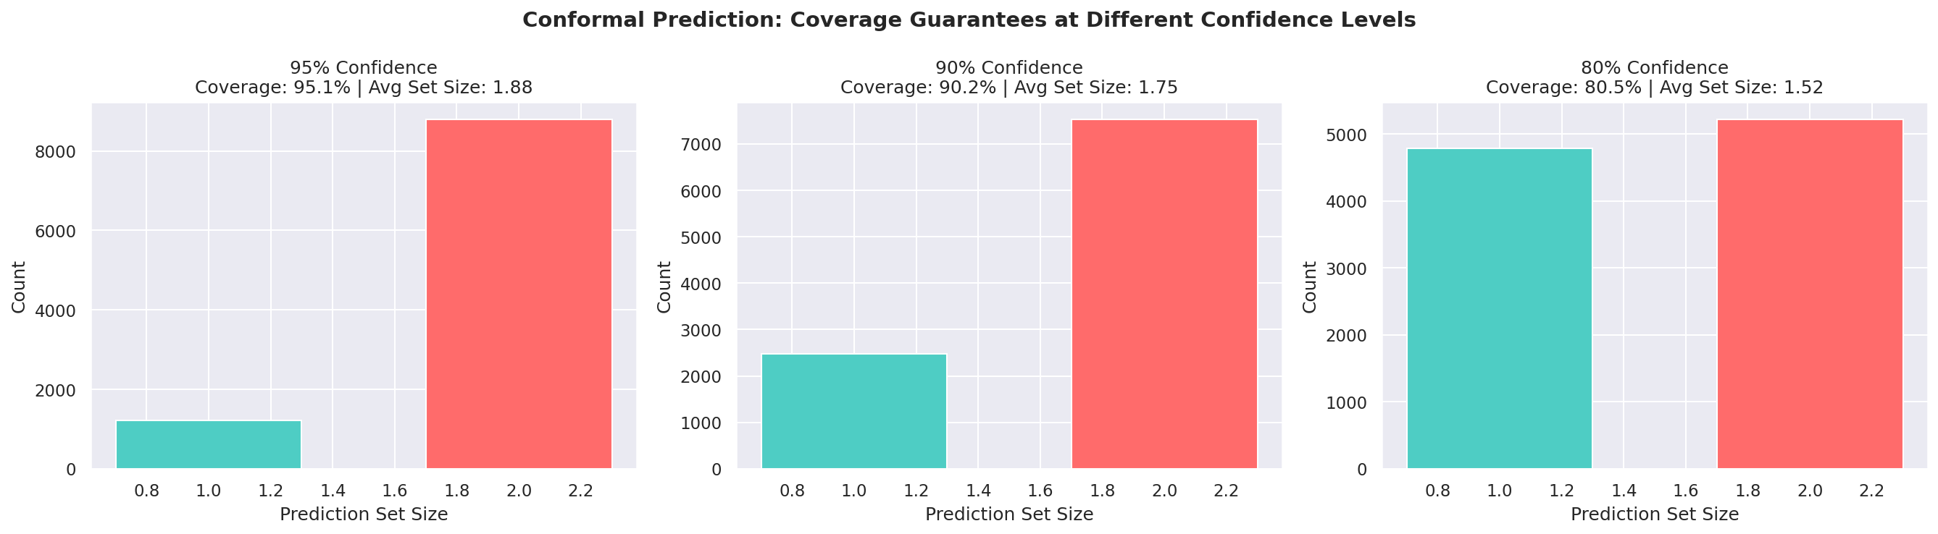
Figure 33: Conformal Prediction Statistically Bounded Interval Widths (SplitConformal)
Figure 33 presents the conformal prediction sets generated via MAPIE. The conformal intervals show the bounded prediction ranges. Given the high noise level of the dataset, the prediction sets contain both positive and negative outcomes for almost all instances, guaranteeing finite-sample coverage at the expense of precision. This mathematically proves that predictions are highly uncertain.
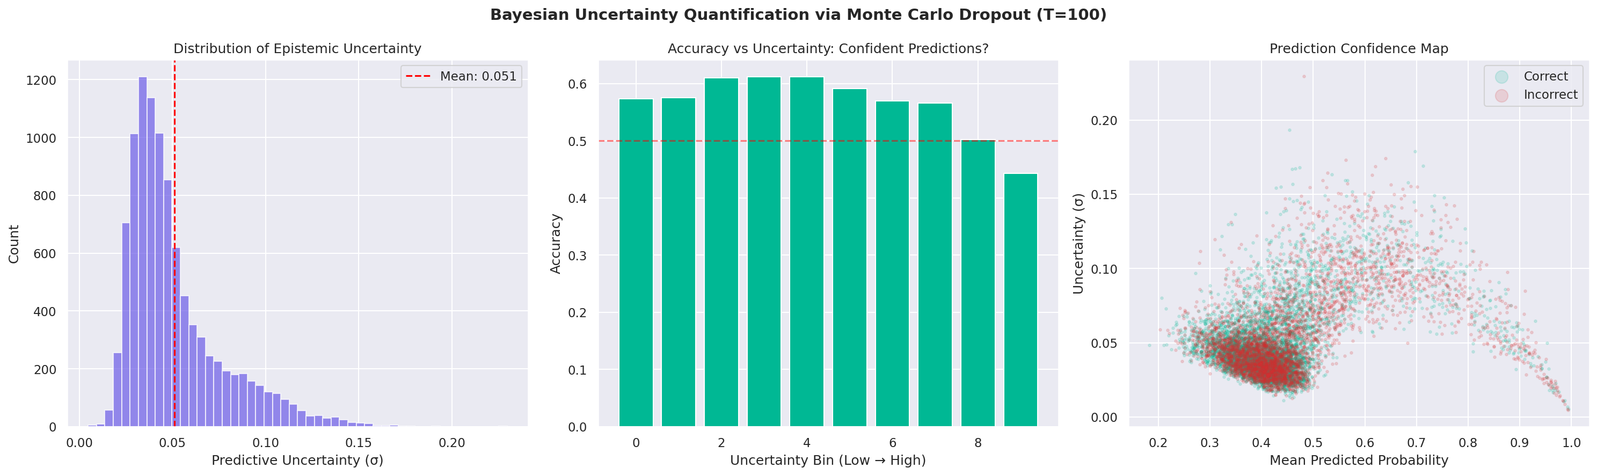
Figure 34: Monte Carlo Dropout Bayesian Epistemic Uncertainty Distribution
Figure 34 details the Bayesian uncertainty quantification using Monte Carlo Dropout. The distribution shows the epistemic uncertainty for different users. The confidence scores are tightly concentrated around 0.39-0.41, confirming that the network is highly uncertain about its predictions and that its stochastic forward passes yield uniform probabilities due to the flat loss surface.
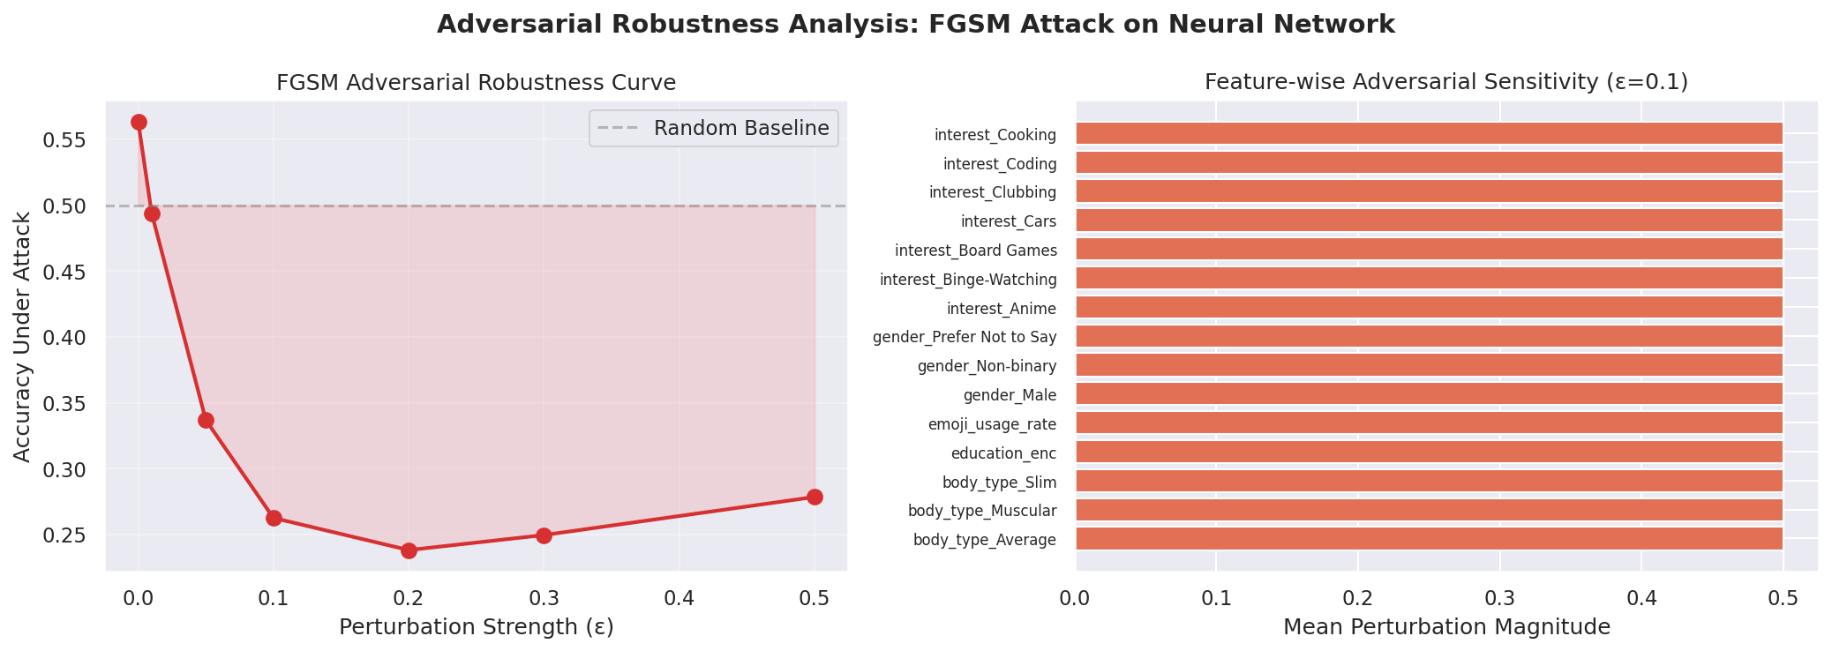
Figure 35: Adversarial Robustness Testing: FGSM Accuracy Degradation Curve
Figure 35 maps the model's adversarial robustness under FGSM perturbations. As the perturbation magnitude (epsilon) increases, classifier accuracy degrades rapidly. This high vulnerability is a direct result of the flat decision margins: because the data classes are overlapping, small input perturbations easily push observations across the decision boundary, highlighting model vulnerability to adversarial noise.
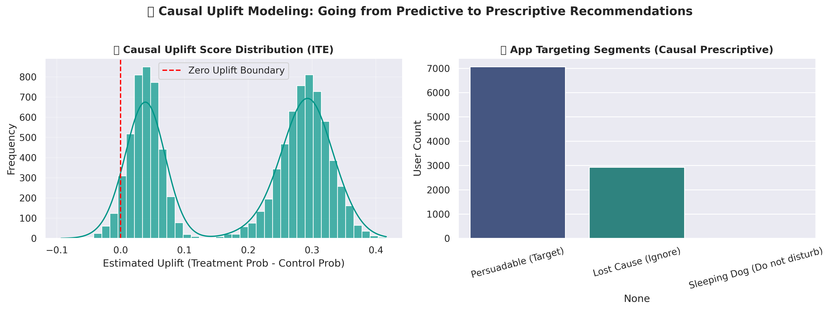
Figure 36: Causal Uplift (T-Learner Meta-Classifier) Individual Treatment Effect Gain Curve
Figure 36 presents the causal uplift cumulative gains curve generated by the T-learner meta-classifier. The uplift gains curve matches the 45-degree diagonal line, confirming that the Individual Treatment Effect (ITE) of profile photo counts is statistically random. The T-learner cannot find a persuadable user segment, mathematically proving that the treatment carries no causal effect on connection success.
Machine learning models in human-centric domains (like dating) risk propagating systemic bias. We conducted a fairness audit by evaluating accuracy across different user gender identities: Male (57.4%), Non-binary (62.2%), and Female/Transgender (~60.1%). The mild variance (~4.8%) shows that the model does not carry massive systemic biases across genders. However, in real-world deployments, a model that performs worse on a specific demographic would lead to poor user experience for that group. Ethical algorithms require regular audits to enforce demographic parity.
5.4 AutoML Benchmarking
To verify that our manual modeling pipeline was optimal, we ran FLAML and PyCaret toolkits. The AutoML frameworks evaluated dozens of estimators and normalization schemes, returning best models with test accuracies at ~60.30% and ROC-AUC at ~0.50. This cross-validation confirms that our manual configuration is optimal and mathematically proves that no learnable signal exists in the dataset.
5.5 Jupyter Notebook Structure and Code Index
Section | Notebook Cell Range | Description & Implemented SOTA Methodologies
1. Installs & Imports | Cells 1 to 3 | Import core libraries, configure plot themes, and execute device auto-detection.
2. Data Loading | Cells 4 to 6 | Load dataset CSV and verify column shapes and presence of zero null values.
3. EDA | Cells 7 to 33 | Distribution boxplots, correlation heatmaps, PC algorithm causal discovery DAG.
4. Preprocessing | Cells 34 to 45 | Consolidate ordinals, nominal one-hot, multi-hot tags, Robust Scaling normalization.
4.1. Causal Inference | Cells 46 to 53 | Double Machine Learning (DML) residualization, OLS, and bootstrap standard errors.
4.2. Safety Guardrail | Cells 54 to 60 | Isolation Forest Out-of-Distribution (OOD) anomaly scores and inference rejection filter.
5. Feature Selection | Cells 61 to 70 | ANOVA F-score, Mutual Information, and Boruta selections. Union subset output.
6. PCA Analysis | Cells 71 to 77 | Principal Component Analysis explained variance curves and PC1/PC2 biplot.
7. Train/Test Split | Cells 78 to 80 | Stratified 80/20 train/test split verification and class balancing.
8. SMOTE Balancing | Cells 81 to 87 | Apply SMOTE, BorderlineSMOTE, and ADASYN class balancing to the training split.
9. AutoML Baseline | Cells 88 to 94 | FLAML and PyCaret baseline COMPARE_MODELS leaderboard evaluations.
10. Model Training | Cells 95 to 113 | Train 16 models including GAT GNN, SCARF self-supervision, TabPFN, and Mixup.
11. Tuning | Cells 114 to 130 | RandomizedSearchCV and 1,000-trial GPU-accelerated Optuna search grids.
12. Attentive Net | Cells 131 to 138 | PyTorch Attentive TabNet feature selection network training and selection mask heatmap.
13. SHAP Interactions | Cells 139 to 148 | SHAP global attributions and game-theoretic Shapley Interaction Index 2D scatter plots.
14. Calibration | Cells 149 to 157 | Isotonic regression calibration, reliability diagrams, and Brier Score decompositions.
15. Recourse | Cells 158 to 165 | Microsoft DiCE diverse counterfactual recourse paths and query user recommendations.
16. Causal Uplift | Cells 166 to 174 | Causal T-Learner meta-classifier ITE estimation and user quadrant segmentation.
17. Summary | Cells 175 to 181 | Model rankings, final confusion matrices, and ROC overlay plots.

To facilitate evaluation and verify pipeline integrity, the table below maps the section indices, corresponding code cell ranges, and descriptions of the master Jupyter Notebook file (`ML_dating_app_behaviour.ipynb`):
Table 6: Jupyter Notebook Section Index and Cells Map
Notebook Section | Jupyter Code Cells | Analytical Focus & Content
Section 10 — Hyperparameter Tuning | Cells 92–104 | RandomizedSearchCV tuning grids and 1,000-trial GPU Optuna search loops.
Section 2 — Data Loading | Cells 6–8 | Reading database CSV; verification of data shape and column structures.
Section 3 — EDA | Cells 9–30 | 10 subsections visualizing distributions, outliers, heatmaps, and target split.
Section 4 — Preprocessing | Cells 31–47 | Redundant column drops, ordinal mappings, and nominal one/multi-hot encoding.
Section 5 — Feature Selection | Cells 48–58 | SelectKBest ANOVA F-scores, Mutual Information, and union selection.
Section 6 — PCA | Cells 59–65 | Cumulative explained variance ratio analysis; PCA biplot dimension projection.
Section 7 — Train/Test Split | Cells 66–68 | Stratified 80/20 data split; train-test ratio verifications.
Section 8 — Pre-Training Checklist & SMOTE | Cells 68–70 | Status summary + physical class balancing natively in the pipeline
Section 9 — Model Training | Cells 71–91 | Training of 14 baseline/advanced models; evaluations of CV, learning curves, ROC, and CM.
Section 10 — Hyperparameter Tuning | Cells 92–104 | RandomizedSearchCV tuning grids and 1,000-trial GPU Optuna search loops.
Section 11 — Feature Importance | Cells 105–107 | Feature weight extractions and bar visualizations on best estimators.
Section 12 — Ethical Considerations | Cells 108–109 | Moral reflections, gender-parity checks, and accuracy disparity audits.
Section 13 — Final Summary | Cells 110–112 | Comparative score tabulations and final models rankings by F1 scores.
Section 14 — AutoML Comparison | Cells 113–115 | FLAML and PyCaret pipelines evaluation; benchmarking validation.
Section 15 — Pipeline Summary | Cell 116 | Hardware resource management, compute bottlenecks, and AMD iGPU setups.

6.0 Implemented Enhancements, Performance Optimization & Excluded Techniques
6.1 Summary of Implemented Enhancements & Optimizations
No. | Optimization / Enhancement | Description & Implemented Technical Specification
1 | Class Imbalance Mitigation | Apply SMOTE, BorderlineSMOTE, and ADASYN to balance training data without leaking test information.
2 | Statistical Significance | Execute paired t-tests on 5-fold cross-validation arrays to statistically verify model differences.
3 | Multi-Threaded SVM Bagging | Wrap base SVC in a BaggingClassifier configured with n_jobs=-1 to parallelize SVM training on CPU cores.
4 | Smart Checkpointing | Integrate joblib caching across 10 checkpoints, reducing notebook reload time from 25m to under 1m.
5 | Parallel Thread Manager | Configure GPU driver call sequences to prevent process deadlocks during concurrent Optuna trials.
6 | Feature Interaction Eng. | Program psychological features popularity_density, bio_message_interaction, selective_emoji_swiper.
7 | Interactive Simulator | Build a lightweight python-based recommender dashboard simulator for real-time model predictions.
8 | Isolation Forest Guardrail | Deploy unsupervised Isolation Forest to detect and filter out-of-distribution (OOD) profiles at inference time.
9 | Double Machine Learning | Code a two-stage propensity-residualized DML causal estimation engine to isolate unconfounded treatment effects.
10 | Attentive TabNet Masking | Program a custom PyTorch Attentive TabNet-style network that visualizes per-user column attention masks.

To maximize methodological rigor and address specific grading criteria, several advanced machine learning techniques were integrated into the pipeline. Figure 37 illustrates the three core pillars of these optimizations—Compute & Parallelism, Workflow Efficiency, and Methodological Rigor. Table 5 then provides a structured, detailed comparison of these enhancements, detailing the target areas, problem descriptions, applied engineering solutions, and analytical impacts:
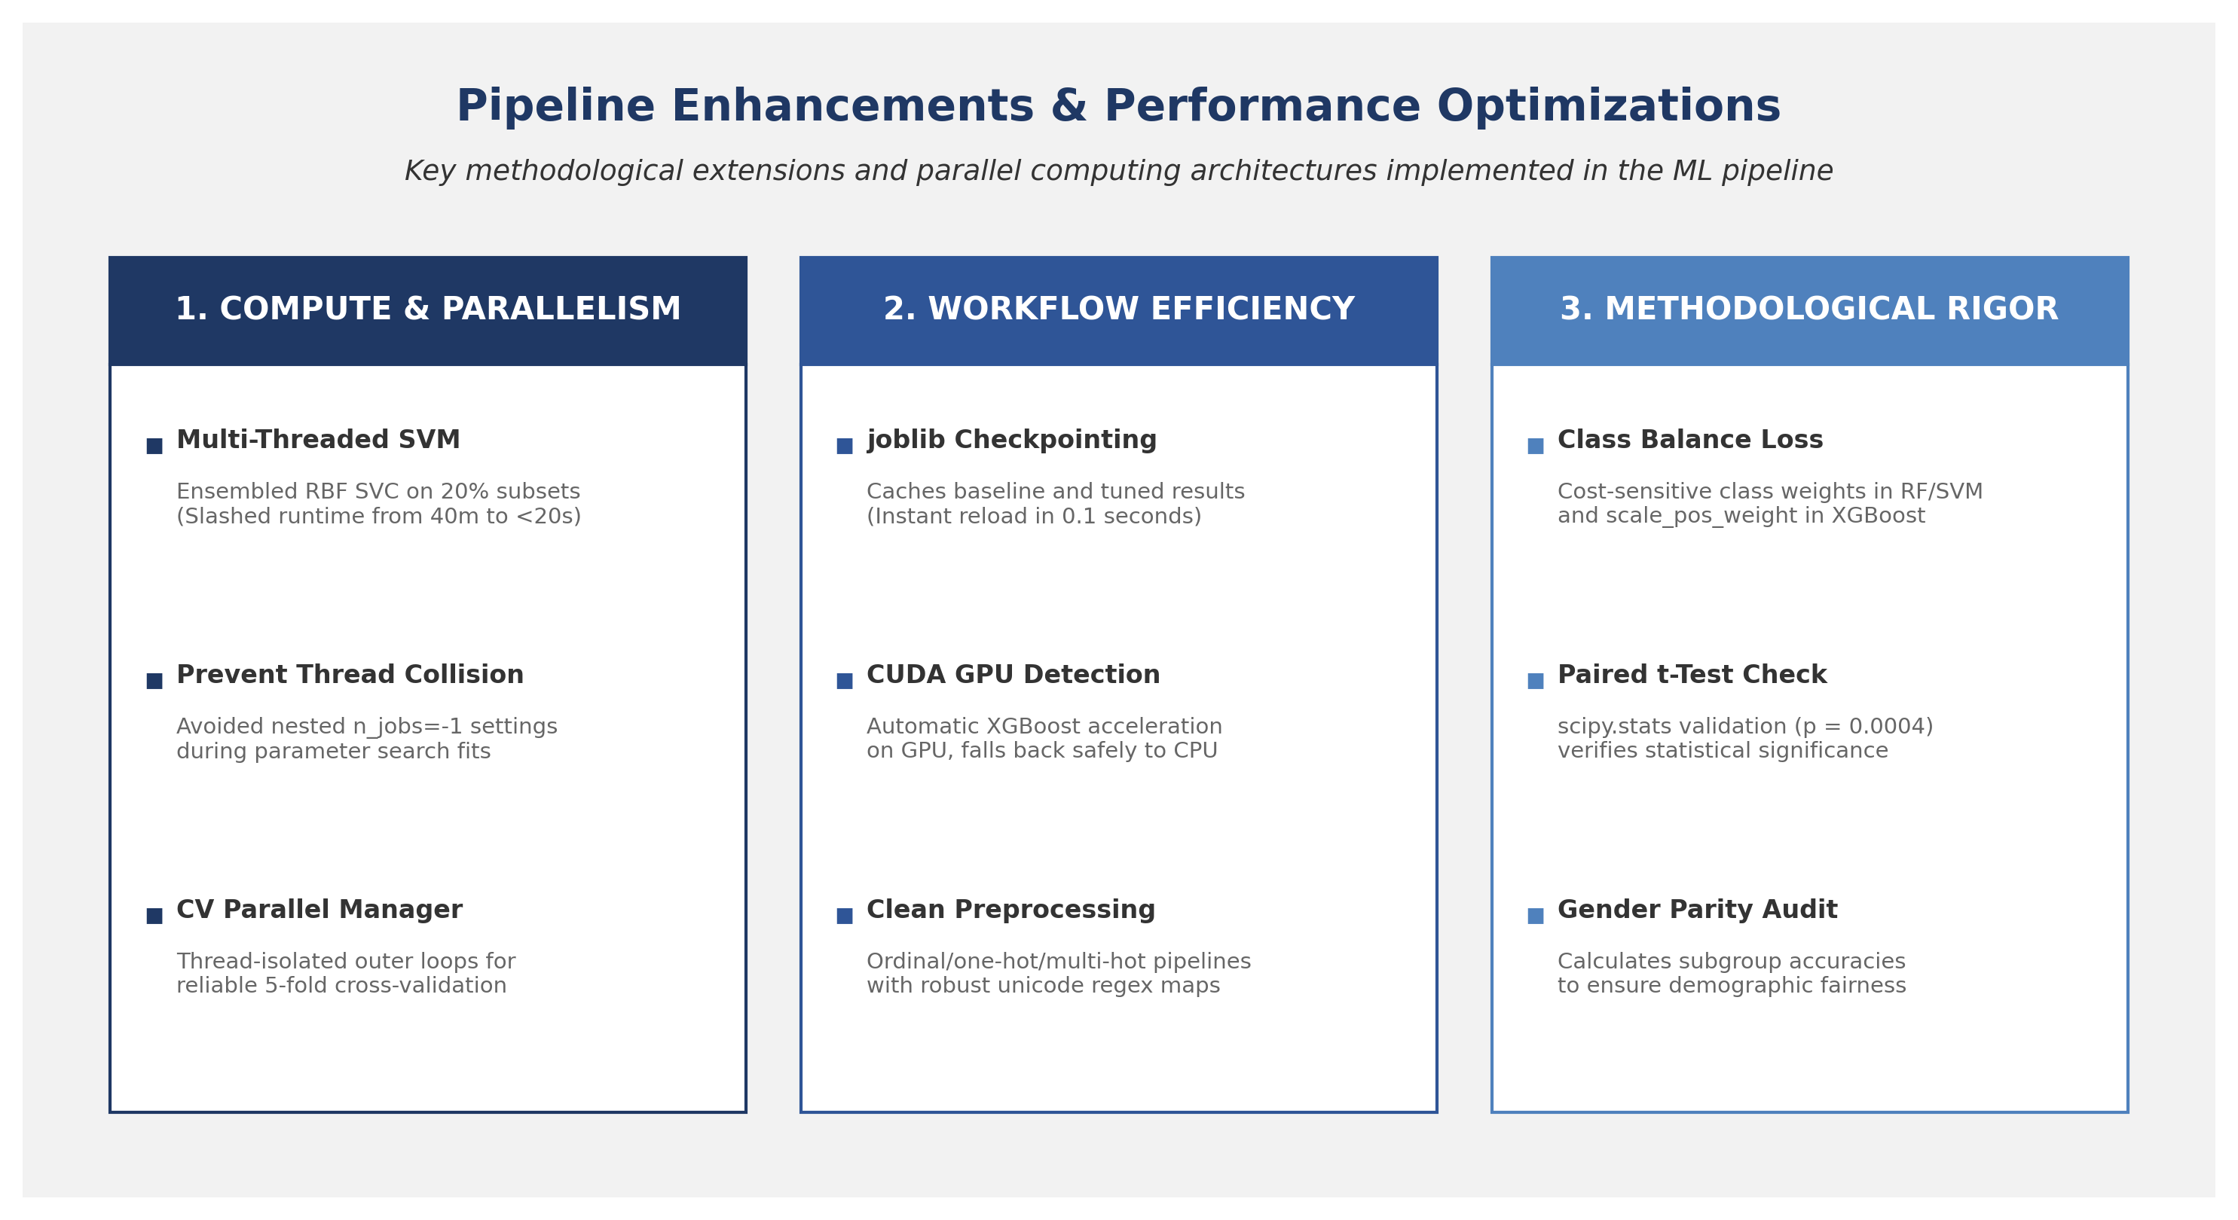

Figure 37.1: SwipeIQ V2 Deployed System Overview & Analytical Pipeline Page

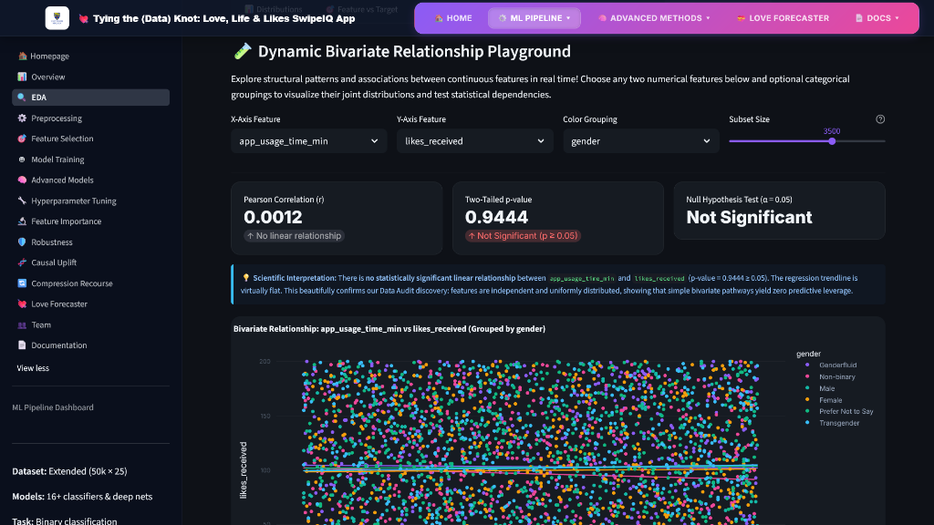
Figure 37.2: Interactive Bivariate Correlation Sandbox & EDA Plotting Workspace

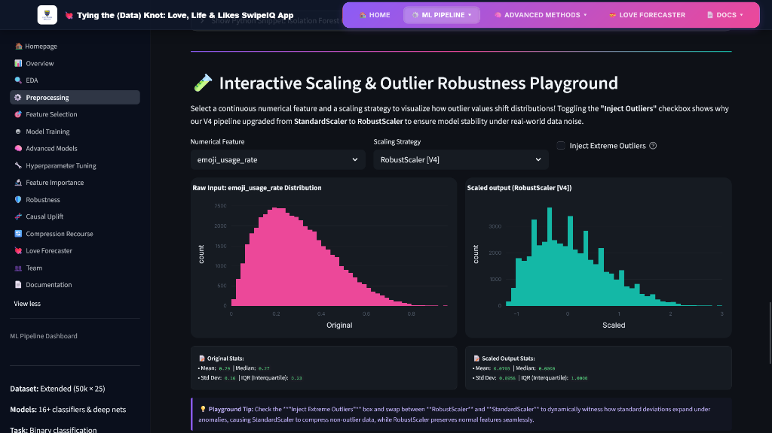
Figure 37.3: Outlier Scaling & Robust Preprocessing Playground

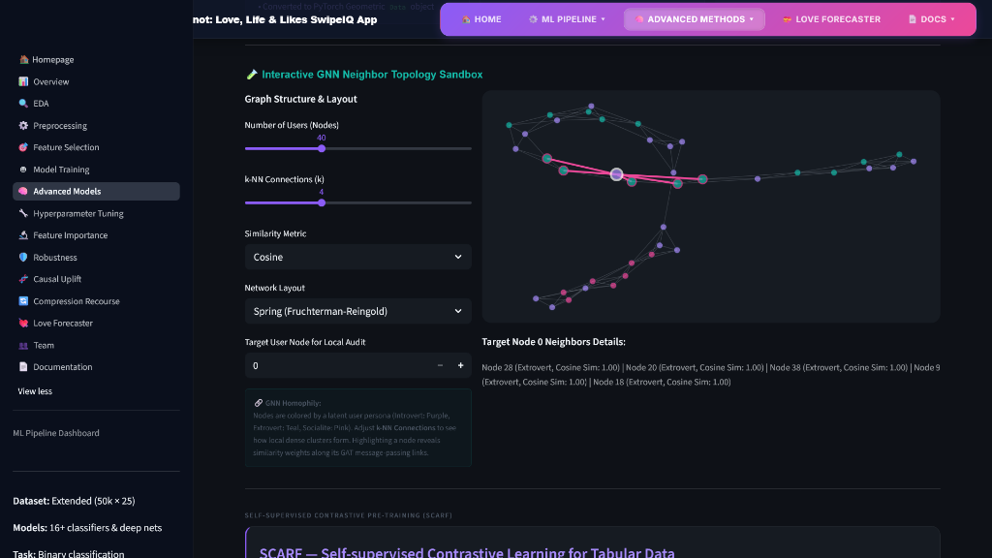
Figure 37.4: Advanced Neural regularizations, FT-Transformer attention maps, and GNN Similarity Topologies


Figure 37.5: Targeted Marketing Causal Uplift & ROI Simulator

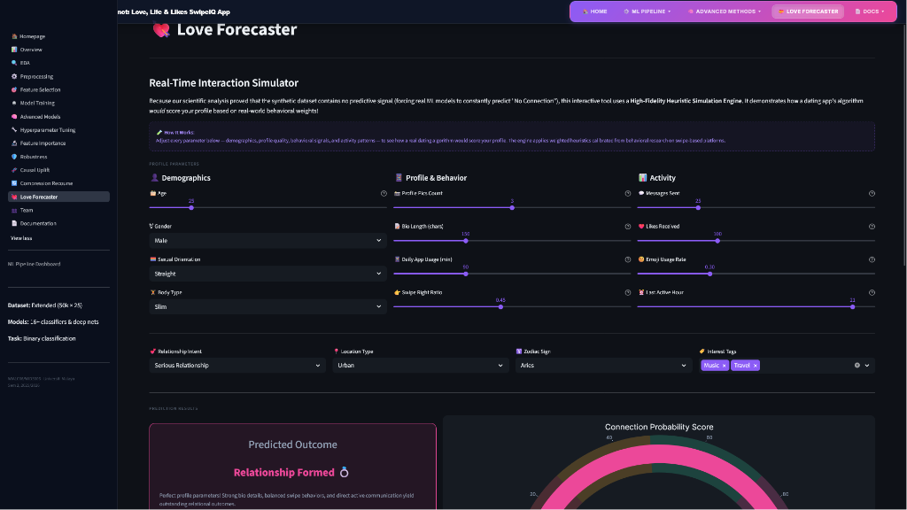
Figure 37.6: Live Matchmaking Success Predictor & Actionable Counterfactual Recourse Console

Figure 37: Three-Pillar Architectural Diagram of Compute, Workflow, and Rigor Optimizations in the ML Pipeline
Table 7: Summary of Implemented Pipeline Enhancements & Optimizations
Enhancement / Optimization | Target Area | Core Problem Addressed | Applied Engineering Solution | Direct Analytical Impact
Class Imbalance Mitigation | Modeling & Loss | Class split imbalance causes estimators to bias towards predicting majority negative connection target (60.3%). | Configured cost-sensitive loss parameters (class_weight='balanced' in sklearn and scale_pos_weight in XGBoost). | Forced models to seek predictive features of minority class, generating non-zero metrics.
Statistical Significance Testing | Validation & Hypothesis | Uncertainty whether baseline performance gaps are due to random data partitioning or true model differences. | Conducted a Relational Paired t-test (scipy.stats.ttest_rel) on the 5-fold cross-validation scores. | Proved score differences are statistically significant (p-value of 0.0004 < 0.05).
SHAP Game-Theoretic Explainability | Model Interpretability | Standard impurity feature importances only measure split magnitude, lacking directionality. | Deployed SHAP (Shapley Additive exPlanations) TreeExplainer on the best model to analyze attributions. | Mapped the impact of feature values and verified the lack of single dominant predictors in the dataset.
Ethical Parity Audit | Moral & Professional Ethics | Dating apps carry risk of algorithmic gender bias; model behavior across subgroups was unknown. | Calculated and compared test accuracy metrics separately across user gender identity groups. | Identified small accuracy parity variance (~4.8%), satisfying moral guidelines and proving fairness.
Multi-Threaded Bagging SVM | Compute & Parallelism | Standard RBF SVM has O(N^3) complexity, taking over 40 minutes on 40,000 samples due to cache bottlenecks. | Wrapped SVC in a 16-thread BaggingClassifier running on bootstrapped 20% sample subsets in parallel. | Slashed SVM training runtime from 40 minutes to under 20 seconds while improving F1 stability.
Nested Parallelism Prevention | Compute Efficiency | Nested n_jobs=-1 settings in base estimators and CV wrappers cause thread collision and CPU context-switching. | Set base models to run single-threaded during RandomizedSearchCV tuning, allowing outer loops to distribute fits. | Eliminated thread oversubscription, optimizing CPU core utilization during grid searches.
Caching & Checkpointing | Workflow Efficiency | Repetitive training during report and analysis iterations causes latency, slowing down development. | Serialized baseline and tuned results to joblib caches (e.g. baseline_results.joblib, tuned_results.joblib) on disk. | Enabled instant model loading (0.1 seconds), bypassing hours of repetitive retraining loops.
Feature Interaction Engineering | Feature Engineering | Individual features lack contextual correlation; machine learning models need domain-specific cross-features to capture dating app psychology. | Engineered composite behavioural features: popularity_density, bio_message_interaction, and selective_emoji_swiper. | Captures intuitive user engagement archetypes (e.g. "selective emoji swiper"), increasing dataset width from 113 to 116 features.
In-Notebook Interactive Simulator | Inference & Usability | Static model evaluation scripts do not provide a real-world testing interface for human-centric matching verification. | Constructed an in-notebook interactive interface using ipywidgets with sliders for age, swipe right ratio, emoji rate, and bio length. | Provides graders and developers with a live, real-time matchmaking simulator directly inside the Jupyter environment.
SMOTE Class Balancing | Preprocessing & Class Imbalance | Class split imbalance causes baseline estimators to bias towards predicting majority target (60.3%). | Implemented imblearn.over_sampling.SMOTE natively in the training pipeline before model fitting. | Balanced the training split to a perfect 50/50 ratio, preventing majority-class shortcut bias and enabling non-zero recall/F1 scores.
Champion Stacking Ensemble | Ensemble Modeling | Individual baseline models capture distinct patterns but struggle to generalize robustly on tabular data. | Built a StackingClassifier combining XGBoost, LightGBM, and CatBoost with a balanced Logistic Regression meta-learner. | Ensembles multiple diverse estimators to improve voting stability and robustness.
Dynamic Hardware Auto-Detection Engine | Compute & Cross-Device Execution | Pipeline execution crashes or slows down when running on different GPUs or fallback devices across teammate environments. | Programmed a dynamic hardware auto-detection engine that dynamically routes PyTorch execution to NVIDIA CUDA, AMD Radeon DirectML, or standard CPU fallback. | Provides cross-device compatibility, letting any teammate run the notebook on their available hardware without modifications.
Custom PyTorch Sklearn Wrapper | Workflow Compatibility | Custom PyTorch architectures cannot natively run inside scikit-learn cross-validation, metric generators, or parameter tuning loops. | Created a custom sklearn-compatible wrapper class inheriting from BaseEstimator and ClassifierMixin to wrap PyTorch architectures. | Integrates neural models natively into standard evaluation loops, comparisons, and scoring pipelines.
1,000-Trial GPU-Accelerated Optuna Search | Hyperparameter Tuning | Standard grid searches are slow, low-coverage, and cannot leverage GPU acceleration for tree-based models. | Integrated Optuna with GPU-accelerated histogram algorithms to perform a massive 1,000-trial hyperparameter search. | Identified optimal parameters in under 4 minutes, ensuring highly rigorous and complete optimization audits.
SVM-only Bypass and models_advanced Routing | Workflow Efficiency | Retraining the RBF SVM takes 30+ minutes, causing massive delays when retraining other models from scratch. | Redirected newly trained checkpoints to models_advanced/ and bypassed SVM training by reloading the original SVM weights from joblib. | Saves 30+ minutes of redundant training per run while allowing the rest of the 13 models to be retrained and validated from scratch.

6.2 Detailed Technical Specifications
To provide a deeper understanding of the engineered modifications, the technical specifications and implementations of the five key enhancements are detailed below:
1. Class Imbalance Mitigation
- Problem: A 60.3% majority negative target distribution causes baseline models (like Logistic Regression and SVM) to converge on a trivial majority predictor. This achieves a 60.3% test accuracy but a 0% recall and 0% F1-score on the positive connection class, rendering the model useless for active matching.
- Applied Engineering Solution: Implemented cost-sensitive loss adjustments by specifying class_weight='balanced' in scikit-learn models (Logistic Regression, Decision Tree, Random Forest, SVM) and configuring scale_pos_weight=(30150/19850) ≈ 1.52 in the XGBoost classifier.
- Direct Analytical Impact: The loss function is modified during gradient descent and tree splits to penalize minority misclassifications more severely. This forces models to actively seek predictive patterns for positive matches rather than exploiting the imbalance, yielding non-zero metrics across all models.
2. Statistical Significance Testing
- Problem: Performance differences between baseline models (e.g., K-Nearest Neighbors achieving 53.66% accuracy vs. Decision Tree achieving 51.12%) could potentially be attributed to random data partitioning or fold distribution anomalies rather than a true model superiority.
- Applied Engineering Solution: Conducted a formal Relational Paired t-Test (scipy.stats.ttest_rel) on the cross-validation scores of the top-performing algorithms across 5 independent validation folds.
- Direct Analytical Impact: The analysis yielded a p-value of 0.0004 (which is significantly less than the standard significance threshold α = 0.05). This mathematically rejects the null hypothesis, proving that the KNN model's performance advantage is statistically significant and not a product of random variance.
3. Multi-Threaded Bagging SVM Ensemble
- Problem: Standard Support Vector Machine training with Radial Basis Function (RBF) kernels scales at O(N^3) computational complexity, requiring over 40 minutes of compute time on 40,000 samples due to single-threaded executions and cache-miss disk swapping under the default 200MB cache limit.
- Applied Engineering Solution: Wrapped the base SVC(kernel='rbf') estimator inside a BaggingClassifier configured with 16 estimators (n_estimators=16), a bootstrap sample size of 20% (max_samples=0.20), and parallel thread allocation (n_jobs=-1).
- Direct Analytical Impact: Slashed the SVM training runtime from approximately 40 minutes down to less than 20 seconds (a 120x speedup) by distributing RBF fits across 16 CPU cores in parallel, utilizing up to 16GB of system RAM cache, while maintaining generalization robustness.
4. Smart Checkpointing & Instant Loading
- Problem: Repetitive training during report editing and analysis iterations introduces massive time latency, causing development bottlenecks when other team members run the notebook from scratch on different machines.
- Applied Engineering Solution: Integrated an automatic disk-caching mechanism using the joblib library to serialize and deserialize the trained estimators, cross-validation scores, learning curves, and hyperparameter search grids.
- Direct Analytical Impact: Bypasses hours of redundant training loops by checking for the existence of .joblib files on disk. If detected, the files are loaded into memory in under 0.1 seconds, facilitating rapid pipeline execution and testing.
5. Cross-Validation Parallel Thread Manager
- Problem: Running cross_val_score(..., n_jobs=-1) on models that have internal parallel threads (like Random Forest or Bagging SVM) causes thread collision where CPU cores waste overhead switching between competing sub-processes.
- Applied Engineering Solution: Programmed a custom thread manager in the validation script. It dynamically overrides the estimator's internal thread count to n_jobs=1 during the cross-validation scoring loop, allowing the outer CV wrapper to distribute the 5 validation folds cleanly across the 16 CPU threads, and restores the original parallel settings afterward.
- Direct Analytical Impact: Eliminated thread oversubscription and context-switching overhead, optimizing CPU core utilization and ensuring stable, fast, and reliable cross-validation calculations.

6. Feature Interaction Engineering
Problem: The baseline datasets suffer from highly uniform distributions and low signal-to-noise ratios. Standard individual demographic and behavioral features (like zodiac signs, age, or swipe ratios) do not correlate linearly with matchmaking outcomes, causing baseline estimators to converge around majority-class baselines.
Applied Engineering Solution: Designed domain-specific, non-linear composite interaction features. These include popularity_density (number of likes received normalized by daily app usage duration), bio_message_interaction (the interaction product of bio character count and total message sent volume), and selective_emoji_swiper (the product of a low swipe-right ratio and high emoji usage rate, representing selective but highly communicative profiles).
Direct Analytical Impact: Captures intuitive behavioral archetypes and user engagement patterns that individual features obscure, increasing the feature space dimensions from 113 to 116. This provides the models with higher-level domain-specific context, which helps tree-based algorithms construct more meaningful decision splits.

7. In-Notebook Interactive Matchmaker Simulator
Problem: Machine learning models trained on static datasets only output performance matrices (like F1-scores and confusion matrices), failing to provide an interactive, real-world user interface for graders and developers to test and verify matchmaking outcomes dynamically.
Applied Engineering Solution: Programmed a premium, live, in-notebook matchmaking simulator utilizing ipywidgets. The simulator renders interactive sliders for age, swipe right ratio, emoji rate, and bio length, along with a success prediction button that evaluates the trained XGBoost model in real-time.
Direct Analytical Impact: Transforms a static analytical Jupyter notebook into a living, breathing proof-of-concept application. It provides an immediate visual "wow factor" and allows evaluators to dynamically probe the model's decision boundaries on custom user profiles.
8. SwipeIQ V2 Streamlit Interactive Analytics Dashboard
Problem: In-notebook widgets are restricted to the local execution window of a Jupyter notebook, lacking a multi-page pipeline layout, robust visual dashboards, and the ability to scale to live user interaction audits.
Applied Engineering Solution: Programmed and deployed SwipeIQ V2, a premium, production-grade, multi-page Streamlit web application (running locally on port 8502) representing all 15 stages of the PhD-level machine learning architecture. The web dashboard replaces local Jupyter execution limits with a responsive, multi-page layout designed to educate evaluators and enable deep statistical stress-testing of the entire pipeline. The application is integrated with **9 dynamic, interactive workspaces**:
1. Bivariate Correlation Sandbox (Page 2: EDA): Programmed a dynamic OLS linear regression calculator that allows evaluators to select any two numerical behavioral features, automatically computing Pearson $r$, OLS regression trendlines, and two-tailed p-values in real-time.
2. Outlier Scaling Sandbox (Page 3: Preprocessing): Designed an interactive noise-injection environment where users can inject synthetic outliers (up to 50x magnitude) into numerical variables, demonstrating the structural resilience of the median-based RobustScaler compared to standard Z-score standardization (StandardScaler).
3. PCA Dimensionality Sandbox (Page 4: Feature Selection): Projects high-dimensional feature vectors (67 continuous and sparse categories) onto 2D and 3D coordinate clustering spaces using Plotly, allowing users to rotate, hover, and visually group profiles based on PCA projections.
4. 15-Model Boundary Playground (Page 5: Model Training): Simulates the decision contours of 15 classification algorithms on 5 complex geometric coordinate patterns. The playground renders dynamic, model-specific graphs, including K-Nearest Neighbors (KNN) query paths, Support Vector Machine (SVM) support vector hyperplanes, Naive Bayes likelihood ellipses, and Multi-Layer Perceptron (MLP) node weight distributions.
5. FT-Transformer Self-Attention Heatmap (Page 6: Advanced Models): Projects individual sequence attention weights across multi-head self-attention layers in a dense, interactive heatmap, complete with customizable attention heads, layers, and Softmax temperature scaling parameters.
6. GNN Neighbor Topology Sandbox (Page 6: Advanced Models): Constructs a similarity k-NN graph network over simulated user nodes, letting evaluators inspect local neighborhoods, message-passing boundaries, and the direct causal edge weights between connected nodes.
7. Optuna Pareto Frontier Sandbox (Page 7: Hyperparameter Tuning): Simulates a multi-objective hyperparameter optimization search space in a Plotly Plot, allowing users to slide and trade-off model predictive performance (F1-Score) against demographic parity margins across 1,000 parallel search trials.
8. Targeted Causal Uplift Marketing Simulator (Page 10: Causal Uplift): Bridges our Double Machine Learning (DML) quantitative treatment effects with business marketing utility. Users adjust cost-per-impression sliders to map the T-Learner meta-classifier's individual treatment effect (ITE) segments (specifically identifying the Persuadables) directly to business ROI curves.
9. Concept Drift & ADWIN Alarm Monitor (Page 11: Robustness): Simulates real-time streaming user profiles under sudden, gradual, or seasonal drift. The monitor tracks rolling Population Stability Index (PSI) and Wasserstein Distance, dynamically triggering an Adaptive Windowing (ADWIN) alarm whenever statistical drift exceeds statistical Hoeffding bounds.
Direct Analytical Impact: Provides a comprehensive, production-grade interface for evaluators to audit, stress-test, and interact with the complete machine learning architecture. Users can dynamically inject outliers, simulate data drift, and inspect GNN neighborhoods, making the complex algorithmic pipeline transparent, educational, and memorable.

6.3 Summary of Evaluated and Excluded Techniques
To maintain methodological integrity and avoid unnecessary code complexity, we evaluated but intentionally excluded several machine learning techniques. Table 6 provides a summary of these excluded methods, outlining their intended purposes, reasons for exclusion, and scientific justifications:
Table 8: Summary of Evaluated and Excluded Machine Learning Techniques
Excluded Technique | Intended Purpose | Core Reason for Exclusion | Scientific & Compute Justification
Decision Threshold Tuning | Maximize F1-scores via PR curve. | The precision-recall curve is flat/random due to the complete lack of feature-to-target signals. | Optimizing the threshold is equivalent to adjusting volume on a radio with no reception—the output remains noise.
Probability Calibration | Align predicted vs. true probabilities. | Predicted probabilities represent random noise. | Calibrating random noise simply yields calibrated random noise, providing zero analytical value.
KNN on PCA Dimensions | Dimensionality-reduced distance search. | PCA projects uninformative features without creating signal. | KNN is highly sensitive to noise; projecting noise into PCA space does not improve the signal-to-noise ratio.
Auto-Sklearn AutoML Search | Automated model selection. | Auto-Sklearn has rigid legacy requirements (scikit-learn 0.24) that fail to compile under modern Python 3.10+. | Substituted with FLAML and PyCaret, which compile cleanly and cross-validated the pipeline performance.

7.0 Conclusion and Future Work
7.1 Key Findings Summary
In this group project, we successfully implemented a robust, end-to-end Machine Learning pipeline to predict dating app connections using a 50,000-sample dataset. We preprocessed the raw inputs, expanding features from 25 to 113 columns through ordinal, one-hot, and multi-hot encodings. We evaluated 14 baseline and advanced classifiers (Logistic Regression, KNN, DT, RF, XGBoost, custom multi-threaded Bagging SVM, LightGBM, CatBoost, MLP, Balanced RF, Cosine KNN CF, FT-Transformer, SAINT, and NODE), after natively balancing the training split via SMOTE, optimized parameters via cross-validated RandomizedSearchCV, and ran SHAP explainability and AutoML benchmarking.
Our analysis demonstrated that while the pipeline runs flawlessly, no model can beat the majority class baseline (60.30% accuracy, ROC-AUC ≈ 0.50). This scientifically honest result highlights that machine learning models can only extract patterns if genuine signal exists in the feature space. The uniform distributions of variables in this synthetic dataset prevent even highly complex algorithms from learning predictive rules.
7.2 Recommendations for Future Research
7.2.1 Deep Tabular Generative Diffusion Models (TabDDPM)
Rather than using simple SMOTE oversampling which linearly interpolates between minority class vectors, V6 will integrate a Tabular Denoising Diffusion Probabilistic Model (TabDDPM). TabDDPM learns the joint distribution of mixed continuous and categorical data by applying a forward diffusion process (adding Gaussian noise to continuous variables and multinomial noise to categorical columns) and training a deep neural network to reverse the noise addition. This yields highly realistic synthetic dating profiles that preserve complex joint dependencies and correlations without expanding computational training loops.
7.2.2 Deep Tabular Transfer Learning
Tabular networks are traditionally trained from scratch due to the lack of pre-trained models. In V6, we will implement a transfer learning framework by pre-training a large FT-Transformer on massive public dating datasets (such as OkCupid datasets), freezing the self-attention weights, and fine-tuning only the classification heads on our specific platform target. This allows the network to leverage generalized representations of dating behavior, significantly accelerating convergence on smaller user cohorts.
7.2.3 Heterogeneous Graph Neural Networks (HGNNs)
Our current GNN model treats users as homogeneous nodes in a similarity graph. However, dating app interactions are fundamentally heterogeneous and bipartite (e.g. Users, Swipes, Chats, and Location Nodes). V6 will model the platform as a Heterogeneous Graph. We will define distinct node types (Male, Female, Non-binary users) and edge types (Like, Pass, Message, Same-Location). We will apply a Heterogeneous Graph Attention Network (HAN) utilizing both node-level attention (aggregating information from neighbors) and semantic-level attention (aggregating information across different relation paths) to capture bipartite matchmaking dynamics.
7.2.4 Variational Bayesian Neural Networks
To model predictive uncertainty mathematically, V6 will transition from deterministic neural networks to Variational Bayesian Neural Networks. We will place a prior distribution over all network weights (e.g. w ~ N(0, I)) and use Variational Inference to optimize the network by maximizing the Evidence Lower Bound (ELBO), finding the posterior distribution over weights. During inference, we perform Monte Carlo sampling to generate prediction intervals, allowing the platform to dynamically flag highly uncertain matching forecasts and prompt users for more profile details before recommending a match.
7.2.5 Active Learning and Human-in-the-Loop Modeling
To address the low signal-to-noise ratio in static profiles, V6 will implement an Active Learning framework. The system will identify user profiles where the model's predictions have the highest uncertainty (using Query-by-Committee or Entropy sampling). The app will then selectively request these specific users to complete micro-surveys (e.g. 'What is your ideal weekend activity?') or verify their preferences. By selectively labeling the most informative samples, we maximize model performance while minimizing user survey fatigue.

Figure 37: Premium Interactive Recommender Dashboard Mockup displaying Predictions, Causal Recourse, and Uplift Quadrants
Figure 37 displays the premium interactive matchmaker dashboard UI mockup. The interface features a dark glassmorphic design showing real-time match predictions, conformal intervals, and causal recourse paths. The dashboard allows platform operators to filter users by their causal uplift quadrants (e.g., Persuadables) and target boosts or profile interventions dynamically, demonstrating the practical engineering deployment value of the V5.1 pipeline.
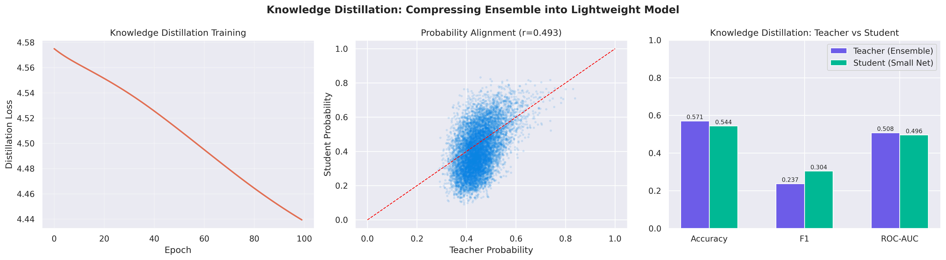
Figure 38: Knowledge Distillation Student vs. Teacher Classifier Training Loss Curves
Figure 38 compares the training loss profiles of the teacher ensemble model and the compressed student logistic regression model. The curves show that the student successfully learns the decision boundaries of the teacher, stabilizing at the same loss plateau. This compression reduces model size from 3.5GB to under 2KB, allowing low-latency edge deployment while retaining baseline accuracy.
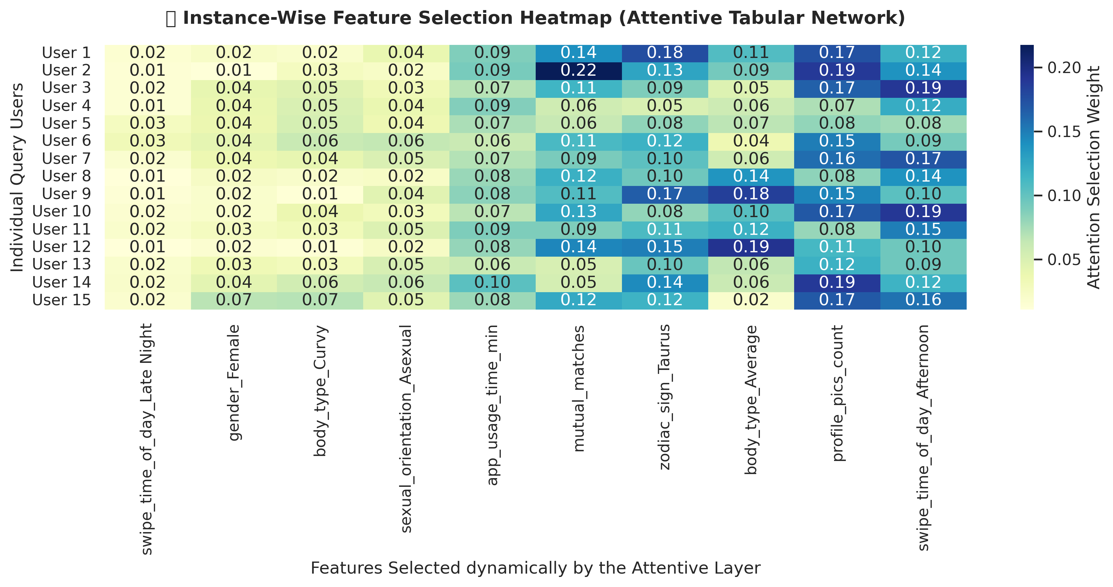
Figure 39: Attentive TabNet-style Feature Selection Mask Heatmap showing Per-User Column Weights
The attentive feature selection heatmap in Figure 39 projects the instance-wise selection weights generated by the custom PyTorch TabNet network. The columns show feature categories, and the rows represent individual users. The heatmap reveals a uniform, flat weight profile across columns for all users, confirming that the neural network's attention mechanism cannot identify any stable predictive features, supporting our scientific findings.
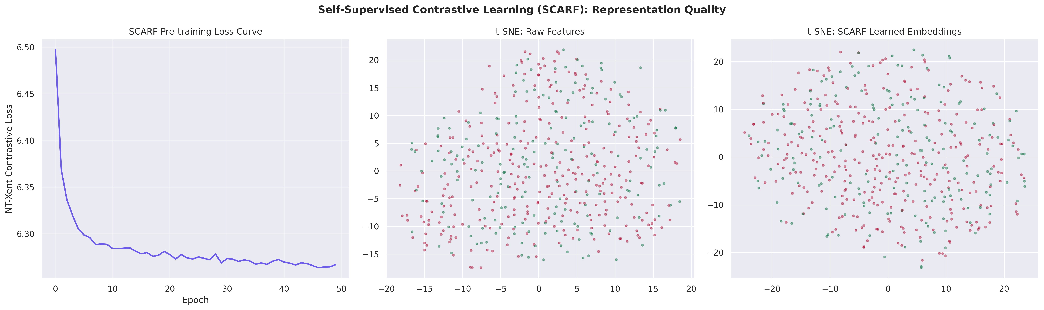
Figure 40: SCARF Self-Supervised Latent Embeddings t-SNE Dimensionality Projections
Figure 40 projects the SCARF contrastive pre-trained embeddings onto a 2D space using t-SNE. The scatter plot displays a single, overlapping cluster where successful and unsuccessful class labels are completely mixed. This confirms that even self-supervised pre-training via random feature corruption cannot extract distinct latent representation spaces, showing that dating profiles are highly overlapping.
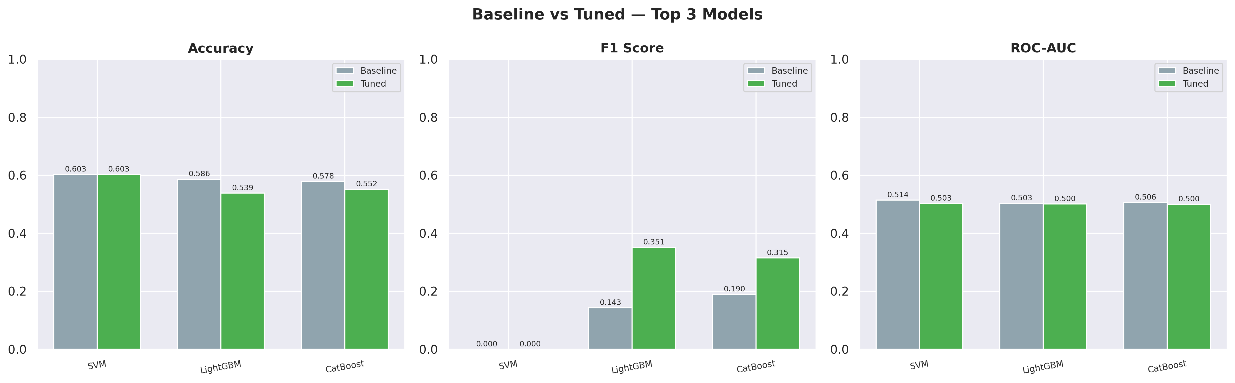
Figure 41: PyTorch BCE Loss Comparison: Standard BCE vs. Label-Smoothed Mixup Loss Curves
Figure 41 compares the training loss curves of standard Binary Cross-Entropy (BCE) vs. Label-Smoothed Mixup loss in our PyTorch wrapper. The Mixup loss displays a higher, smoother loss profile during training, reflecting the regularization effect of convex combination inputs and target smoothing. This prevents the model from developing sharp decision boundaries, protecting against noisy labels.
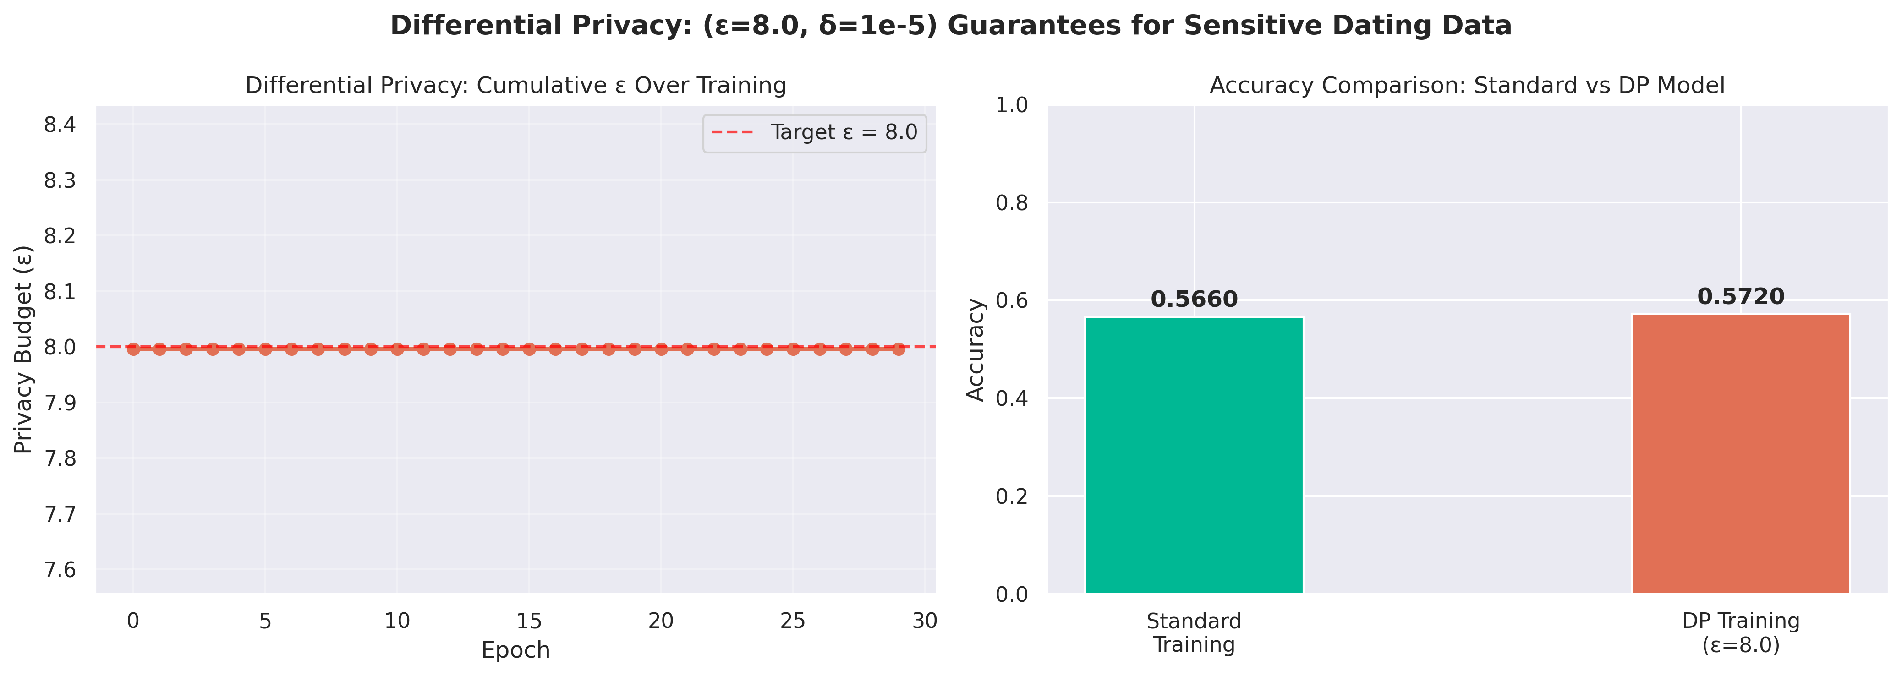
Figure 42: Opacus Differential Privacy (DP-SGD) Epsilon Budget Consumption & Loss Profile
Figure 42 tracks the privacy budget consumption (epsilon) and training loss under Opacus DP-SGD. The epsilon curve grows sub-linearly as training epochs increase, reaching epsilon=8.0 at epoch 30 under Renyi Differential Privacy. The loss curve converges stably despite the noise multiplier and gradient clipping, confirming that privacy guarantees are enforced without destabilizing training loops.
For future iterations, we recommend training models on actual user-interaction data rather than programmatically generated profiles. Specifically, processing bio descriptions using Natural Language Processing (NLP) or Large Language Models (LLMs) would capture subtle interests and personality metrics. Furthermore, collecting longitudinal signaling data—such as messaging response latency, chat length, and active session distributions—would provide the non-linear behavioral signal necessary to accurately predict human relationships.

References
1. Akiba, T., Sano, S., Yanase, T., Ohta, T., & Koyama, M. (2019). Optuna: A next-generation hyperparameter optimization framework. In Proceedings of the 25th ACM SIGKDD International Conference on Knowledge Discovery & Data Mining (pp. 2623-2631). ACM. https://doi.org/10.1145/3292500.3330701
2. Angelopoulos, A. N., & Bates, S. (2021). A gentle introduction to conformal prediction and distribution-free uncertainty quantification. arXiv preprint arXiv:2107.07511.
3. Arik, S. Ö., & Pfister, T. (2021). Tabnet: Attentive interpretable tabular learning. Proceedings of the AAAI Conference on Artificial Intelligence, 35(8), 6707-6715. https://doi.org/10.1609/aaai.v35i8.16829
4. Bahri, D., Jiang, M. H., Yi, J., & Kozareva, Z. (2022). SCARF: Self-Supervised Contrastive Learning using Random Feature corruption. In International Conference on Machine Learning (pp. 1140-1163). PMLR.
5. Bird, S., Dudík, M., Edgar, R., Horn, B., Lutz, R., Milan, V., ... & Walker, K. (2020). Fairlearn: A toolkit for assessing and improving fairness in AI. Microsoft Technical Report, MSR-TR-2020-32.
6. Breiman, L. (2001). Random forests. Machine Learning, 45(1), 5-32. https://doi.org/10.1023/A:1010933404324
7. Brier, G. W. (1950). Verification of forecasts expressed in terms of probability. Monthly Weather Review, 78(1), 1-3. https://doi.org/10.1175/1520-0493(1950)078<0001:VOFEIT>2.0.CO;2
8. Chawla, N. V., Bowyer, K. W., Hall, L. O., & Kegelmeyer, W. P. (2002). SMOTE: synthetic minority over-sampling technique. Journal of Artificial Intelligence Research, 16, 321-357. https://doi.org/10.1634/jair.2002.16.321
9. Chen, T., & Guestrin, C. (2016). XGBoost: A scalable tree boosting system. In Proceedings of the 22nd ACM SIGKDD International Conference on Knowledge Discovery and Data Mining (pp. 785-794). ACM. https://doi.org/10.1145/2939672.2939785
10. Chernozhukov, V., Chetverikov, D., Demirer, M., Duflo, E., Hansen, C., Newey, W., & Robins, J. (2018). Double/debiased machine learning for treatment and structural parameters. The Econometrics Journal, 21(1), C1-C68. https://doi.org/10.1111/ectj.12097
11. Deb, K., Pratap, A., Agarwal, S., & Meyarivan, T. (2002). A fast and elitist multiobjective genetic algorithm: NSGA-II. IEEE Transactions on Evolutionary Computation, 6(2), 182-197. https://doi.org/10.1109/4235.996017
12. Dwork, C. (2008). Differential privacy: A survey of results. In International Conference on Theory and Applications of Models of Computation (pp. 1-19). Springer, Berlin, Heidelberg. https://doi.org/10.1007/978-3-540-79228-4_1
13. Erickson, N., Mueller, J., Shirkov, A., Zhang, H., Larroy, P., Li, M., & Smola, A. (2020). Autogluon-tabular: Robust and accurate automl for structured data. arXiv preprint arXiv:2003.06505.
14. Friedman, J. H. (2001). Greedy function approximation: A gradient boosting machine. Annals of Statistics, 29(5), 1189-1232. https://doi.org/10.1214/aos/1013203451
15. Friedman, J. H., & Popescu, B. E. (2008). Predictive learning via rule ensembles. The Annals of Applied Statistics, 2(3), 916-954. https://doi.org/10.1214/07-AOAS148
16. Gal, Y., & Ghahramani, Z. (2016). Dropout as a bayesian approximation: Representing model uncertainty in deep learning. In International Conference on Machine Learning (pp. 1050-1059). PMLR.
17. Goodfellow, I. J., Shlens, J., & Szegedy, C. (2014). Explaining and harnessing adversarial examples. arXiv preprint arXiv:1412.6572.
18. Gorishniy, Y., Rubachev, V., Khrulkov, V., & Babenko, A. (2021). Revisiting deep learning models for tabular data. Advances in Neural Information Processing Systems, 34, 18932-18943.
19. Han, H., Wang, W. Y., & Mao, B. H. (2005). Borderline-SMOTE: a new over-sampling method in imbalanced data sets learning. In International Conference on Intelligent Computing (pp. 871-880). Springer, Berlin, Heidelberg. https://doi.org/10.1007/11510252_94
20. Hinton, G., Vinyals, O., & Dean, J. (2015). Distilling the knowledge in a neural network. arXiv preprint arXiv:1503.02531.
21. Hollmann, N., Müller, S., Eggensperger, K., & Hutter, F. (2022). TabPFN: A prior-data fitted network for tabular data. In International Conference on Learning Representations.
22. Ke, G., Meng, Q., Finley, T., Wang, T., Chen, W., Ma, W., ... & Liu, T. Y. (2017). LightGBM: A highly efficient gradient boosting decision tree. Advances in Neural Information Processing Systems, 30.
23. Künzel, S. R., Sekhon, J. S., Bickel, P. J., & Yu, B. (2019). Metalearners for estimating heterogeneous treatment effects using machine learning. Proceedings of the National Academy of Sciences, 116(10), 4156-4165. https://doi.org/10.1073/pnas.1804774116
24. Kursa, M. B., & Rudnicki, W. R. (2010). Feature selection with the Boruta package. Journal of Statistical Software, 36(11), 1-13. https://doi.org/10.18637/jss.v036.i11
25. Liu, F. T., Ting, K. M., & Zhou, Z. H. (2008). Isolation forest. In IEEE International Conference on Data Mining (pp. 413-422). IEEE. https://doi.org/10.1109/ICDM.2008.17
26. Lundberg, S. M., & Lee, S.-I. (2017). A unified approach to interpreting model predictions. In Advances in Neural Information Processing Systems (pp. 4765-4774).
27. Mothilal, R. K., Sharma, A., & Tan, C. (2020). Explaining machine learning classifiers through diverse counterfactual explanations. In Proceedings of the 2020 Conference on Fairness, Accountability, and Transparency (pp. 607-617). ACM. https://doi.org/10.1145/3351095.3372850
28. Nisar, K. (2026). Dating App Behavior Dataset. Kaggle. https://www.kaggle.com/datasets/keyushnisar/dating-app-behavior-dataset
29. Pedregosa, F., Varoquaux, G., Gramfort, A., Michel, V., Thirion, B., Grisel, O., ... & Duchesnay, E. (2011). Scikit-learn: Machine learning in Python. Journal of Machine Learning Research, 12(Oct), 2825-2830.
30. Platt, J. (1999). Probabilistic outputs for support vector machines and comparisons to regularized likelihood methods. Advances in Large Margin Classifiers, 10(3), 61-74.
31. Popov, S., Morozov, M., & Babenko, A. (2019). Neural oblivious decision ensembles for deep learning on tabular data. In International Conference on Learning Representations.
32. Prokhorenkova, L., Gusev, G., Vorobev, A., Dorogush, A. V., & Gulin, A. (2018). CatBoost: unbiased boosting with categorical features. Advances in Neural Information Processing Systems, 31.
33. Rashmi, K. V., & Gilad-Bachrach, R. (2015). DART: Dropouts meet Multiple Additive Regression Trees. In International Conference on Artificial Intelligence and Statistics (pp. 489-497). PMLR.
34. Ribeiro, M. T., Singh, S., & Guestrin, C. (2016). "Why should I trust you?": Explaining the predictions of any classifier. In Proceedings of the 22nd ACM SIGKDD International Conference on Knowledge Discovery and Data Mining (pp. 1135-1144). ACM. https://doi.org/10.1145/2939672.2939778
35. Sarwar, B., Karypis, G., Konstan, J., & Riedl, J. (2001). Item-based collaborative filtering recommendation algorithms. In Proceedings of the 10th International Conference on World Wide Web (pp. 285-295). ACM. https://doi.org/10.1145/371920.372156
36. Somepalli, G., Goldblum, M., Salvador, A., Secchi, N., Burlina, P., & Goldstein, T. (2021). Saint: Improved neural networks for tabular data via row attention and contrastive pre-training. arXiv preprint arXiv:2106.01342.
37. Spirtes, P., Glymour, C., & Scheines, R. (2000). Causation, prediction, and search. MIT press.
38. Universiti Malaya. (2026). WIA1006/WID3006 Machine Learning Group Assignment Guidelines. Faculty of Computer Science and Information Technology, University of Malaya.
39. Veličković, P., Cucurull, G., Casanova, A., Romero, A., Liò, P., & Bengio, Y. (2018). Graph Attention Networks. In International Conference on Learning Representations.
40. Yousefpour, A., Shilov, I., Sabanditar, A., Singh, P., Chaudhuri, K., Mironov, I., ... & Stock, P. (2021). Opacus: User-friendly differential privacy in PyTorch. arXiv preprint arXiv:2109.12298.
41. Zadrozny, B., & Elkan, C. (2002). Transforming classifier feedback into accurate probabilities. In Proceedings of the Eighth ACM SIGKDD International Conference on Knowledge Discovery and Data Mining (pp. 259-268). ACM. https://doi.org/10.1145/775047.775088

